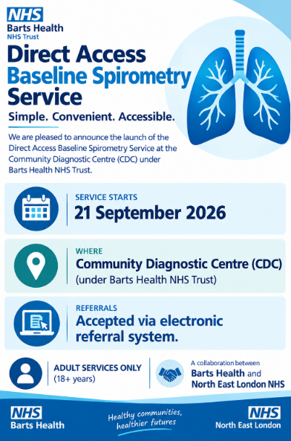

Mile End Community Diagnostic Centre (CDC)
Mile End Hospital
Bancroft Road
London

Date: 14 September 2026

Dear Colleague,
Direct Access Baseline Spirometry Service

We are pleased to inform you that the Mile End Community Diagnostic Centre (CDC) will be accepting referrals for a Baseline Spirometry Service from 21 September 2026.

Support early diagnosis and management of respiratory conditions and breathlessness queries within primary care environments. Helping to prevent unnecessary specialist centre referrals and keep patients on the right treatment paths.
This service provides baseline Spirometry measurements, including FEV1, FVC, FEV1:FVC and PEF. Alongside Flow-Volume Loops and appropriate technical explanations of the results in line with current best practice guidelines.

Referral Process
- Referrals can be submitted via the NHS Electronic Referral System (eRS) from 21 September 2026.
  - Baseline Spirometry - (RLH) - Barts Health NHS Trust - R1H

All referrals will be triaged to ensure patients are directed to the most appropriate diagnostic pathway and clinic based on clinical need.

With testing delivered and overseen by specialist Respiratory Physiology staff, the service provides:
- High-standard, quality-assured spirometry testing
- Comprehensive technical interpretation and reporting
- Reliable diagnostic results to support primary care decision-making
- Access to straight-to-test diagnostic results

You will remain involved in your patients’ care throughout the pathway and will receive timely updates regarding outcomes and management recommendations.

We look forward to working collaboratively with you to deliver this service and improve care for patients across our community.
If you require further information or have any queries, please do not hesitate to contact the CDC team.

Yours sincerely,
Mile End CDC Cardiac Clinical Team
Barts Health NHS Trust

