Protocol for Delivering Neonatal BCG Vaccine in London to Infants Aged 0 - 12 Months
July 2026 v5.0


Contents
Document Management 3
1. Introduction 4
2. Aim 5
3. London Neonatal BCG Programme Pathway (Figure. 1) 6
4. Eligibility Assessment 7
5. Referral Pathways 7
5.1 Maternity Pathway 7
5.2 Health visitor pathway 9
5.3 GP Pathway 10
5.4 Self-referral pathway 10
5.5 Incorrect/missed referrals 10
5.6 Figure 2. BCG pathway for babies born out of area 12
6. BCG Community Provider Pathway 13
7. Information Flows 14

Document Management
Revision History
Version | Date | Summary of Changes
4.0 | 23/09/10 | Document moved to new template. Updated Section 5.3 GP Pathway to cover referral and recording of vaccination. Updated self-referral section. Updated figures to include five day delay for provider sharing outcome with GP. Note that previous versions and authors have not been carried across to new document.

Reviewers
This document must be reviewed by the following:
Name | Title | Date | Version
Rehana Ahmed | Senior Immunisation Commissioning Manager |  | V5.0
Dawn Hollis | Head of Public Health Commissioning - ANNB Screening, Immunisations, CHIS, ICARS, Digital Transformation
Susan Elden | Consultant in Public Health

Document Author
This document was authored by the following:
Name | Title | Date | Version
Khalida Aziz | Immunisation Commissioning Manager | 1/10/2026 | V5.0
Jane Ritchie | Immunisation Commissioning Manger | 1/10/2026 | V5.0
Hilary Hewit | Commissioning Team Lead (CHIS and Immunisations) | 1/10/2026 | V5.0

Approved By
This document must be approved by the following people:
Name | Signature | Title | Date | Version

- Introduction
          - The national BCG immunisation programme is delivered as a risk-based programme. A key part of this risk-based approach is the selective neonatal programme targeted at those infants most at risk of exposure to TB. Those most at risk are defined in the Green Book as:
          - All infants (aged 0 to 12 months) with a parent or grandparent who was born in a country where the annual incidence of TB is 40/100,000 or greater (tuberculosis by country: rates per 100,000 people)
          - All infants (aged 0 to 12 months) living in areas of the UK where the annual incidence of TB is 40/100,000 or greater (TB Strategy Monitoring Indicators - Data | Fingertips | Department of Health and Social Care)
          - London historically had a higher annual incidence of TB. In many areas of London, the BCG immunisation programme was universally offered to newborn babies. However, the annual incidence of TB in London has been in decline, falling from a rate of over 40 per 100,000 in 2012 to a current overall rate of 17.8 per 100,000. The number of infants most at risk of exposure to TB in London has also decreased significantly.
          - On the 1st September 2020, neonatal BCG immunisation in London moved to a targeted programme, delivered to those infants most at risk of exposure to TB (as defined in section 1.1). This brought the London region in line with the national programme and the rest of England.
          - In addition, on 1st September 2020, neonatal BCG vaccine delivery in London moved from maternity units to community vaccination clinics. This was in preparation for changes to the neonatal BCG pathway from September 2021 due to the SCID screening evaluation.
          - From 6th September 2021, the SCID screening evaluation has been running in pilot areas throughout the country. In pilot areas, the Newborn Bloodspot (NBBS) includes a screening test for SCID. The national neonatal BCG pathway therefore changed to allow time for the SCID screening outcome result to be checked prior to BCG vaccination.
          - BCG is a live attenuated vaccine and should not be given to a baby with an immune suppressed condition without specialist clinical advice.

- Aim
          - The aim of the national neonatal BCG immunisation programme is to prevent infection from TB and reduce the risk of progression to severe disease. The London system remains committed to further reducing TB incidence through its programme of work through the London TB Control Board.
          - This protocol clarifies how the NHSE Neonatal BCG Immunisation Programme offers neonatal BCG vaccination to those infants aged 0-12 months in London eligible for the programme. It should be read in conjunction with the National BCG Immunisation Programme Service Specifications (see Appendix 2).
          - Vaccination of other eligible adults or children or of children under the age of one, who may be household contacts of someone with TB, is not covered by this protocol.

- London Neonatal BCG Programme Pathway (Figure. 1)
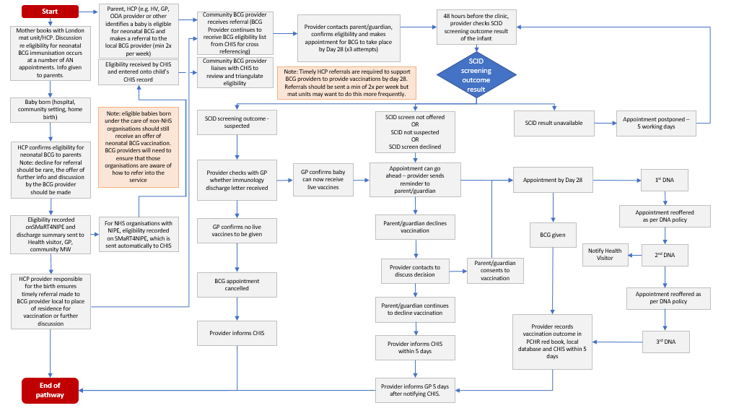

- Eligibility Assessment
          - An infant is eligible for the neonatal BCG immunisation programme in London if the answer is yes to EITHER of the following two questions:
  - All unvaccinated infants (aged 0-12 months) living in areas of the UK where annual incidence of TB is greater than or equal to 40/100,000 (in London currently, it is only the borough of Newham where a universal service is to be offered);
  - All unvaccinated infants (aged 0-12 months) with one or more parent or grandparent who was born in a country where the annual incidence of TB is greater than or equal to 40/100,000; and
    - All unvaccinated infants (aged 0-12 months) who were born, or resided for three months or more, in a country where the annual incidence of TB is greater than or equal to 40/100,000. A list of countries with a high rate of TB is available online (tuberculosis by country: rates per 100,000 people).
- Referral Pathways
  - Maternity Pathway
    - Babies born in London maternity units
- London maternity providers are required to identify whether the baby is eligible for BCG immunisation. This process should start during the antenatal period, preferably from the initial booking appointment. Eligibility should be recorded in the maternal and neonatal notes, on the Maternity Information Systems and on the baby’s NIPE (SMaRT4NIPE) record.
    - Completion of the neonatal BCG eligibility mandatory fields in SMaRT4NIPE will ensure that the local CHIS is informed of the eligibility status. Maternity units must ensure that a clinical referral to the local BCG community provider for where the baby resides is also undertaken within 48 hours (see BCG Provider list at Appendix 1). The London CHIS also send eligibility lists to BCG providers as a triangulation/failsafe process twice weekly alongside a missing outcome summary list monthly, to enable them to cross check referrals received from maternity units and support the return of outcome data from the BCG provider.
    - Babies born to private healthcare providers – private maternity providers/independent midwives - should be encouraged to assess the baby for eligibility for neonatal BCG and refer as appropriate. However, health visitors/GPs and community midwives who may also be responsible for care in the neonatal period must also ensure that they identify any eligible baby who has received non-NHS care and refer appropriately.
    - Out of Area (OOA) Babies
Babies born in London and reside outside of London
    - Babies born in London hospitals but who reside outside London should be assessed for BCG eligibility by the maternity provider. Eligibility for neonatal BCG should be recorded in the relevant fields in SMaRT4NIPE. Appropriate referral must be discussed with the parents and a clinical referral must be made in accordance with the parents’ wishes. The maternity unit responsible for the birth will be responsible for funding the BCG immunisation via the maternity pathway payment.
    - The maternity provider must refer the baby to the BCG provider responsible for the borough the maternity provider is based within. The BCG provider must offer the baby BCG vaccination.
    - If the parents decline the provider because they would prefer to have the BCG vaccination in their area of residence, and if they live out of London, the BCG provider must send the original maternity referral onto the local BCG provider responsible for the baby’s out of London resident area.
    - The CHIS team of the child’s residential area should also be notified of the baby when the child is registered with a new GP or via health visiting service or other services (such as NEMS, A&E, social services, LAC etc).
Baby born outside of London and resides in London
    - Babies born outside of London, but who reside in London should be assessed for BCG eligibility by the maternity provider, who if eligible will offer the BCG vaccination.
    - If the parents decline the provider because they would prefer to have the BCG vaccination in their area of residence, the maternity provider must send a clinical BCG referral onto the London BCG provider responsible for the baby's resident borough. The London BCG provider must then offer the baby vaccination.

Neonatal Unit/Special Care Babies
    - If a baby is admitted to SCBU or NICU shortly after birth, the Trust retains responsibility and there should be an organisational process in place between maternity and NICU to ensure that the baby has a clinical referral and that the information is recorded on SMaRT4NIPE and in neonatal and maternity IT systems.
    - If the baby is still in SCBU or NICU when the BCG community provider makes contact to book the appointment, the BCG community provider will make arrangements to rebook at a later date.
See figure 2 for BCG pathway for babies born out of area.
  - Health visitor pathway
    - As part of the Health Child Programme, HVs have a role to play in checking immunisation eligibility and status and encouraging parents to take up all offers of recommended vaccinations. Health visitors are required to identify which babies in their care are eligible for BCG immunisation and ensure they have been referred to their appropriate community provider.
    - Newborn babies
    - Health visitors should assess eligibility for the neonatal BCG programme at the new baby review within 14 days of birth and ensure that the parents/guardians have received an appointment for BCG immunisation.
    - If a baby is eligible for BCG, the health visitor should check the baby’s CHIS record to see if a BCG flag has been raised and therefore a referral to the BCG provider is unnecessary.
    - If a baby is born in London, the baby should have been referred to the community BCG provider. Maternity discharge documentation and discussion with the parents/guardians should evidence this.
    - For any baby born out of London but resides in London or resident out of London but was born in London or, who the HV service or GP has assessed as eligible and believes has not had a clinical referral, they should make a referral to the local BCG immunisation service.
    - Movers in up to 12 months (babies born elsewhere)
    - ‘Babies born elsewhere’ are defined as babies who were:
    - Born in any country outside of England (includes births in other countries within the United Kingdom) and subsequently move into London after birth.
    - Born in any area of England outside of London. The parents may already have been living in London prior to birth.
    - Babies born elsewhere (up to 12 months of age) and moving into the geography covered by the health visiting service should be assessed for BCG eligibility and their BCG vaccination history checked by the health visiting service.
    - If the baby is eligible for neonatal BCG immunisation, has not received a BCG vaccination previously, and there is no reason that the baby cannot receive live vaccines, the health visitor should refer the baby to the community provider via the established referral route. A copy of SCID result (if available) should be included.
  - GP Pathway
    - Referral Process
- GPs are required to check that eligible babies in their care, who are able to receive live vaccines, have received BCG vaccination.
- If a baby is eligible for neonatal BCG immunisation and not yet vaccinated:
  - Moves into the area, or
  - Changes GP practice, or
  - Has not yet been referred
The GP practice must refer the baby to the local neonatal BCG immunisation service.
- At this stage: Do not code the vaccine as 'given' until the BCG provider has confirmed administration.
    - Recording Vaccination
- If a baby moves into the area (as defined in section 5.2.2 and has already received the BCG vaccination elsewhere, the GP must:
  - Verify the date of birth is correct.
  - Code the vaccine as ‘Vaccine Given’ in the clinical system.
  - Document the actual date the vaccine was administered
- It is strongly recommended that where possible, include the following in the clinical notes:
  - Location where the vaccine was given.
  - Any additional documentation or details related to the vaccine.
  - Incorrect/missed referrals collated by BCG Providers
- Providers should send their NHSE commissioners a monthly report of babies that were incorrectly referred or were missed by maternity units. On top of this providers should also follow the below pathways (5.5.1-5.5.5) for incorrect or missed referrals.
    - Incorrect maternity referrals
- If you receive an incorrect maternity referral that is either meant for another BCG provider or has missing/incorrect information, please go back directly to the maternity unit notifying them and asking for the additional information/for them to redirect the referral to the correct provider. All maternity units have been sent the BCG provider contact details and the boroughs they cover.
    - Babies referred who are not eligible
- If a provider receives a referral (or on the CHIS failsafe list) for a baby who is not eligible for BCG vaccination, please notify the maternity unit so they can investigate the error, and also notify CHIS so they can remove the BCG eligibility flag on the record.
    - Babies on the CHIS failsafe list that do not appear on maternity referrals
- For babies that appear on the twice weekly CHIS BCG failsafe list that providers did not also receive a separate maternity referral for, they should flag these babies to the maternity units so they can follow-up on their side and look into the reason for the delay in referral or the baby being missed.
- It is crucial for providers to be continually checking the twice weekly CHIS BCG failsafe list in order to pick up any BCG eligible babies who have been missed and prevent any delays in providing a vaccination offer. This will also ensure there is no build-up of babies with missing outcomes on CHIS and prevent another serious incident from occurring.
    - Babies on maternity referrals not on CHIS failsafe list
- If providers receive a BCG referral from a maternity unit that has not appeared on the twice weekly CHIS BCG failsafe list, this baby needs to be notified to CHIS so they can place the BCG flag on the patient record and put the failsafe is in place for them. Providers also need to notify the maternity unit, so they can check their end that the correct eligibility criteria was followed and investigate why the baby was not marked as BCG eligible on the Smart4Nipe assessment.
    - Babies referred through other routes, not on CHIS failsafe list or Maternity referrals
- If you receive a referral for a baby eligible for BCG via other routes (e.g. GP or Health Visitor) that does not appear on the CHIS failsafe list or maternity referral, please notify CHIS so they can place the BCG flag on their record. If the baby was born in a London maternity unit, notify that unit so they can follow-up internally on why the baby was not marked as BCG eligible on the Smart4Nipe assessment.

  - Figure 2. BCG Pathway for Babies Born Out Of Area

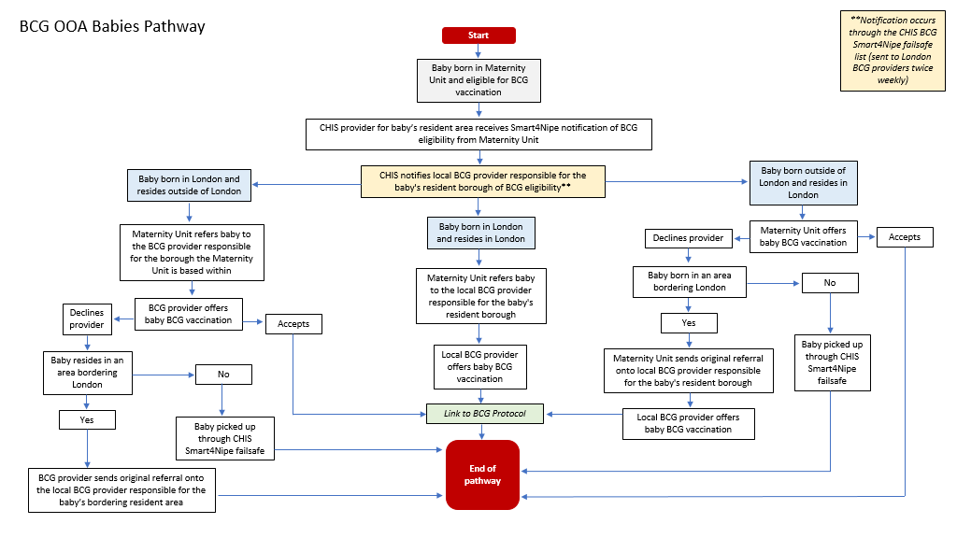
- BCG Community Provider Pathway
  - All BCG vaccinations will be offered in the community by the commissioned community providers. Details of these community providers, determined by baby’s borough of residence, are included in Appendix 1. National service standards for community providers are in Appendix 2.
  - The BCG community provider must ensure that systems are in place to address health inequalities and ensure equity of access to the service. Further details are available in section 2.3 of the national BCG schedule 2 (see Appendix 2).
  - The London pathway in Section 3 of this protocol provides detail of the steps in the community provider pathway in and out of London.
  - Community providers are required to accept referrals for all eligible babies. Eligibility for neonatal BCG vaccination in London is set out in Section 4 of this protocol and in the Green Book.
  - Once a referral is received, the community provider must contact the parent/guardian, confirm eligibility and offer a BCG appointment within the first 12 days of receipt of BCG referral, (whilst the SCID screening outcome is pending), the BCG vaccination to take place preferably by 3 months of referral.
  - All babies must be invited by the preferred method of contact of the parent/guardian, and a combination of methods should be used to contact the parent/guardian, including letter, email, phone call and/or text message. If the baby has had 3 DNA’s and has been discharged as per the providers DNA policy, the outcome of this must be notified to CHIS as “discharged as per the providers DNA policy”. The parents/carer should also be sent a discharge letter, detailing how they can get in contact to ensure the infant receives a BCG vaccination.
  - When a baby DNA’s a 2nd time, the BCG provider must notify the infant’s Health Visitor of their 2nd DNA, so they can have a conversation with the family to ensure they understand the BCG offer and the consequences of DNA’ing a 3rd time.
  - Where a baby was not brought to the service a third time (i.e. 3rd DNA) the Provider should send written confirmation to the baby’s GP that the child was not brought and that the GP is now required contact the parents and make a fresh referral to the appropriate BCG service (See Appendix 1.1).
  - The community provider is responsible for checking the SCID screening outcome result 48 hours before the scheduled BCG appointment. The SCID screening outcome result determines the next steps to be taken.
  - Neonatal BCG vaccination can only take place when the SCID screening outcome result is:
  - ‘SCID not suspected’ or
  - ‘SCID screen not offered’ (i.e. not screened as the baby is outside the area of the evaluation) or
  - ‘SCID screen declined’
Once this result is confirmed, the community provider should send an appointment reminder to the parent/guardian and vaccinate the baby preferably by day 28.
  - Babies who have obtained a ‘SCID suspected’ screening result will not be given the BCG vaccine until they have been reviewed by a specialist team. For these babies, the community provider is responsible for checking with the baby’s GP whether an immunology discharge letter has been received and whether live vaccines can be given. If the immunology discharge letter has not been received, vaccination cannot go ahead.
  - For those babies who cannot receive live vaccines, the community provider must cancel the BCG appointment and inform CHIS.
  - The community provider must not vaccinate if a SCID screening outcome is unavailable and should follow up with CHIS to confirm the screening outcome before vaccinating.
  - If the baby does not attend their vaccination appointment, the community provider must make at least two further attempts to contact the parent/guardian to rearrange the appointment. One of these attempts must be carried out by a health care professional, using contact such as telephone, or face to face. For those that do not attend for their appointments, the community provider will ensure best endeavours are made to re-invite, encourage attendance, and vaccinate as soon as is practically possible.
  - In all cases the community provider must update the patient record to record the actions taken and the response, including any failure to attend booked appointments.
  - The community provider must inform CHIS and the patient’s GP of the outcome of the vaccination offer. List of fields that must be included in the community provider report to CHIS for each baby is detailed in Appendix 3.2.
- Information Flows
  - Figure 2 below sets out the flow of information in London for the neonatal BCG programme from 1st September 2023.
  - The maternity provider is responsible for ensuring that the correct information on BCG eligibility is entered on SMaRT4NIPE and for referring the eligible baby to the appropriate community BCG provider within 48 hours.
  - The CHIS are responsible for:
    - Receiving BCG eligibility information from maternity systems and sending this to:
    - Health visitors on a daily basis
    - BCG community providers on a twice monthly
    - Receiving the SCID screening outcome result and sending this to:
    - Health visitors on a daily basis
    - BCG community providers on a twice weekly basis
    - Receiving the BCG vaccination outcome from the community provider and sending this on a daily basis to the health visitor.
  - The community provider is responsible for:
    - Receiving BCG referral from the maternity unit and contacting the parent/guardian.
    - Receiving and processing the clinical referral from the maternity provider or other clinician (e.g. GP).
    - Receiving the SCID screening outcome result from the CHIS and checking this prior to vaccination of the baby.
    - Recording the outcome of the BCG vaccination in the provider system and in the baby’s Red Book.
    - Communicating the outcome of the BCG vaccination to CHIS within 5 working days. Communicating the outcome of the BCG vaccination to GP 5 working days after notifying the CHIS.
  - Appendix 3 sets out the suggested list of fields in the BCG community provider patient database (Appendix 3.1), and the fields the community provider should include in the report to CHIS for each baby within 5 working days of vaccination (Appendix 3.2).
  - NHSE London Commissioning team will review uptake data for each community provider at contract/performance meetings and on a monthly basis using the data provided by the CHIS. Uptake data is also reviewed at the ICB Immunisation Boards.

  - Figure 2 - London information flows: BCG/SCID pathway from 1st September 2023

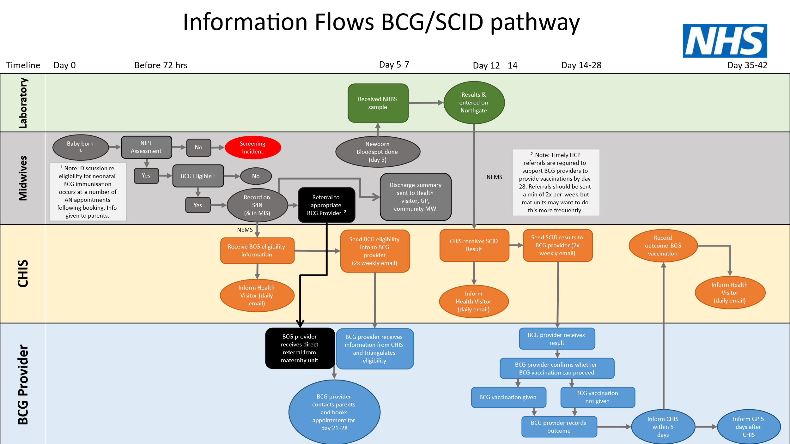

- Glossary
AN | Antenatal
A & E | Accident and Emergency
BCG | Bacillus Calmette Guerin Vaccine
CHIS | Child Health Information Service
DNA | Did Not Attend
GP | General Practice
HCP | Healthcare Practitioner
HV | Health Visitor
ICB | Integrated Care Board
LAC | Looked after child
MW | Midwife
NEMS | National Events Management System
NBBS | Newborn Bloodspot
NHSE | National Health Service England
NICU | Neonatal Intensive Care Unit
NIPE | Newborn Infant Physical Examination
OOA | Out of area
PCHR | Personal Child Health Record
SCBU | Special Care Baby Unit
SCID | Severe Combined Immune Deficiency
TB | Tuberculosis

Appendix 1 - Contacts

Appendix 1.1 – Community Providers by Borough
ICB | Borough | Provider | BCG email
SEL | Greenwich | KRFT | hrch.selbcg@nhs.net
SEL | Bexley | KRFT | hrch.selbcg@nhs.net
SEL | Bromley | KRFT | hrch.selbcg@nhs.net
SEL | Lambeth | KRFT | hrch.selbcg@nhs.net
SEL | Southwark | KRFT | hrch.selbcg@nhs.net
SEL | Lewisham | KRFT | hrch.selbcg@nhs.net
SWL | Croydon | KRFT | hrch.swlbcg@nhs.net
SWL | Wandsworth | KRFT | hrch.swlbcg@nhs.net
SWL | Kingston | KRFT | hrch.swlbcg@nhs.net
SWL | Richmond | KRFT | hrch.swlbcg@nhs.net
SWL | Merton | KRFT | hrch.swlbcg@nhs.net
SWL | Sutton | KRFT | hrch.swlbcg@nhs.net
NEL | Newham | Vaccination UK | vul.nlbcgreferrals@nhs.net
NEL | Tower Hamlets | Vaccination UK | vul.nlbcgreferrals@nhs.net
NEL | City & Hackney | Vaccination UK | vul.nlbcgreferrals@nhs.net
NEL | Barking & Dagenham | Vaccination UK | vul.nlbcgreferrals@nhs.net
NEL | Havering | Vaccination UK | vul.nlbcgreferrals@nhs.net
NEL | Redbridge | Vaccination UK | vul.nlbcgreferrals@nhs.net
NEL | Waltham Forest | Vaccination UK | vul.nlbcgreferrals@nhs.net
NCL | Barnet | Vaccination UK | vul.nlbcgreferrals@nhs.net
NCL | Camden | Vaccination UK | vul.nlbcgreferrals@nhs.net
NCL | Enfield | Vaccination UK | vul.nlbcgreferrals@nhs.net
NCL | Haringey | Vaccination UK | vul.nlbcgreferrals@nhs.net
NCL | Islington | Vaccination UK | vul.nlbcgreferrals@nhs.net
NWL | Harrow | Vaccination UK | vul.nlbcgreferrals@nhs.net
NWL | Brent | Vaccination UK | vul.nlbcgreferrals@nhs.net
NWL | Ealing | Vaccination UK | vul.nlbcgreferrals@nhs.net
NWL | Hillingdon | Vaccination UK | vul.nlbcgreferrals@nhs.net
NWL | Hammersmith & Fulham | Vaccination UK | vul.nlbcgreferrals@nhs.net
NWL | Hounslow | Vaccination UK | vul.nlbcgreferrals@nhs.net
NWL | Kensington & Chelsea | Vaccination UK | vul.nlbcgreferrals@nhs.net
NWL | Westminster | Vaccination UK | vul.nlbcgreferrals@nhs.net

Appendix 1.2 – CHIS Providers by ICB
ICB | CHIS Email Address
SEL | hil.selchis@nhs.net
SWL | swl.chis@nhs.net
NWL | hil.nwlchis@nhs.net
NCL | nelchishub@nelft.nhs.uk
NEL | nelchishub@nelft.nhs.uk

Appendix 1.3 – Maternity Units
ICB | Maternity Unit | NHS Trust
NCL | North Middlesex University Hospital | North Middlesex Hospital University Hospital
NCL | Barnet Hospital | Royal Free London NHS Foundation Trust
NCL | Royal Free Hospital | Royal Free London NHS Foundation Trust
NCL | University College Hospital | University College London Hospitals NHS Foundation Trust
NCL | The Whittington Hospital | Whittington Health Trust
NEL | Queen's Hospital | Barking, Havering and Redbridge University Hospitals
NEL | Newham University Hospital | Barts Health NHS Trust
NEL | The Royal London Hospital | Barts Health NHS Trust
NEL | Whipps Cross University Hospital | Barts Health NHS Trust
NEL | Homerton University Hospital | Homerton University Hospital NHS Foundation Trust
NWL | Chelsea and Westminster Hospital | Chelsea and Westminster Hospital NHS Foundation Trust
NWL | West Middlesex Hospital | Chelsea and Westminster Hospital NHS Foundation Trust
NWL | Queen Charlotte's Hospital | Imperial College Healthcare NHS Trust
NWL | St Mary's Hospital | Imperial College Healthcare NHS Trust
NWL | Northwick Park Hospital | London North West Healthcare NHS Trust
NWL | Hillingdon Hospital | The Hillingdon Hospitals NHS Foundation Trust
SEL | Guy's and St. Thomas' Hospital | Guy's and St. Thomas' Foundation Trust
SEL | King's College Hospital | King's College NHS Foundation Trust
SEL | Princess Royal University Hospital | King's College NHS Foundation Trust
SEL | Queen Elizabeth Hospital | Lewisham and Greenwich NHS Trust
SEL | University Hospital Lewisham | Lewisham and Greenwich NHS Trust
SWL | Croydon University Hospital | Croydon Health Services NHS Trust
SWL | St. Helier Hospital | Epsom and St. Helier University Hospitals NHS Trust
SWL | Epsom Hospital | Epsom and St. Helier University Hospitals NHS Trust
SWL | Kingston Hospital | Kingston Hospital NHS Foundation Trust
SWL | St George's Hospital | St George's University Hospitals NHS Foundation Trust

Appendix 2 – National service specifications
BCG National Service Specification: Schedule 2
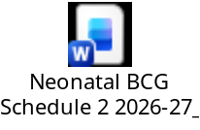
BCG National Service Specification: Schedule 4

BCG National Service Specification: Schedule 6
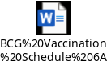

Appendix 3 – London data requirements

A3.1 Suggested list of fields in BCG community provider patient database
Data field | Suggested field options
Source of referral | NIPE SMART;  Health Visitor;  GP;  Self-referral
Baby first name | Free text
Baby surname | Free text
Baby date of birth | dd/mm/yyyy
Baby postcode | Free text
Baby NHS number | Number
SCID result received | Yes  No
SCID result | SCID screen not offered; SCID not suspected; SCID suspected; SCID screen declined
Vaccination can be given | Yes  No
Consent given | Yes  No
Consent given by | e.g. parent, guardian
21 days of age target | dd/mm/yyyy
1st Appointment offered | Yes  No
Did they attend? | Yes  No
2nd Appointment offered | Yes  No  n/a
Did they attend? | Yes  No  n/a
3rd Appointment offered | Yes  No  n/a
Final Status | Vaccination given  Declined (include date of decline if available)  Discharged (either due to DNAs / no response to offers or parent confirmed vaccination given elsewhere but there is no record of this)  Child deceased  Moved out of area  Does not meet criteria / Not eligible (must be flagged to CHIS so they can remove the BCG flag on the record)
If DNA or decline, reason given | Free text
Date BCG given | dd/mm/yyyy
28 day vaccine target | dd/mm/yyyy
Age in days when vaccine given | XX days
28 day vaccine standard met? | Yes  No
Venue code | Free text
Provider code | Free text
Site and route of administration | Free text
Name of immuniser | Free text
Vaccine name | Free text
Product name | Free text
Batch Number | Free text
Expiry Date | dd/mm/yyyy
Any contraindications to the vaccine and any alternative offered | Free text
Adverse reactions | Free text
Has the GP and CHIS been notified within 5 days | Yes  No
Date notification sent to GP/CHIS | dd/mm/yyyy
Comments | Free text

A3.2 List of fields in community provider report to CHIS for each baby
Data field | Notes
Source of referral
Baby first name
Baby surname
Baby date of birth
Baby postcode
Baby NHS number
Vaccination can be given | Contraindications included in comments
Consent given | Details of non-consent included in comments
Final Status | Vaccination given  Declined (include date of decline if available)  Discharged (either due to DNAs / no response to offers or parent confirmed vaccination given elsewhere but there is no record of this)  Child deceased  Moved out of area  Does not meet criteria / Not eligible (must be flagged to CHIS so they can remove the BCG flag on the record)
Date BCG given
Venue code | Not available for all venues
Site and route of administration
Batch Number
Any contraindications to the vaccine and any alternative offered | Included under comments
Comments

A3.3 List of fields in CHIS data report to NHSE each month
Data field
Number of eligible babies missing a final BCG outcome on CHIS by month and brought from September 2020 – the final day of the month prior to reporting

https://worldhealthorg.shinyapps.io/tb_profiles/?_inputs_&entity_type=%22country%22&iso2=%22AF%22&lan=%22EN%22
Kingston and Richmond NHS Foundation Trust (KRFT), previously Hounslow and Richmond Community Healthcare NHS Trust (HRCH)

