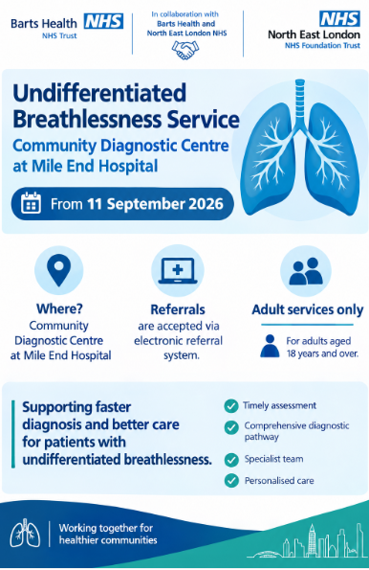

Mile End Community Diagnostic Centre (CDC)
Mile End Hospital
Bancroft Road
London

Date: 11 September 2026
Dear Colleague,
Launch of Undifferentiated breathlessness Clinical Pathway at Mile End CDC
We are pleased to inform you that the Mile End Community Diagnostic Centre (CDC) will be accepting referrals for the undifferentiated breathlessness Clinical Pathway from 1st September 2026
This pathway has been developed to support the timely assessment and management of patients presenting with unexplained breathlessness. It aims to improve access to diagnostic services within the community, enhance patient experience, and facilitate earlier diagnosis and intervention.

Referral Process
Referrals can be submitted via the NHS Electronic Referral System (eRS).
- General Respiratory - Respiratory Medicine (MEH) - Barts Health NHS Trust - R1H

All referrals will be reviewed and triaged to ensure patients are directed to the most appropriate diagnostic pathway and clinic.

Key Benefits
- Improved access to diagnostic services closer to patients’ homes
- Reduction in waiting times for investigations
- Streamlined assessment of breathlessness
- Improved communication between primary and secondary care

You will remain involved in your patients’ care throughout the pathway and will receive timely updates regarding outcomes and management recommendations.

We look forward to working collaboratively with you to deliver this service and improve care for patients across our community.

If you require further information or have any queries, please do not hesitate to contact the CDC team.

Yours sincerely,
Mile End CDC Cardiac Clinical Team
Barts Health NHS Trust

Suitability guidance

Conditions treated
Unexplained and/or Disproportionate Breathlessness. This pathway is designed for people who have an unclear cause for their breathlessness. It is not appropriate for those in whole a diagnosis of asthma/COPD/Heart Failure is strongly suspected based on the clinical presentation - please use usual pathways in this case. This pathway is also appropriate for advice and guidance and MDT discussion of patients with breathlessness of unclear cause and/or disproportionate to their known pathology, if you are unsure if the patient would be appropriate for this pathway, consider an A&R request and a clinician will assess suitability and/or provide advice

Procedures performed
Most patients will be triaged to undertake an upfront CPET-SE (cardiopulmonary exercise test combined with stress echocardiogram). The results will be reviewed in the Breathlessness MDT and triaged to the most appropriate clinic, which includes Cardiology, Respiratory and Physiotherapy clinics

Exclusions
Children under 16 years old. Exclusion criteria for CPET-SE*: · Heart attack, myocarditis, pericarditis, stroke or acute pulmonary embolism within the last three months · Angina · Uncontrolled hypertension (systolic BP >200mmHg and/or diastolic BP >100mmHg) · Uncontrolled cardiac arrhythmias, e.g. atrial flutter/atrial fibrillation · Musculoskeletal pain exacerbated by exercise* · Severe muscle weakness or any other known condition that would limit exercise · Acute systemic infection or fever · Pregnancy · Decompensated heart failure, known severe valvular disease, aortic aneurysm · Weight >120Kg (exercise bike maximum limit is 120Kg) *Your patient would still be eligible for this pathway even if they are unsuitable for CPET-SE. Please inform us via A&G whether your patient has any of the above. If you are unsure whether your patient is suitable for this pathway, please contact A&G for further advice

Suggested investigations
FBC, Thyroid function, Renal function, NT-ProBNP, Chest X-ray

Administrative requirements
Not recorded

Alternative services
Not recorded

Additional service information
https://www.bartshealth.nhs.uk/respiratory/

