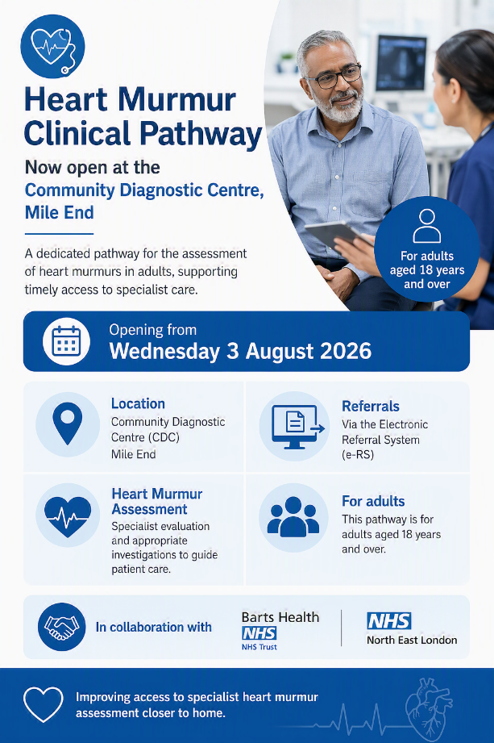

Mile End Community Diagnostic Centre (CDC)
Mile End Hospital
Bancroft Road
London

Date: 11 September 2026

Dear Colleague,
Launch of Rapid Murmur Assessment Service at Mile End CDC

We are pleased to inform you that the Mile End Community Diagnostic Centre (CDC) will be accepting referrals for a Rapid Murmur Assessment Service (RMAS) from 3rd of August 2026.

This pathway has been developed to support the timely assessment of patients with a newly detected or previously undocumented heart murmur, enabling earlier identification of valvular heart disease and appropriate onward management.

The service is designed as a diagnostic-focused pathway within the community, improving access, reducing delays, and ensuring patients are managed in the most appropriate setting.

Referral Process
- Referrals can be submitted via the NHS Electronic Referral System (eRS) from 1st June 2026.
  - Cardiology - Valve Disorder Rapid Access - Barts Health NHS Trust - R1H

All referrals will be triaged against national guidelines to ensure patients are directed to the most appropriate diagnostic pathway and clinic based on clinical need.

Key Benefits
- Rapid assessment of patients with suspected valvular heart disease
- Clear, standardised diagnostic pathway for heart murmurs
- Patients can be referred to secondary care where appropriate, with flexibility to opt into ongoing clinical follow-up or return care to primary care with guidance

You will remain involved in your patients’ care throughout the pathway and will receive timely updates regarding outcomes and management recommendations.

We look forward to working collaboratively with you to deliver this service and improve care for patients across our community.
If you require further information or have any queries, please do not hesitate to contact the CDC team.

Yours sincerely,
Mile End CDC Cardiac Clinical Team
Barts Health NHS Trust

