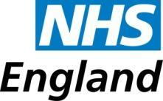

NHSE Immunisation Payments Query
Practice Code | Practice Name | Contact Name | Contact email | Date

Immunisation claimed | Details of query  Please state if this is regarding an over or underpayment | Achievement month | Amount claimed  £

Please note that enquiries cannot be processed without a clinical audit report from the practice system. Excel spreadsheets are not an accepted form of evidence and please do not send any patient identifiable data.
System supplier templates are available to produce a report that shows the correct figures for each of the different payment indicators within a programme. We will accept a whole programme figure for the relevant month, but we will need to know the correct figures per payment indicator to be able to update the achievement.

Please email this enquiry to: england.londonimms@nhs.net
We aim to respond to all emails within 48 hours.
Please note that our payment terms are 2 months following a validated CQRS submission. Payments are made to PMS Practices on the 15th of the month and to GMS Practices on the 20th of the month.

