Name_________________________ | Date of Birth____________ | NHS Number_______________

BLADDER AND BOWEL DIARY

CHILD’S FULL NAME

DATE OF BIRTH

ADDRESS

TELEPHONE

DATE COMPLETED

This information will help assist the clinician with your child’s assessment and aid with any interventions and, if necessary, any treatments.
Bladder problems can be causes by bowel problems that have not always been identified which is why we need this information.
Bladder problems can be caused due to bladder size, poor fluid intake etc, we can find out lots of information about your child’s bladder/bowel health from completing these charts for us.
It is best if you can fill this diary in when they are at home rather than at school, i.e. over a couple of weekends or during school holidays. It does not have to be consecutive days.
If you have any questions regarding completion of this diary, please contact the clinician that you are working with.
Please return your completed diary to the clinician you are working with.
Thank you.

Drinks record
Please keep a record of how much your child drinks as it is important for the clinician to know your child’s fluid intake.

It is best if you record the amount in millilitres (mls).
Please measure the liquid in your child’s favourite cup/beaker and use this as a basis for your measurements.

Drinks - measure all drinks for 3 days

Time finished | Amount (ml) | What was the  drink? | Time finished | Amount (ml) | What was the drink?
DAY 1 / DATE:
e.g. 9am | 220ml | Water
DAY 2 / DATE:
DAY 3 / DATE:

Wee record

Buy a cheap plastic jug to measure. Please measure each wee and make sure this is recorded.
It helps if you check the colour, get your child to tell you if it is dark, light or if it is strong smelling. If the urine smells offensive or ‘fishy’ and your child seems unwell, please take a sample to your GP for checking.

Wees - measure all wees for 3 days

 | Time | Where i.e. pants, loo? | How much? (ml) | D-dark, M-medium, L-light
DAY 1 / DATE: | e.g. 9.00 | Toilet | 125ml | M
DAY 2 / DATE:
DAY 3 / DATE:

Poo record
Bristol Stool Chart - please make a note of which most closely resembles your child’s poo, and
record it in the last column.
If your child strained or appeared not to be aware of feeling, hid themselves away or tried to retain the poo, please make a note in the last column of poo section.
Bristol Stool chart
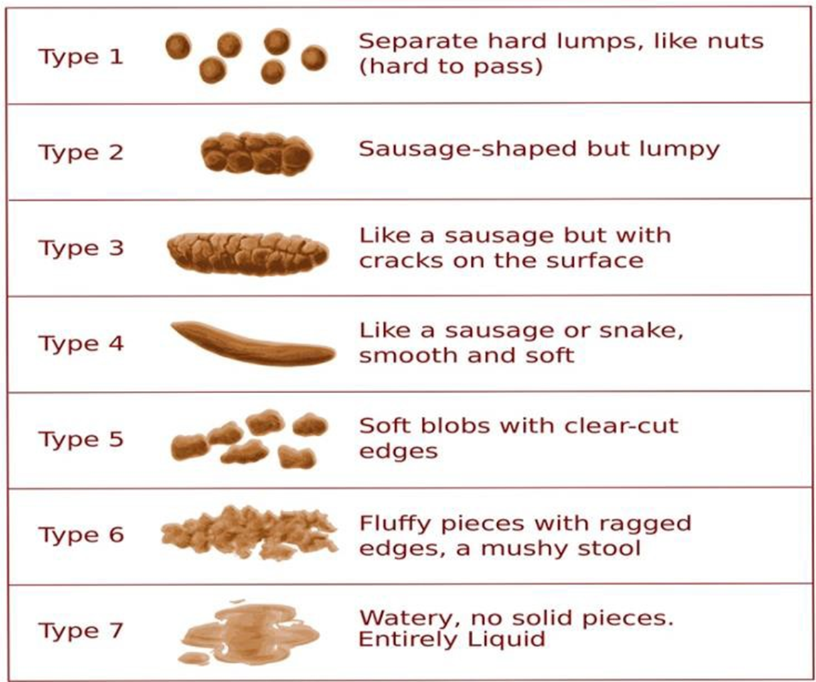

Poo – record all poos for 1-2 weeks
Date | Time | Where | Size | Type | Notes
e.g. 10 February 2025 | 17:30 | Toilet | Large | 2 | Painful, strained

