Large print and other languages
This information can be made available in alternative formats, such as easy read or large print, and may be available in alternative languages, upon request. For more information, speak to your clinical team.
এই তথ্যগুলো সহজে পড়া যায় অথবা বৃহৎ প্রিন্টের মত বিকল্প ফরম্যাটে পাওয়া যাবে, এবং অনুরোধে অন্য ভাষায়ও পাওয়া যেতে পারে। আরো তথ্যের জন্য আপনার ক্লিনিক্যাল টিমের সাথে কথা বলুন।
Na żądanie te informacje mogą zostać udostępnione w innych formatach, takich jak zapis większą czcionką lub łatwą do czytania, a także w innych językach. Aby uzyskać więcej informacji, porozmawiaj ze swoim zespołem specjalistów.
Macluumaadkaan waxaa loo heli karaa qaab kale, sida ugu akhrinta ugu fudud, ama far waa weyn, waxana laga yabaa in lagu heli luuqaado Kale, haddii la codsado. Wixii macluumaad dheeraad ah, kala hadal kooxda xarunta caafimaadka.
Bu bilgi, kolay okunurluk veya büyük baskılar gibi alternatif biçimlerde sunulabilir, ve talep üzerine Alternatif Dillerde sunulabilir. Daha fazla bilgi için klinik ekibinizle irtibata geçin.
یہ معلومات متبادل فارمیٹس میں دستیاب کی جا سکتی ہیں، جیسا کہ پڑھنے میں آسان یا بڑا پرنٹ اور درخواست پر متبادل زبانوں میں بھی دستیاب ہو سکتی ہیں۔ مزید معلومات کے لیے، اپنی کلینکل ٹیم سے بات کریں'۔

Tell us what you think
Tweet us @NHSBartsHealth
Talk to us via facebook.com/bartshealth
Leave feedback on NHS Choices www.nhs.uk

Patient Advice and Liaison Service (PALS)
Please contact us if you need general information or advice about Trust services: www.bartshealth.nhs.uk/pals

Reference: BH/PIN/1189
Publication date: January 2023
All our patient information leaflets are reviewed every three years.

Whipps Cross Homebirth Service
Having your baby at home


2
11

Your care with the Homebirth Team
At Whipps Cross we aim to provide you choice of place of birth.

Our dedicated and experienced Homebirth Team aims to provide continuity throughout your pregnancy, labour and postnatally.

Being cared for by the Homebirth Team means that you will get to know your midwife and team, really well.

Most of your care will take place at your home, including Homebirth Set-Up and birth plan at 36 weeks*

You will also receive early labour support and assessment, labour care at home, fully supported hospital transfer if needed, along with your postnatal appointments at home*

*Appointments may be offered in hospital if your midwife is at a birth or if you live out of area

If you wish to know more, you may find the following useful:
Birth Place Study (2011)
NHS Where Can I Give Birth?

Please do not hesitate to contact the Homebirth Team:
Email - bartshealth.wxhomebirth@nhs.net
Instagram - whippscrosshomebirth

Other Useful Contacts:
Lilac Birth Centre - 0208 539 5522 Ext 4697
Triage - 0208 539 5522 Ext 5532
Delivery Suite - 0208 539 5522 Ext 6769





Who can give birth at home?
The choice is yours!

Homebirth is particularly recommended for all people who are medically well and experiencing a straightforward pregnancy.

If you have had significant previous birth complications, have certain medical conditions or your baby needs extended monitoring after birth, you may be recommended to give birth in hospital at the Lilac Birth Centre or Delivery Suite.

You may be offered a Birth Options appointment with a Consultant Midwife if you have additional risk factors and would like to give birth at home.

The Homebirth Team will support your informed choice.
10
3

Frequently asked questions:

Isn't it safer to give birth in the hospital?
Evidence from the Birthplace Study shows that for women having their second or subsequent baby, home is the safest place (lower rates of interventions such as caesarean section or instrumental birth). It is just as safe for a first-time mum. However, there are slightly higher risks of injury for baby (9 per 1000 babies, compared to 5 per 1000 babies in other birth places)

Can I use any pain relief at home?
Yes! Pain relief in labour is a very personal decision and the Homebirth Team will support you in your choices. Women birthing at home tend to require less pain relief. However, Hypnobirthing, Aromatherapy, Massage, Transcutaneous Electrical Nerve Stimulation (TENS), Water and Gas and Air can all be used at home. If you decide you would like anything else such as an epidural we will support you in transferring to the labour ward where you can have this.

What about the mess?
We will help you to prepare your home and birth space prior to birth, hoping to avoid any mess at the birth. We will clear up after ourselves and take all our rubbish with us

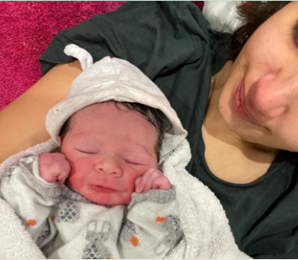

Testimonial
My pregnancy care was brilliant and a big part of that was the 'Continuity of care'. I had the opportunity to build a relationship beyond charts and measurements with my midwife. She would visit my house, learn about my environment and my family (who were also home due to childcare and office closures) and therefore learn about me. Seeing the same person for every appointment in my home made me feel safe, informed and heard.

Two midwives arrived, one being the person I met throughout my pregnancy, and they gave me the perfect balance of space and support to progress through my labour. I was mostly in my own focused zone, listening to music through headphones and timing contractions. Being at home meant I had everything I might have needed at hand to be comfortable, I moved from the birthing ball to the sofa, to walking around. Without even thinking about it, I could get up and be as mobile as I felt like at that time.

Once the baby was born, the post birth experience was so gentle and calm. Being at home meant we didn't have to move like you do at hospital. The midwives cleared everything away and apart from the new born baby there was no evidence that a birth had taken place in the room, it was so clean!

Once the midwives left,
the three of us, Mum, Dad
and baby all went and
had a nap in the bedroom.

Saran’s Homebirth, 2021.
Photo with permission.
9
4

Testimonial
My main reason of choosing a home birth was so that I could be in my own bed afterwards and be surrounded by family, I got just that and for that reason my homebirth will forever be a special memory for all our family.

I was helped through the pain with gas and air, and to be honest being at home, surrounded by everyone, with my own music playing and comforts I felt very happy (even in a lot of pain!) I was being checked by my then 3 year old dressed up as Doc McStuffins which is a memory I will always cherish. Our son Arthur was then born after a very quick labour at 7.02pm surrounded by his grandmothers, aunties, dad and two very amazing midwives.

Big Sister Emily (Doc McStuffins) and
Baby Arthur. Yasna’s Homebirth, 2021.
Photo with permission.

Frequently asked questions:

What if there is an emergency?
Our Midwives are all trained to respond to childbirth emergencies. In the case of emergency, an ambulance will be called to get you / your baby to hospital as soon as possible.

I'm already halfway through my pregnancy am I too late to have a homebirth?
No, you can refer at any time during your pregnancy. Each of our midwives does have a limited caseload to ensure we can provide the service we strive for. If we are already at capacity we may not be able to caseload you, but your homebirth may be facilitated by the Community Midwifery Teams. Women who have the majority of their care with us, may notice the greatest benefits. However, you can join us at any time!

Please do not hesitate to contact us with any questions or queries!
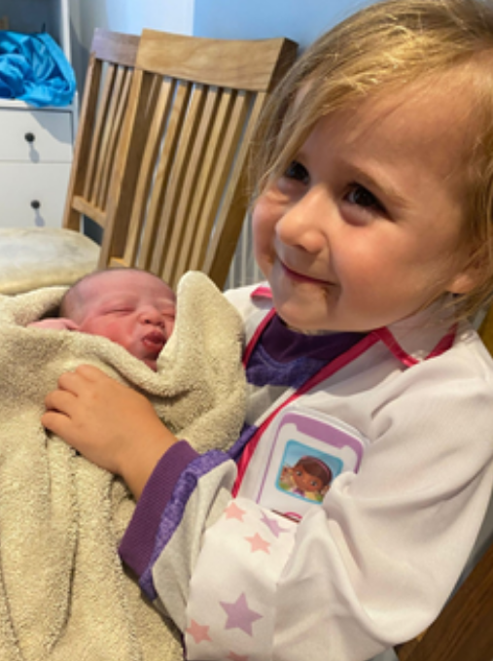
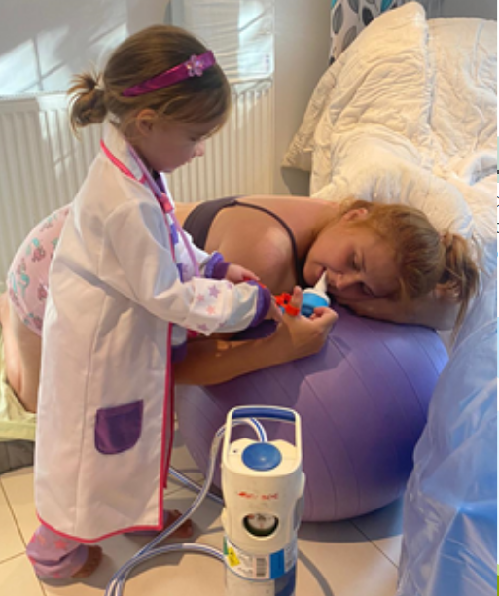
5
8

Testimonial
I gave birth to our daughter Jean at home in January 2022, following care from the Whipps continuity team throughout my pregnancy. It was my second pregnancy, but the first under Whipps and the care I received from the continuity team throughout pregnancy, birth and in the postnatal period was exemplary and compared favourably to my first birth at another trust. We felt supported in our choices and were fortunate to have a very speedy labour at home one sunny afternoon with no interventions. We were able to stay at home after the birth and our antenatal and postnatal appointments were also at home.

Having a relationship with the same midwife throughout pregnancy and building trust between us made such a difference to us and I have no doubt played a part in the positive outcome.

Alex’s Homebirth 2022,

Referring to the Homebirth Team

Midwife referral
Your midwife can complete a referral for you. You should get the opportunity to speak about your place of birth at your booking appointment and regularly throughout your pregnancy.

Self-referral
If you would like to give birth at home, you can self-refer by completing the ‘Homebirth Team Referral Form’ on the Whipps Cross Website. Your form can be emailed to the address below.

Contact the team with any questions, to request a call back, or to submit your referral form
bartshealth.wxhomebirth@nhs.net

6
7

