

You can fill it in yourself or ask an adult to help you. You can ask your GP to add it to your health records.
It has important information about you for when you go to the hospital, doctor, dentist and other health appointments.
When you go to hospital or other appointments, you or your important adults should tell them you have a Health Passport. You can print it and give it to them, or you can ask your GP to send it to them on the computer.
Health Passport for people with SEN and Disabilities
There are three parts:

THIS IS MY
HEALTH PASSPORT.

Things you must
know about me
Things that are
important to me
My strengths, likes and dislikes

I am ____________ and this is My Health Passport
Please add to my hospital passport and flag my files as someone with Learning Disabilities or Special Needs
Date it was filled in:
Date it will be reviewed.
Things you must know about me

Name (including any other names I like to be called)
How to pronounce my name eg Esja=like Ayrshire
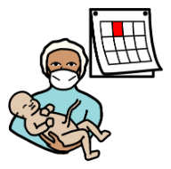
Date of birth

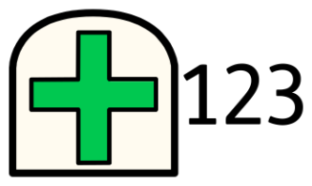
NHS number

Gender
I like to be known as (please circle):
He she They

My languages
(in appointments and at other times)


My religion (if I have one)


Address and where I live:(please circle)
With my family
In shared accommodation
In supported living
How I like to be contacted (please circle)
I like to be contacted by:
phone call text WhatsApp email

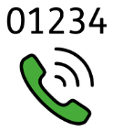

How to contact the important adult who looks after me – person 1

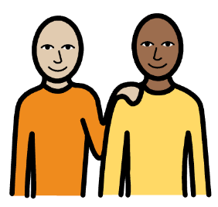
How to contact the important adult who looks after me – person 2

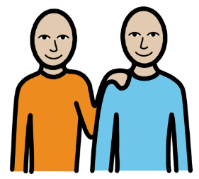


How I like to communicate
(Including how people should tell/ask me things/things to know about how I advocate for myself e.g. saying ‘I’m fine’ does not always mean I’m ok)


How to know if I am in pain, upset or uncomfortable
(signs to look out for and how I communicate that I’m in pain or anxious)
How I use the toilet (continence aids, help to get to toilet) (please circle)
I need help all the time
I need some help – I’ll tell you by..
I don’t need any help
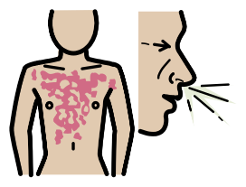
Anything I am allergic to
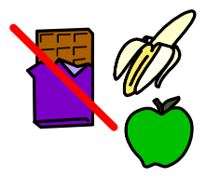
My dietary requirements

My medication

How I take my medication e.g. if I cannot swallow pills, or need them crushed, in liquid on spoon or in a syringe

Any unusual responses to medication doctors need to know
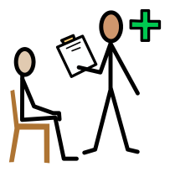
My diagnoses

NB you can add a link to information about the diagnosis if it is a rare syndrome
My hearing and vision

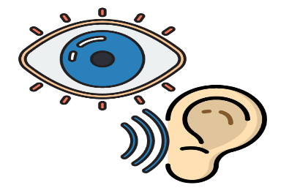
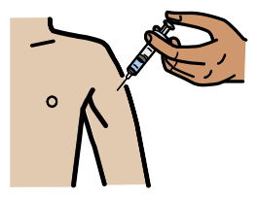
What I need during medical procedures/how to support me

(E.g. giving me injections, measuring my blood pressure)

Professional adults who help me
(Name/job/where they work/best way to contact them)
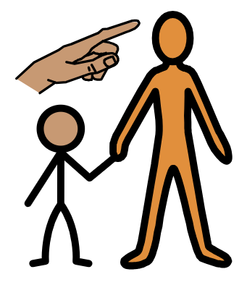

Things that are important to me
What you can do to make things easier for me
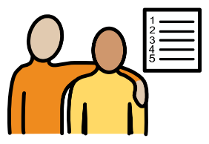
For example: my sensory preferences, use simple instructions, tell me before you touch me, a quiet room, low lighting, if I need 2 people, how long I can be alone and be ok
Things I need extra help with
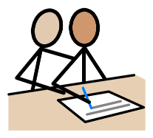
For example: walking, using the toilet, eating, bathing, getting dressed, going to sleep

Important things to know about my religion or culture
For example: prayer rooms, events

My strengths/likes and dislikes
Likes/Strengths: for example – what makes me happy, things I like to do, food I like to eat, what people like about me, what I am good at
Dislikes: for example – loud noises, foods I don’t like, physical touch, words
Things I like/strengths | Things I don’t like
 | 

