**Short-acting beta-2 agonists (SABAs)**

* **EMIS Search:** In EMIS, you can utilize searches designed to identify patients who may be overusing SABAs, potentially without the necessary inhaled corticosteroids, which is a key concern due to the risks associated with SABA overuse
* **Overuse:** Studies show that SABA overuse can increase the risk of severe asthma attacks and even mortality
* **Safety:** Overuse of SABAs without adequate anti-inflammatory treatment (like inhaled corticosteroids) can be detrimental. MHRA advises healthcare professionals to be aware of the risks and changes in prescribing guidelines related to SABAs

**Instructions on how to conduct the SABA search in EMIS**

**Step 1** – Saving the EMIS search

Drop and drag the EMIS search file (attached below) to an appropriate location on your computer.



**Step 2** - Importing the search file

To use the search file, import the file into 'Population Reporting in EMIS Web'.

Open 'Population Reporting' by going to the EMIS 'Orb', select 'Reporting' and then 'Population Reporting'.

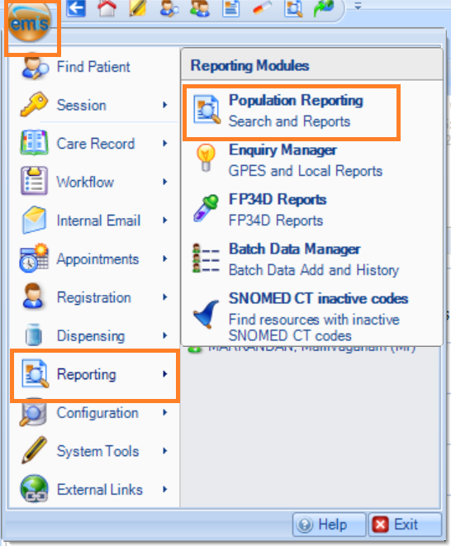

Select the folder you want to import your search or report into.

Highlight the folder and click ‘Import’ in the ribbon menu.

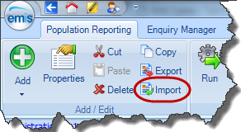

Navigate and import the EMIS search from the folder where you saved it.

**Step 3** - Using the searches

To run the search, go to population manager, right-click the search folder and select ‘Run’.

To run the search as of today’s date, click yes.

Further information: [EMIS Web - Importing and exporting searches and reports in EMIS Web](https://www.emisnow.com/csm?id=kb_article&sys_id=0b58f8203b2822549429d04a85e45a37&spa=1#mcetoc_1hnsthn0u4c)