

Information about Joining the
Dynamic Support Register

This easy read leaflet is about the Dynamic Support Pathway and deciding if you give your consent to join it.


Dynamic


Support

Pathway
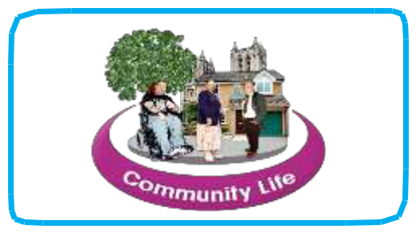

This leaflet is for people diagnosed with a learning disability and/or ASD, including Asperger Syndrome who might be at risk of going into a specialist hospital because of a mental health problem or behaviour which is seen as challenging.

It is also for family carers and other people who can support you to understand what the pathway is about and if it’s right for you.

The Dynamic Support Pathway is about helping you get the right care and treatment in your community whenever possible, by working with you and those who care for and support you.

Most people with mental health problems or challenging behaviour can live well in the community and may never need to go into a specialist hospital for assessment or treatment.


1


But if you do experience a difficult time and your current care is not meeting your needs, you and people who support you will need to think about what extra support you will need.


Often this support can be given locally in your community but sometimes people need to go into a specialist hospital to get better. This form is about making sure you are included in decisions.

What is the Dynamic Support
Pathway?


The Dynamic Support Pathway is about checking if someone’s care isn’t meeting their needs and what changes can be made to help with this and to stop people reaching crisis point. It helps services work with you to decide what support you may need.
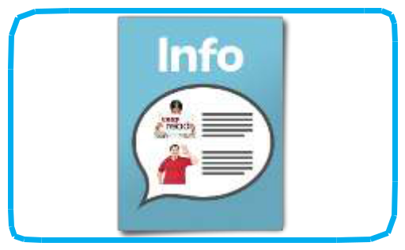

This leaflet gives you information so you can decide if you want to be on the pathway. This is called consent.


2


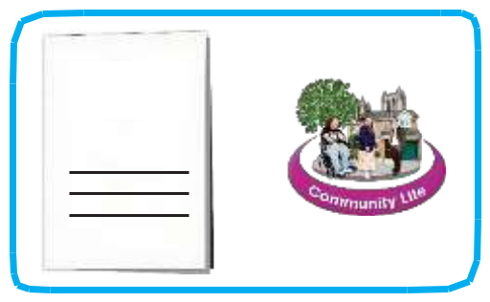

Dynamic

Support

Pathway

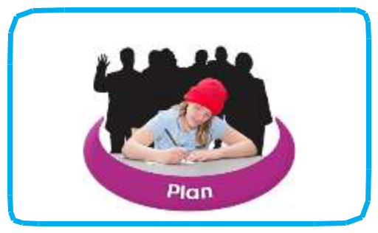
Specialist hospitals are often a long way from your family and friends. Sometimes you may need to spend a long time in hospital.

The Dynamic Support Pathway is one of the local changes that is happening to help more people get the support they need to stay in their community.

What are the good things about joining the pathway?

The Dynamic Support Pathway is about helping you get the right support as fast as possible, if you ever need it.

This is because services will know what extra help and support you might need and can plan their support around this. You will be involved in planning your care and support.

3
What if I don’t want to join it?


You will still get support if you need it, but if services do not already know about you, this may affect how much support you get at the time.
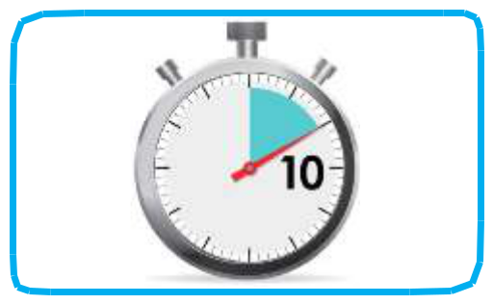

This is because services need more time to plan urgent care.

Is it right for me?
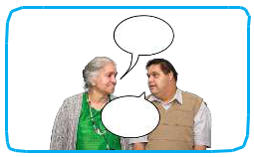

It is a good idea to talk to people who

understand your support needs. They will

help you understand what the

Pathway is about and help you decide if

it’s right for you.

What happens if I am on the pathway?
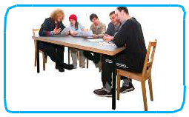

If you are on the pathway this means the people who pay for your care can work together to think about the support they can offer you should your needs increase.

4

If you are at risk of going into hospital, we will invite you to have a Care and Treatment Review, called a Community CTR. This should happen before any decisions are made about whether hospital care is right for you.
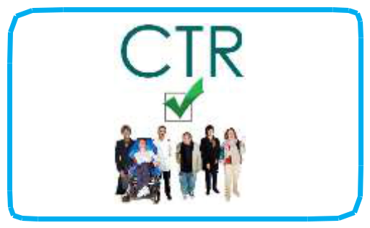

This looks at why you might need to go into hospital and whether extra support can be given in the community instead. It helps you and your care team plan for the support you need in the place you need it.
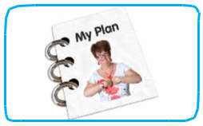

How your care co-ordinator can help


You can talk to your care co-ordinator if you aren’t sure about anything, or if you want to change your mind about being on the register. You can add the care co-ordinator’s details in the table below.


The Care
co-ordinator is:

Mobile phone number:

Office telephone
number:

5

What is consent and why do we need it?
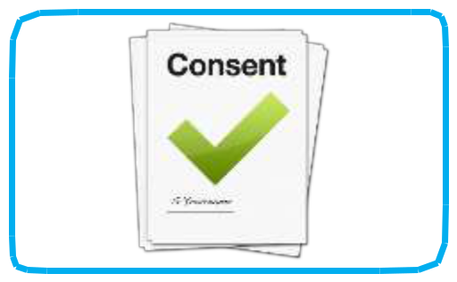

Consent is about giving your permission for something.

You will only be put on the pathway if you have given consent.
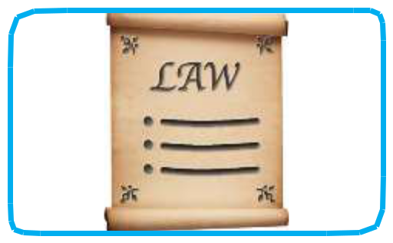

If you are an adult and do not have the capacity to decide, people involved in your care will follow the Mental Capacity Act to decide if it is in your best interests to join the pathway.


If you are under the age of 16, a parent or guardian must give their consent for you.

About your consent:
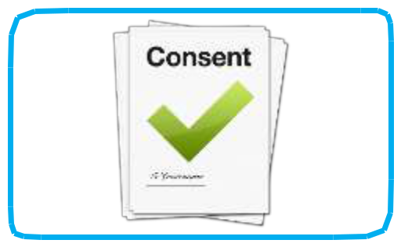

- you can change your mind at any time

- you will receive a copy of the consent form

- you can find out what information is being held about you

6





Dynamic

Support

Pathway
What will happen to my information?

Your personal information will be kept in a safe place and it will only be shared with you and the people who provide your care.

Information from the pathway is sometimes shared with other parts of the NHS. This information does not include people’s names or any other personal information which could identify anyone.

This information helps health and social care teams understand what difference the pathway is making in people’s lives and provide the right kind of services.

7
What sort of information will it include?

The information will depend on you and your care and support needs. But usually it will include information about:

- the care and treatment you are receiving

- your health, including your mental health

- any health and care plans that have been developed for you

- where you live and who you live with

- things that can make you upset and what helps you feel well

- anything that people involved in providing your care and support should know to keep them and you safe.

7


Next steps – giving your consent

Have you understood the information in this document?


If so, you are ready to fill in the Consent Form to say whether or not you give your consent.


Your care co-ordinator or someone involved in supporting you can help you fill it in.

7

