# London Regional guideline and pathway for the management of Rhinitis

## Introduction

This guideline has been created as a pan London guideline for the diagnosis and treatment of Rhinitis.

## Rhinitis key facts:

## Rhinitis is common in children and adults and is a significant cause of morbidity. Symptoms can affect quality of life, sleep, school and work performance.

## Rhinitis is subdivided into allergic rhinitis (AR) and non-allergic rhinitis (NAR). This distinction can be made based on the history, and/or on the results of allergy tests to common aeroallergens if needed.

## Allergic rhinitis can be seasonal (i.e. hayfever) or perennial (e.g. dust allergy). Non-allergic rhinitis is usually perennial.

## All patients with rhinitis must be evaluated for asthma symptoms, and both upper and lower-airway conditions should be treated together when present. 75% of children with asthma suffer from AR, and AR increases the risk of hospitalisation in children with asthma.

## Most patients with moderate-severe rhinitis symptoms require long-term administration of a nasal steroid spray. Patients must be educated about the importance of good nasal spray technique and compliance, and adherence to therapy should be established before stepping up therapy.

## Nasal steroid sprays take around 6 weeks to reach their maximum effect. Short-term prescription (e.g. 4-6 weeks) of nasal steroid sprays for rhinitis is therefore not appropriate. An initial 2-3 month trial of a recurring prescription should be started before evaluating response.

## Rhinitis is a long-term condition. If the patient responds well to a spray it should usually be continued in the long term, although the dose can be halved if this still controls their symptoms. Mometasone and fluticasone-based nasal sprays have an excellent safety profile for long-term use.

## Diagnosis:

## *Symptoms:* Nasal congestion (usually bilateral/alternating), clear rhinorrhoea, itchy nose or eyes, sneezing.

## *Timing:* Ask about seasonality and exacerbation from contact with dust/pets.

## *PMH:* Ask about atopic diseases and any symptoms of asthma.

## *DHx*: Combined OCP, nasal decongestant sprays, beta-blockers, NSAIDs can cause/exacerbate rhinitis.

## *SHx:* Smoking, cocaine, occupational exposures.

## NB: Predominant sneezing/itching/clear rhinorrhoea suggests AR and possible response to oral antihistamine monotherapy. Predominant nasal blockage without sneezing/itching suggests NAR, usually requiring regular nasal steroid spray.

## Examination:

## Look for bulky, moist inferior turbinates (the relative size will alternate with the nasal cycle).

## Septal deviations are less likely to be significant if patient has bilateral/alternating blockage.

## Investigations:

## Allergy testing is not required in all cases:

## Mild or seasonal symptoms that respond to oral antihistamines can be assumed to be allergic in origin.

## Most moderate-severe rhinitis patients respond to a regular, long-term nasal steroid spray, regardless of aetiology.

## Therefore, complete response to Step 1 + 2 therapies largely negates the need to distinguish between AR and NAR.

## Consider allergy testing in:

## Severe allergic-type symptoms (sneezing, itching, rhinorrhoea)

## Symptoms resistant to long-term use of first-line steroid spray

## Considering long-term Dymista or Ryaltris, or referral for immunotherapy (now NICE approved).

## Specific IgE (RAST) testing – Send serum sample and request ‘specific IgE to aeroallergens’ (includes grass pollen mix, tree pollen mix, house dust mite, cat, dog and mould mix) and any other suspected allergens e.g. other animals. Skin prick testing – where available, gives information on reactivity to common aeroallergens within 10-15 mins. Not suitable in dermographia or if antihistamines taken in last 72 hours

## Document History

### Version: V 2.2

Author: ENT Rhinitis Pathway working group (Mr Peter Andrews, Mr Hassan El-Hassan, Mr Samit Unadkat, Dr Aditi Shah, Dr Alexandra Armstrong, Dr Edward Farrell, Naoimh Reilly, Emma Johnson, Juliana Da-Silva, Sukhpreet Bassi)

Approved by: London ENT Clinical Leadership Group

Approval date: 12/07/24

Revised: 27/03/25

**NHS Pan London guideline for the management of Rhinitis**

**Full history, nasal examination and RAST testing**

Further investigation needed if **RED FLAGS** present

**Step 5a: Investigations for persistent Symptom**

For ongoing symptoms despite treatment, consider investigations, where available:

* Inhaled Allergen Blood Tests (RAST)
* Skin prick testing
* CT paranasal sinuses

**Step 5b: Treatment Not Adequately Managing Symptoms**

* Review the cause of treatment failure
* Consider compliance to both self-management strategies and treatment
* Consider alternative diagnosis

**Step 5c: Refer to secondary care**

* If structural problem or patient choice for surgical intervention, consider referral to ENT
* If symptoms primarily due to single allergen, consider referral to allergy/medical rhinology for immunotherapy (now NICE approved)

**STEP 2: Antihistamine\***

**Step 3: Regular Intranasal Corticosteroid**

* Intranasal Corticosteroids Sprays: fluticasone propionate (OTC), mometasone furoate (POM), fluticasone furoate (POM)

**For Severe Nasal Obstruction:**

* Fluticasone proprionate nasules

**Self-Management Strategy**

* Nasal Douche: Saline preparations (OTC)
* Video Demonstration: https://youtu.be/GW2PiOFhFtY
* [Allergen Avoidance Techniques](https://www.nhs.uk/conditions/allergies/)

**Severe, Uncontrolled Symptoms that are significantly affecting Quality of Life**

Consider prescribing a short course of oral corticosteroids to provide rapid symptom relief, such as:

* **For adults:** prednisolone 0.5mg/kg in the morning for 5 to 10 days.
* **For children:** prednisolone 10 to 15 mg in the morning for 3 to 7 days.

Advise the person to continue using an intranasal corticosteroid preparation, to allow improved intranasal drug penetration.

**STEP 5: Investigations and Referral**

**Step 2– PRN Antihistamine**

* Intranasal Antihistamine Preparations: Azelastine (POM)

Or

* Non-sedating Oral Antihistamines: Cetirizine (OTC), Loratadine (OTC) and Fexofenadine 120mg (OTC)

*Combined use of an intranasal and oral antihistamine is not recommended.*

**For those in which antihistamines are contraindicated or not tolerated:** Intranasal Chromone**:**

**Step 4a: Regular Combination Intranasal Corticosteroid and Antihistamine**

* azelastine hydrochloride and fluticasone propionate (POM)
* olopatadine hydrochloride and mometasone furoate monohydrate

**Step 4b: OR Regular Oral Antihistamine**

* Regular Non-sedating Oral Antihistamines: Cetirizine, Loratadine, Fexofenadine (120mg)

**Step 4c: OR Combination Nasal Douche and corticosteroid**

* Nasal Douche: Saline preparations (OTC) with addition of Fluticasone propionate (POM)
* +/- Intranasal Antihistamine Preparations: Azelastine (POM)

**STEP 1: Saline Rinse**

**STEP 4: Combinations\*\***

**STEP 3: Corticosteroid**

**RED FLAGS** – Urgent referral to ENT Specialist

* Unilateral symptoms including new/progressive unilateral blockage
* Unilateral facial/orbital pain
* Progressive headache, raised ICP signs, visual or neurological signs
* Unilateral rhinorrhoea, especially if serosanguinous
* New anosmia associated with unilateral nasal symptoms

**Review every 2-3 months at each step**

**Step up if symptoms uncontrolled**

**Maintain therapy when patient gains control**

**MODERATE–SEVERE OR PERSISTENT**

* Troublesome symptoms
* Impaired daily activities
* Abnormal sleep, sleep disturbance
* Perennial

Commence step 1,2 and 3

If congestion is only symptom, commence step 1 and 3 only

**MILD AND INTERMITTENT OR PERSISTENT SYMPTOMS**

* Completes normal daily activities
* Sleep not affected
* Seasonal

**Commence step 1 and 2**

**INITIAL TREATMENT SELECTION:**

*\* Sodium Cromoglicate not referenced in Step 2 as the product is no longer available*

*\*\* Further detail on the specifics within Step 4 can be seen in the table below:*

|  |  |
| --- | --- |
| **Symptom** | **Pharmacotherapy** |
| Nasal Congestion | Intranasal Decongestant:  Ephedrine (OTC) or Xylometazoline (OTC)  NB short-term use only for up to 5–7 days  Intranasal Corticosteroid:  Fluticasone proprionate nasules (POM) |
| Persistent Watery Rhinorrhoea | If combined use of an intranasal corticosteroid and oral antihistamine is ineffective consider an  Intranasal Anticholinergic:  Ipratropium bromide (POM)  NB avoid in glaucoma |
| Nasal Itching and Sneezing | If monotherapy with either an antihistamine (taken regularly) or intranasal corticosteroid is ineffective consider an  Antihistamine and Corticosteroid Intranasal Combination Spray:  Azelastine/Fluticasone (POM)  NB combined use of an intranasal *and* oral antihistamine is not recommended |
| Patients with ongoing symptoms and a history or asthma | Consider leukotriene receptor antagonist e.g. [montelukast (POM)] in addition to an oral or intranasal antihistamine. |

**Appendix 1: Nasal spray technique guidance for patients (Image courtesy of ENT UK, September 2022)**

**Appendix 2: Saline nasal irrigation guidance for patients**

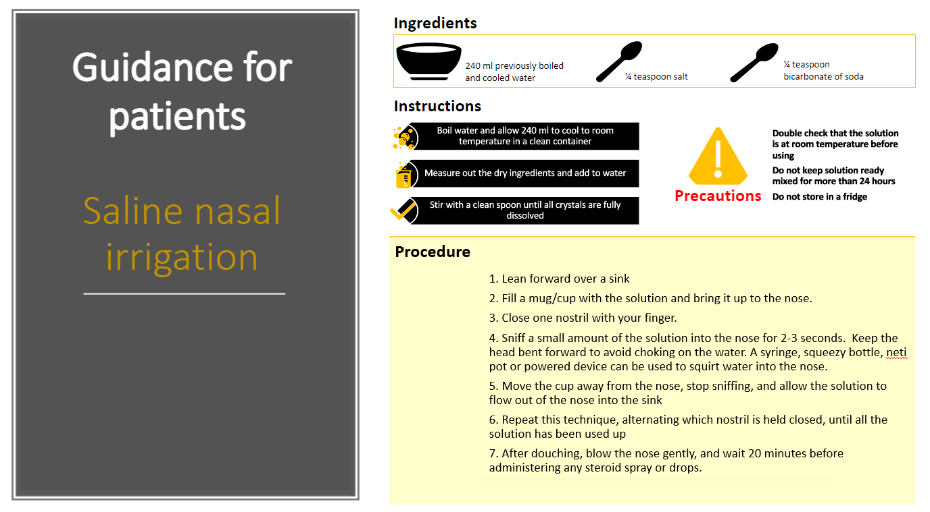

**Appendix 3: Advice for patients on avoiding allergens**

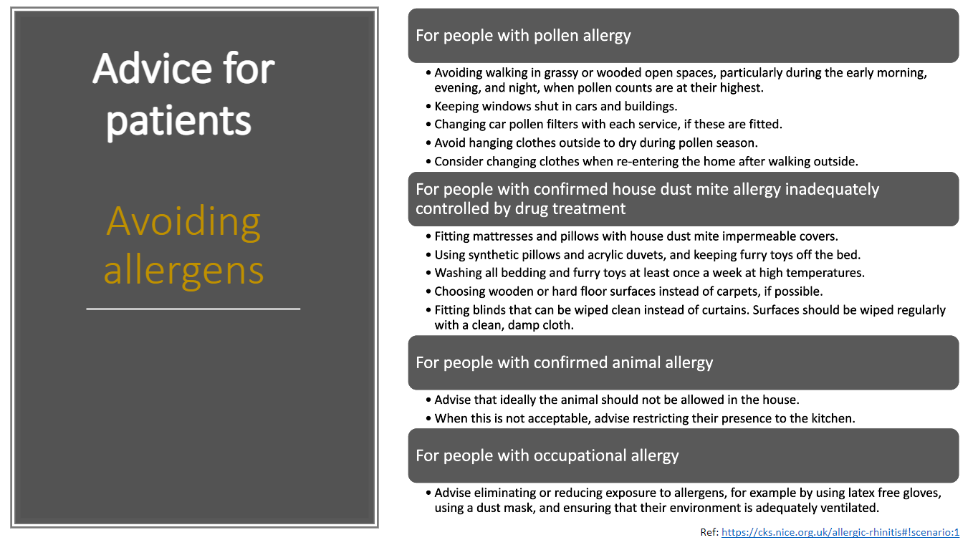

**Appendix 4: Useful Links**

* Nasal spray technique video
  + <http://www.itchysneezywheezy.co.uk/RhinitisVideos.html>
* Four Seasons Booklet from Allergy UK about managing asthma and allergic rhinitis
  + [Layout 1 (allergyuk.org)](https://www.allergyuk.org/wp-content/uploads/2021/08/Four-Seasons-Booklet.pdf)
* NHS Choices Allergic Rhinitis
  + Allergic rhinitis - NHS (www.nhs.uk)
* NICE Clinical Knowledge Summary
  + [Allergic rhinitis | Health topics A to Z | CKS | NICE](https://cks.nice.org.uk/topics/allergic-rhinitis/)
* BSACI Rhinitis Guidelines 2017
  + [https://www.bsaci.org/wp-content/uploads/2020/01/Scadding_et_al-2017 Clinical_amp_Experimental_Allergy.pd](https://www.bsaci.org/wp-content/uploads/2020/01/Scadding_et_al-2017%20Clinical_amp_Experimental_Allergy.pd)
* Improving air quality
  + [At Home | Allergy UK | National Charity](https://www.allergyuk.org/living-with-an-allergy/at-home/)