Date | Copy | Asset
For use until 02/01/25 | Some pharmacies in London will have different opening hours during the festive period. 💊  To find an open pharmacy near you, visit nhs.uk/find-a-pharmacy | 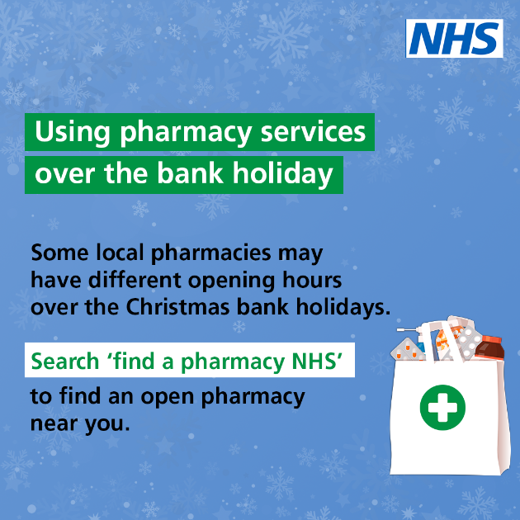  Alt: A bag from a pharmacy in the bottom-right of the screen with medication inside. Text to the left reads: Using pharmacy services over the bank holiday. Some local pharmacies may have different opening hours over the Christmas bank holidays. Search ‘find a pharmacy NHS’ to find an open pharmacy near you.
For use until 02/01/25 | If you need urgent dental treatment over the festive period, contact your usual dentist. 🦷  If you can’t contact your dentist, use NHS 111 online or call 111 for information about your local out of hours service. 111.nhs.uk | 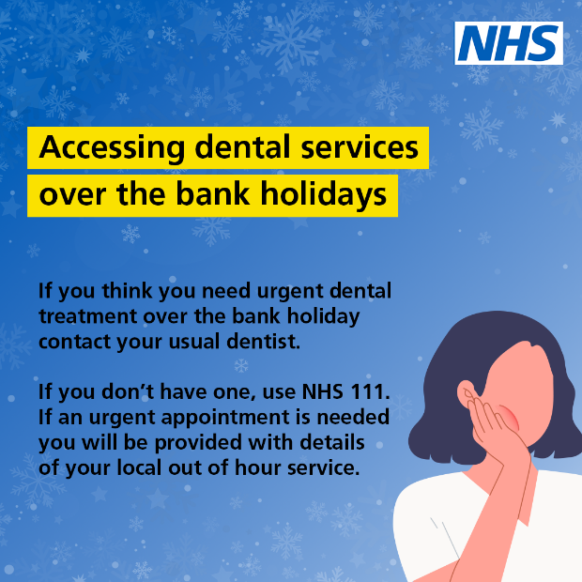  Alt: A person holding their hand to their mouth mimicking having toothache. Text to the left reads: Accessing dental services over the bank holidays. If you think you need urgent dental treatment over the bank holiday contact your usual dentist. If you don’t have one, use NHS 111. If an urgent appointment is needed you will be provided with details of your local out of hours service.
For use until 02/01/25 | Some GP services will be available over the festive bank holidays. 🩺  If you have a health concern, please contact your GP practice, use NHS 111 online or call 111 for urgent medical help. | 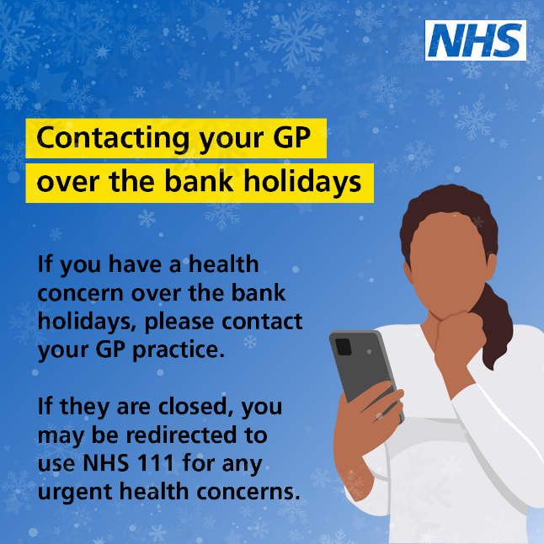  Alt: A person using a mobile phone looking like they are about to make a phone call. Text to the left reads: Contacting your GP over the bank holidays. If you have a health concern over the bank holidays, please contact your GP practice. If they are closed, you may be redirected to use NHS 111 for any urgent health concerns.
For use until 02/01/25 | Ahead of the Christmas and New Year bank holidays, remember to order your repeat prescriptions in good time. 📃  Order through the NHS App or at your GP surgery. https://www.nhs.uk/nhs-services/prescriptions/how-to-order-a-repeat-prescription/ | 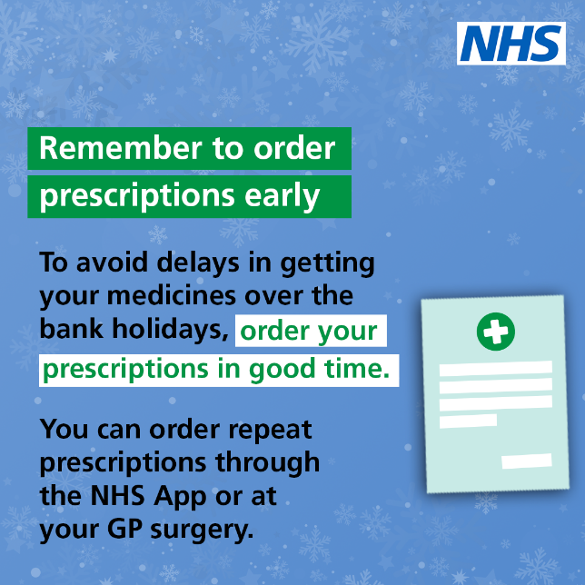  Alt: A prescription on the right-hand side on a blue background. Supporting text reads: Remember to order prescriptions early. To avoid delays in getting your medicines over the bank holidays, order your prescriptions in good time. You can order repeat prescriptions through the NHS App or at your GP surgery.

