**Personalised Eczema Plan**

**Name: D.O.B:**  **NHS:**

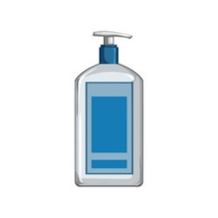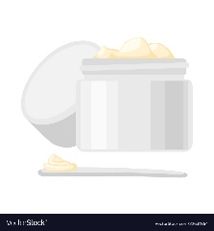

**Moisturiser**:

Apply in a downwards motion **ALL OVER** face and body **every day,** even if skin is not itchy or visibly dry.

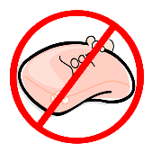

**Soap Substitute/Leave on emollient:**

**QV Gentle wash** - for daily baths and wash

(Bathe for 20 minutes daily)

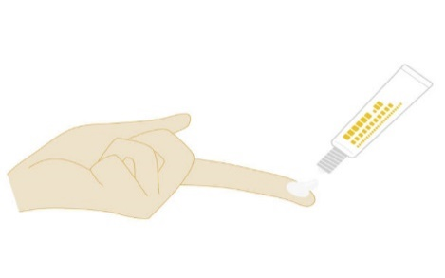

**Treatment for flare** (skin is red, itchy & inflamed)

To be applied at least 20 minutes before moisturiser

|  |  |  |  |
| --- | --- | --- | --- |
| **Treatment** | **Where to?** | **How often?** | **How long for?** |
| **Topical Steroid:** Eumovate (Clobetasone butyrate ointment) | Face and Neck | Apply thin FTU layer to active eczema OD | 7-14 days |
| **Topical Steroid:** Elocon (Mometasone furoate 0.1% ointment) | Body and Limbs | Apply thin FTU layer to active eczema OD | 7-14 days |
| Hydrocortisone | Under Eye | Apply thin FTU layer to active eczema OD | 7-14 days |
|  |  |  |  |

Oral Medication if required __________________________________________________________

**Maintenance treatment (preventer treatment to keep commonly affected areas clear)**

|  |  |  |
| --- | --- | --- |
| **Treatment** | **Where to?** | **How often?** |
| **Bandaging:**  ZipZoc Stocking and  Coban Dressing cohesive bandage or any self-adherent cohesive bandage to keep the zipzoc in place such as steroban/steroplast | Limbs | Change daily or every other day |
| **Protopics:** | Apply a thin layer to affected areas | Twice weekly after topical steroid treatment. |
|  |  |  |

********If no improvement within 7-14 days with all the above in place. Please make an appointment with your GP for them to assess the skin.**

***Things to remember: If emollients are not used the skin will not heal. If the skin is yellow and crusty it needs to be swabbed and should not be bandaged.***