**Guide for Tower Hamlets General Practice Clinicians**

**Understanding and Navigating Education-Related Children and Young People (CYP) Support Services in Tower Hamlets**

**Lead author Dr Helen Jones**

The purpose of this document is to raise the profile of the wide range of services available in the Borough that can help support Children and Young People (CYP) and their families engage in a meaningful manner with state provided education offers. Please also refer to separate Tower Hamlets GP resources:

1. **A guide for schools in understanding and navigating community health services for YP**[1]
2. **Child Safeguarding flow chart for TH primary care[2]**

**Glossary of terms**

|  |  |  |  |  |  |  |  |  |  |  |  |  |  |  |  |  |
| --- | --- | --- | --- | --- | --- | --- | --- | --- | --- | --- | --- | --- | --- | --- | --- | --- |
| |  |  | | --- | --- | | **CYP** | Children and Young People | | **EHCP** | Education and Health Care Plan - a legal document that sets out the education, healthcare and social needs of a child or young person (0-25 years) who requires support beyond that which an educational setting can provide | | **SEND** | Special Educational Needs and/or Disability | | **SENDCO** | Special Educational Needs and/or Disability Coordinator (based in school | | **NEET** | Not in Education, Employment or Training. Tends to refer to young people 16-25 yrs old | | **Fixed term exclusion** | Suspended from school for a set period. CYP can only be excluded for a max of 45 days in a school year | | **Permanent Exclusion** | (expelled) child can no longer attend that school, local authority must arrange full time education from the 6th school day | | **AP** | Alternative Provision. Educational provision other than school, arranged by local authorities or schools themselves e.g. PRU (pupil referral unit), online learning, elective home education | |

You will find references throughout this document to further information links which are listed on the last page.

**1.0 Introduction**

In general practice we often support CYP or families with concerns/facing challenges relating to education. Such concerns include:

* struggles with attendance (which may be incurring fines)
* families requesting sick notes for their child as “evidence” of health conditions that they believe mean their child can’t attend school
* CYP/families reporting traumatic experiences relating to the school environment
* concerns about learning difficulties and appropriate support in schools

It is essential that as General Practitioners we advocate for our CYP and families, but at the same time ensure we are appropriately safeguarding and working together with wider professional networks so that all CYP can access and engage with an education offer in line with the **UNCR rights of the child**[3] and the law.

It can be challenging for health professionals to know where to start and this document is intended to raise the profile of the wide range of services available in the Borough that can help support CYP and families engage in a meaningful manner with state provided education offers.

GPs are not well placed to decide or provide proof to schools that a child cannot attend school. We should not be issuing “fit notes” (a statement of Fitness for Work) for CYP - these are documents for adults to submit as evidence to an employer or DWP i.e. they relate to employment *not* education.

As GPs our role is to ensure any concern/difficulty relating to ability to engage with education is explored collaboratively with parent/carers and relevant professionals through a “team around the child” approach, with the best interests of the child at the centre.

Any children with significant long term health conditions that impact their daily function/ability to engage with education will generally be known to specialist children’s teams e.g. paediatricians, CAMHS, community children’s specialist teams.

There are also a range of other teams that can be accessed to explore the concerns further and ensure the CYP/family and school are supported to ensure removal of barriers/reasonable adjustments with the best interests of the child at the centre.

Ultimately if clinicians are unsure where best to turn for advice, we would encourage a discussion with practice Child Safeguarding leads, and/or the named GPs for child safeguarding.

**2.0 A reminder of the law**

|  |
| --- |
| CYP aged 5-16yrs must by law receive an education that is suited to their needs  YP can leave school on the last Friday in June if they will be 16 by the end of the summer holidays but must then do one of the following until they are 18:   * Stay in fulltime education eg college * Start an apprenticeship * Spend >20hr/week working or volunteering, while in part-time education or training |

|  |
| --- |
| CYP with EHCPs must be offered support to be in education/training/employment up until they are 25yrs. |

**3.0 Special Educational Needs Concerns**

For some CYP it is clear at birth or early years that they will need extra support to engage in education. In these cases, social and health care professionals such as community children's services will already have ensured that appropriate packages of care are in place. For other children their needs may become apparent once they start school/ over the course of time.

The first port of call for parents who are concerned about their school aged child’s educational needs should be with the **SENDCO** at the school who will be able to provide information about how the school is supporting the child. If the child’s special educational needs are severe enough to warrant additional support from the local authority as well as that provided by their school, then the SENDCO may consider making a request for an **Education, Health Care Needs Assessment**[4] (EHC) which is submitted to the local authority **SEN department**[5].

The request for an EHC assessment would usually be made by the school or early years setting with parental agreement, but can be made by the **child’s parents, YP or carers[6]** or other **professionals**[7].

If the threshold is met, a statutory EHC assessment will be conducted involving wider relevant agencies e.g. speech and language therapists (SLT), child neurodevelopment clinic (NDC) etc.

A caseworker will liaise with the CYP and family. The SEN panel will decide whether an Education, Health and Care Plan is required.

If a plan is not issued, the panel may instead issue a **School Support plan**, which summarises the child’s special educational needs and specifies the provision to be made by the school from its own resources. Mainstream maintained schools and academies are notified each year of a clearly identified but notional SEN budget, within their overall budget allocation, towards the costs of fulfilling their duty to use their ‘best endeavours’ to secure that special educational provision for their pupils with **SEN**[8].

[**Annual reviews of EHCPs**](https://5f2fe3253cd1dfa0d089-bf8b2cdb6a1dc2999fecbc372702016c.ssl.cf3.rackcdn.com/uploads/ckeditor/attachments/5484/EHCP_Annual_Review_Guidance_v5.pdf)**[9]** are the mechanism by which the EHCP is reviewed and kept fit for purpose and are a statutory duty of the local authority.

|  |
| --- |
| **Confirming if a CYP has an EHCP**  In general practice we often do not know if the CYP has an EHCP**/** if it is up to date, but the information is highly useful and helps to inform the healthcare we provide/support.  Ideally the CYP/family should have a copy which they can share with us.  Alternatively with the patient/family consent we can contact the [assigned EHCP caseworker for their school](https://view.officeapps.live.com/op/view.aspx?src=https%3A%2F%2F5f2fe3253cd1dfa0d089-bf8b2cdb6a1dc2999fecbc372702016c.ssl.cf3.rackcdn.com%2Fuploads%2Fckeditor%2Fattachments%2F12757%2FSchools_Allocation_List_2023.xlsx&wdOrigin=BROWSELINK) or alternatively email: [**SpecialEducational.Needs@towerhamlets.gov.uk**](mailto:SpecialEducational.Needs@towerhamlets.gov.uk)**.** |

**4.0 Need more help?**

In general practice we will also come across CYP/families with (suspected or known) SEN who are struggling to navigate our systems, expressing concern about accessing support including EHCP assessments/requests. We would recommend signposting them to TH Local Offer and SENDIASS.

**Tower Hamlets Local Offer[10]** website holds a wealth of information, resources and support including **Tower Hamlets SEND Information and Advice Support Service (SENDIASS)**[11]which islocated at the Parents Advice Centre who offer:

* Dedicated services for young people
* SEND Young People Forum (Our Time All Ability Forum)
* Advice, Information and Support on Education, Health and Social Care
* Case work for parents and young people
* Specialist support groups for parents e.g. SEN support group and ADHD support group
* Advice and support with Admissions, Exclusions, Bullying including Appeals and Managed moves for any child or young Person in Tower Hamlets
* Signposting to the [**Local offer**](https://www.localoffertowerhamlets.co.uk/pages/local-offer/what-is-the-local-offer)website
* Training for parents, young people and professionals
* Mediation service for schools, parents and young people
* Monthly Educational Psychologists (EPs) Surgery
* Monthly Developmental Language Disorder Surgery

**5.0 School engagement/attendance concerns**

This section is a summary of local support services we can liaise with to ensure CYP and families are appropriately supported to help ensure they are in appropriate education and able to engage.

**5.1 The Behaviour and Attendance Support Service**

The service provides a range of support to/in schools to ensure good attendance and positive behaviour for learning for all pupils including those with SEND. They aim to promote best practice for schools to be able to be fully inclusive. Support can be whole school, cohort or individual (CYP and families).

This team works with CYP until the end of year 11 (16 years) but for 16 and 17 years olds will track destinations and placements should be confirmed and reported to the LA.

There are 2 components to this service:

* **Attendance and welfare** 
  + Email: [WelfareServiceAdmin@towerhamlets.gov.uk](mailto:WelfareServiceAdmin@towerhamlets.gov.uk)
* **Tower Hamlets Behaviour Support team** 
  + Email: [BehaviourSupportAdmin@towerhamlets.gov.uk](mailto:BehaviourSupportAdmin@towerhamlets.gov.uk)

From the health side we can consider contacting this team for support for CYP and families (with consent). For example:

* if we have concerns about CYP’s attendance/ability to engage with their educational setting
* if we are concerned about the fines a family might be receiving relating to poor attendance
* if we are sighted on a CYP who we believe is not in education/on roll and aren’t able to find out what the plan is regarding their access to education (at risk of being NEET).

The team work closely with **Tower Hamlets Education Safeguarding Service[12] (THESS)** which includes the **TH Children Missing Education (CME) team[13].**

This service ensureschildren (up to the age of 16) out of school are monitored/ tracked on the Pupil Services Admissions database (includes permanently excluded pupils and children who are home educated).

Schools have a legal duty to refer CYP within 5 days who stopattending school and there is no formal confirmation about their destination, engagement in education (CME) or their safety.

* **TH named person for CME:**
  + Email: [Brendan.Mulcahy@towerhamlets.gov.uk](mailto:Brendan.Mulcahy@towerhamlets.gov.uk)
* **TH Education Safeguarding Manager:**
  + Email: Sharifa.Chowdhury@towerhamlets.gov.uk

As health professionals we will come across CYP **who are home educated and with consent, we should be informing the CME team** to ensure they are able to support the home education offer.

**5.2 16-25 yrs with EHCP**

If the CYP (up to 25yr) also has an EHCP and becomes NEET then the education establishment has a duty to notify the SEN department.

As health providers, if we become aware of YP (16-25) with EHCPs and are concerned that they have become NEET or aren’t being supported appropriately to engage with education/employment/training we can contact the SEND department via email at [**SpecialEducational.Needs@towerhamlets.gov.uk**](mailto:SpecialEducational.Needs@towerhamlets.gov.uk) **to** share our concerns and seek assurance.

We can also consider support for the family/YP from SENDIASS as well as Young Workpath (see below).

**5.3 16-18 years without EHCP**

Of note is that although the government raised the participation age to 18 some years ago, it did not give the LA statutory powers or legal interventions to ensure that YP are engaged in education, employment of training beyond year 11/ age 16. Ideally schools should keep track of their pupils when they leave statutory education in year 11 and refer any vulnerable pupils who are not engaging to Young Workpath.

**5.4 Children in our Care / Care Experienced Young People**

Support comes from the **Virtual School Team[14]** who can be contacted via email at [**vsinfo@towerhamlets.gov.uk**](mailto:vsinfo@towerhamlets.gov.uk)**.**

These YP can be moved frequently and can face significant difficulty in engagement with education. VS isn’t a building or place but a team – VS doesn’t replace the school they are enrolled at but seeks to monitor, track and coordinate offers and champion the YP’s rights.

**Careers** **Young WorkPath[15]** advisors provide careers information, advice and guidance to young people aged 13-19 years and up to 25 years if the young person has an **EHCP**[16], this includes NEET YP, and other vulnerable cohorts such as care experienced YP, those in youth justice system or at risk of becoming NEET as identified by their school/college.

They help young people to explore career options, navigate post 16/18 education, training and employment opportunities and participate in transitional reviews for year 9 pupils.

They contribute to annual reviews for year 11 and post 16 pupils with an EHCP and help prepare SEND young people to transition well into adult life. We can contact this team on behalf of YP and families for support via email at [**Youngworkpath@towerhamlets.gov.uk**](mailto:Youngworkpath@towerhamlets.gov.uk)

**5.6 Communication Difficulties - Speech and Language Therapy (SLT)**

In general practice we at times encounter CYP with suspected communication difficulties and it is helpful to understand options for appropriate assessment and support.

Any CYP who is experiencing a communication difficulty which affects their ability to have their basic needs met, or their ability to enjoy relationships with family and friends and to participate at home, school or in the community should be offered SLT support. Such difficulties include:

* Stammering
* Speech production problems
* Communication difficulties associated with conductive and sensorineural hearing loss,
* Language Delay or Disorder
* Social Communication difficulties or suspected Autistic Spectrum Disorders.

In Tower Hamlets most educational establishments have commissioned their own (non NHS) SLT service. Ideally when speech and language difficulties are identified within the education setting the CYP should therefore be referred to their in-house SLT service by the school SENCO for further assessment. There are a few instances according to clinical need where the SENCO may refer into the local NHS SLT service.

However, there are some educational providers who have not bought in SLT services and in health we would not know which ones they are. As such we (or parents) can contact the local NHS commissioned SLT service for advice and guidance from a senior SLT by emailing [**SLTconsultation.bartshealth@nhs.net**](mailto:SLTconsultation.bartshealth@nhs.net).

If a referral to the NHS-commissioned SLT service is appropriate, this is made via the community children’s **Single Point of Access (SPA) form**[17].

Please remember that we can view our local NHS SLT consultations on community EMIS and/or Cerner.

**5.7 Functional difficulties impacting ability to engage in activities of daily life (including school) - Children’s Occupational Therapy service[18]**

The OT service offers support for children with a developmental disability or medical condition impacting on their ability to perform or participate in activities of daily life at home, school or in the community.

E.g. in the context of autism or learning disability, a child might be struggling with issues relating to accessing and negotiating the school environment, managing class routines and self-care activities, or the ability to work independently.

Parents or any professional (including teachers, GPs) relevant to the CYP can make a direct referral via the community childrens SPA form (as above).

Again, remember that we can view community children’s OT consultations on community EMIS/Cerner.

**5.8 Educational psychology service[19]**

Every state funded school and childrens centre in the Borough has a link Educational Psychologist (EP). They can offer support when there is concern about a child or a young person’s progress, development or emotional well-being and can provide adviceas part of an EHC needs assessment.

Requests for EP involvement are made through schools and children’s centres, GPs cannot refer to EPs. EPs also offer regular drop-in service at SENDIASS (see above section) for parents and YP 16-25, and parenting support at every **Children’s Centre**[20] in Tower Hamlets.

Check out this fab leaflet for YP that explains more: [**How can an Educational Psychologist help you? (towerhamlets.gov.uk) [21]**](https://www.towerhamlets.gov.uk/Documents/Education-and-skills/Educational_Psychology_Service/Educational-Psychology-leaflets-Young-People-digital.pdf)

**Appendix**

**Summary of health offers school can access direction for YP:**

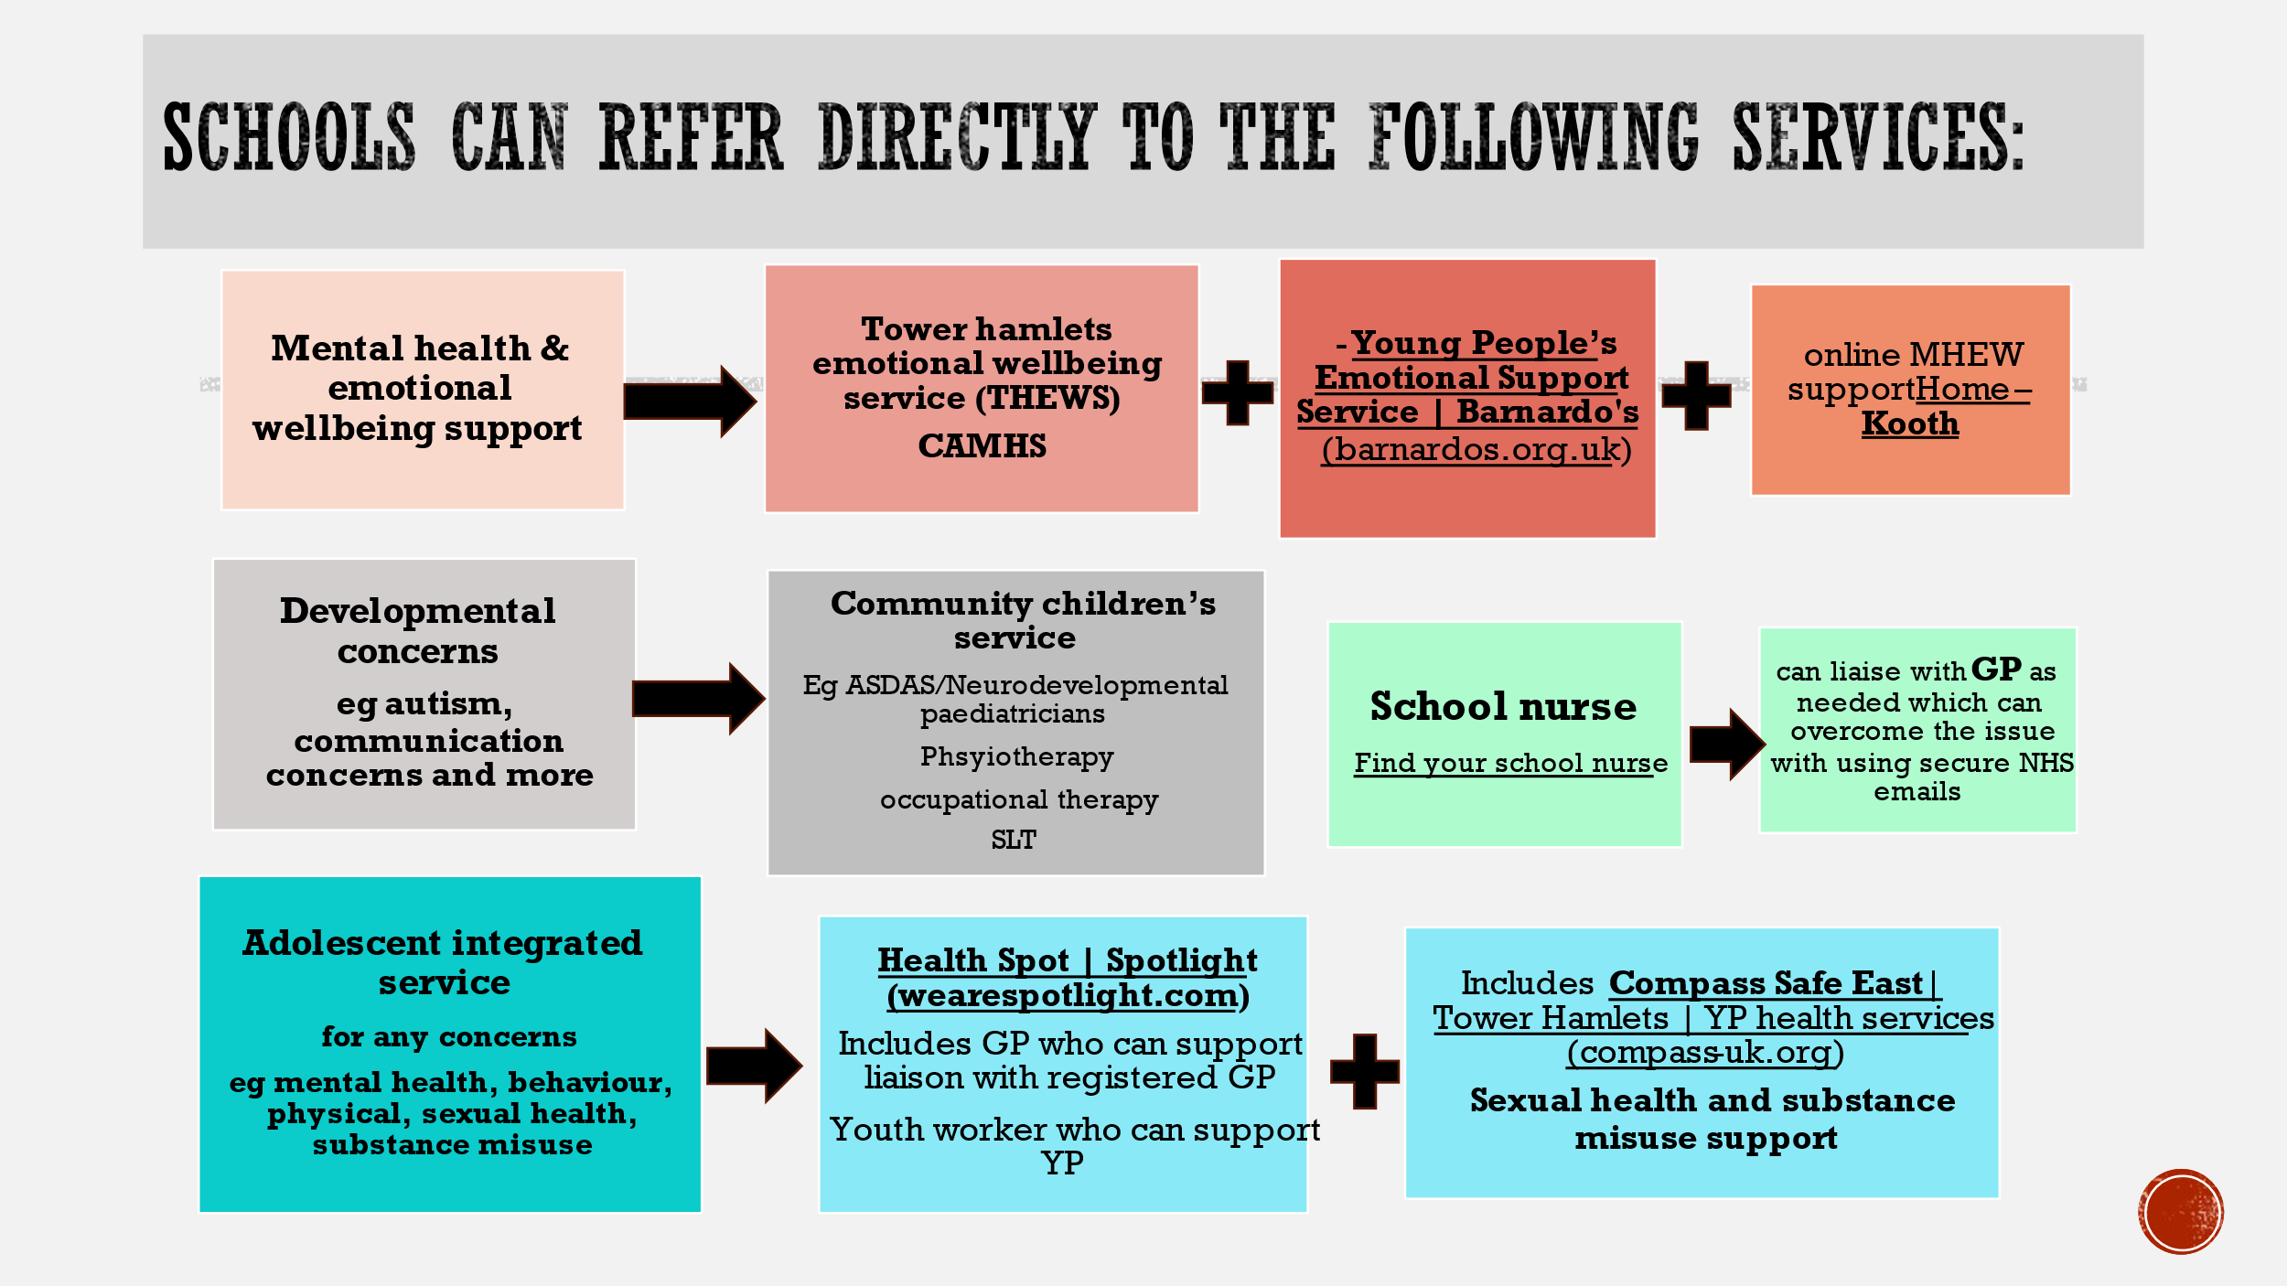

**TH primary care cSG flow chart:**

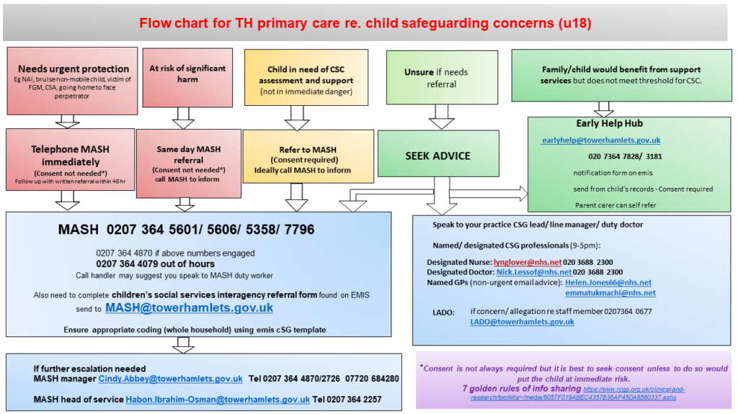

**Links to Further Information (as per references above)**

1. Top tips from a GP for schools 
2. [Children and Young People’s Safeguarding](https://primarycare.northeastlondon.icb.nhs.uk/home/childhealth/children-and-young-peoples-safeguarding/) 
3. [Convention on the Rights of the Child](https://www.right-to-education.org/resource/convention-rights-child)
4. [Special Education Needs Assessments](https://www.towerhamlets.gov.uk/lgnl/education_and_learning/parental_support/special_educational_needs/sen_assessments.aspx)
5. Tower Hamlets Special Educational Needs

   Tower Hamlets Town Hall,

   160 Whitechapel Road,

   London, E1 1BJ

   Tel: 020 7364 4880  
   Email: [SpecialEducational.Needs@towerhamlets.gov.uk](mailto:SpecialEducational.Needs@towerhamlets.gov.uk)
6. [Self Referral EHC Needs Assessment](https://www.towerhamlets.gov.uk/Documents/Children-and-families-services/Local-offer/Parental-EHC-Needs-Assessment-request-form.docx)
7. [EHC Notification](https://www.towerhamlets.gov.uk/Documents/Children-and-families-services/Special-education/EHC-Notification.docx)
8. [Notional SEN budget for mainstream schools](https://www.gov.uk/government/publications/pre-16-schools-funding-local-authority-guidance-for-2023-to-2024/the-notional-sen-budget-for-mainstream-schools-operational-guidance)
9. [EHCP Annual Review Guidance](https://5f2fe3253cd1dfa0d089-bf8b2cdb6a1dc2999fecbc372702016c.ssl.cf3.rackcdn.com/uploads/ckeditor/attachments/5484/EHCP_Annual_Review_Guidance_v5.pdf)
10. [Special Educational Needs and Disability (SEND)](https://www.localoffertowerhamlets.co.uk/pages/local-offer/send/send)
11. [Tower Hamlets SEND Information, Advice and Support Service](https://www.towerhamlets.gov.uk/lgnl/education_and_learning/parental_support/SEND_IASS_PAC.aspx) [TowerHamlets&City.SENDIASS@towerhamlets.gov.uk](mailto:TowerHamlets&City.SENDIASS@towerhamlets.gov.uk)
12. [TH-Children-Missing-Education-CME-guidance](https://view.officeapps.live.com/op/view.aspx?src=https%3A%2F%2Fwww.towerhamlets.gov.uk%2FDocuments%2FChildren-and-families-services%2FChild-protection%2FTH-Children-Missing-Education-CME-guidance.docx&wdOrigin=BROWSELINK)
13. [TH-Children-Missing-Education-CME-guidance](https://view.officeapps.live.com/op/view.aspx?src=https%3A%2F%2Fwww.towerhamlets.gov.uk%2FDocuments%2FChildren-and-families-services%2FChild-protection%2FTH-Children-Missing-Education-CME-guidance.docx&wdOrigin=BROWSELINK)
14. [Virtual School](https://virtualschool.towerhamlets.gov.uk/Home.aspx)
15. [Young WorkPath](https://www.towerhamlets.gov.uk/lgnl/education_and_learning/young_people/Employment-and-opportunities.aspx)
16. [Careers guidance and support for young people with special educational needs and disabilities](https://www.towerhamlets.gov.uk/lgnl/jobs_and_careers/employment_and_training_initia/Workpath/Careers_guidance_and_support_for_young_people_with_special_educational_needs_and_disabilities.aspx) 
17. [SPA-form-TH-Comm-Paed](https://view.officeapps.live.com/op/view.aspx?src=https%3A%2F%2Fwww.bartshealth.nhs.uk%2Fdownload.cfm%3Fdoc%3Ddocm93jijm4n21408&wdOrigin=BROWSELINK)
18. [bartshealth.thchildrenstherapies@nhs.net](mailto:bartshealth.thchildrenstherapies@nhs.net)
19. [Educational Psychology Service (EPS)](https://www.towerhamlets.gov.uk/lgnl/education_and_learning/schools/help_and_support/educational_psychology_support.aspx) 
20. [Children and Family Centres](https://www.towerhamlets.gov.uk/lgnl/health__social_care/children_and_family_care/Early_Help/Children-and-Family-Centres/Children-and-Family-Centre.aspx)
21. [How can an Educational Psychologist help you?](https://www.towerhamlets.gov.uk/Documents/Education-and-skills/Educational_Psychology_Service/Educational-Psychology-leaflets-Young-People-digital.pdf) 