

**Mild to Moderate  
non-IgE -­ mediated CMA**  
**‘Delayed’ Onset Symptoms**

Mostly 2-­‐72 hrs. after ingestion of CMP Formula fed, exclusively breast fed

or at onset of mixed feeding

One, or often, more than one of these symptoms:

**Gastrointestinal**

‘Colic’

Vomiting - ‘Reﬂux’ - GORD

Food refusal or aversion Loose or frequent stools Perianal redness Constipation

Abdominal discomfort,

Blood and/or mucus in stools in an otherwise well infant

**Skin**

Pruritus, erythema Signiﬁcant atopic eczema

**Respiratory**

‘Catarrhal’ airway symptoms   
(usually in combination with one

or more of the above symptoms)

**Can be managed in Primary Care   
See**

**Management Algorithm**

**Severe**

**Non - IgE - mediated CMA**

**‘Delayed’ Onset Symptoms**

Mostly 2-­‐72 hrs. after ingestion of CMP

Formula fed, exclusively breast fed   
or at onset of mixed feeding

**Severe** persisting symptoms of one or more of:

**Gastrointestinal**

Diarrhoea, vomiting, abdominal pain, food refusal   
or food aversion, signiﬁcant blood and/or mucus  
in stools, irregular or uncomfortable stools.

+/-­‐ Faltering growth

**Skin**

Severe Atopic Eczema + / -Faltering Growth

**Mild to Moderate  
IgE-­‐mediated CMA**

**‘Acute’ Onset Symptoms**

Mostly within minutes of ingestion of CMP   
Mostly formula fed or at onset of mixed feeding

One or more of these symptoms:

**Skin**

Acute pruritus, erythema, urticaria, angioedema

Acute ‘ﬂaring’ of atopic eczema

**Gastrointestinal**

Vomiting, diarrhoea, abdominal pain/colic

**Respiratory**

Acute rhinitis and/or conjunctivitis

Cow’s Milk Free Diet

**Extensively Hydrolysed Formula -­ eHF**(Initial choice, but some infants may then need an   
**Amino Acid Formula -­ AAF** trial if not settling)

Advise breast feeding mother to exclude all CMP from her own diet and to take daily Calcium (1000mg) and Vit D (10mcg) supplements

IgE testing needed.

**If diagnosis conﬁrmed (which may require a Supervised Challenge) –** Follow-­‐up with serial IgE testing and later planned and Supervised Challenge to test for acquired tolerance

Dietetic referral required

**If competencies to arrange and interpret testing are not in place -­ early referral to a paediatrician with an interest in allergy - advised**

**Suspected Cow’s Milk Allergy (CMA) in the 1st Year of Life**

**-­having taken an Allergy-­focused Clinical History**

Cow’s Milk Free Diet   
**Amino Acid Formula   
AAF**

Advise breast feeding mother to exclude all CMP from her own diet and to take daily Calcium (1000mg) and Vitamin D (10mcg) supplements

Ensure:

Urgent referral to a paediatrician with an interest in allergy

Urgent dietetic referral

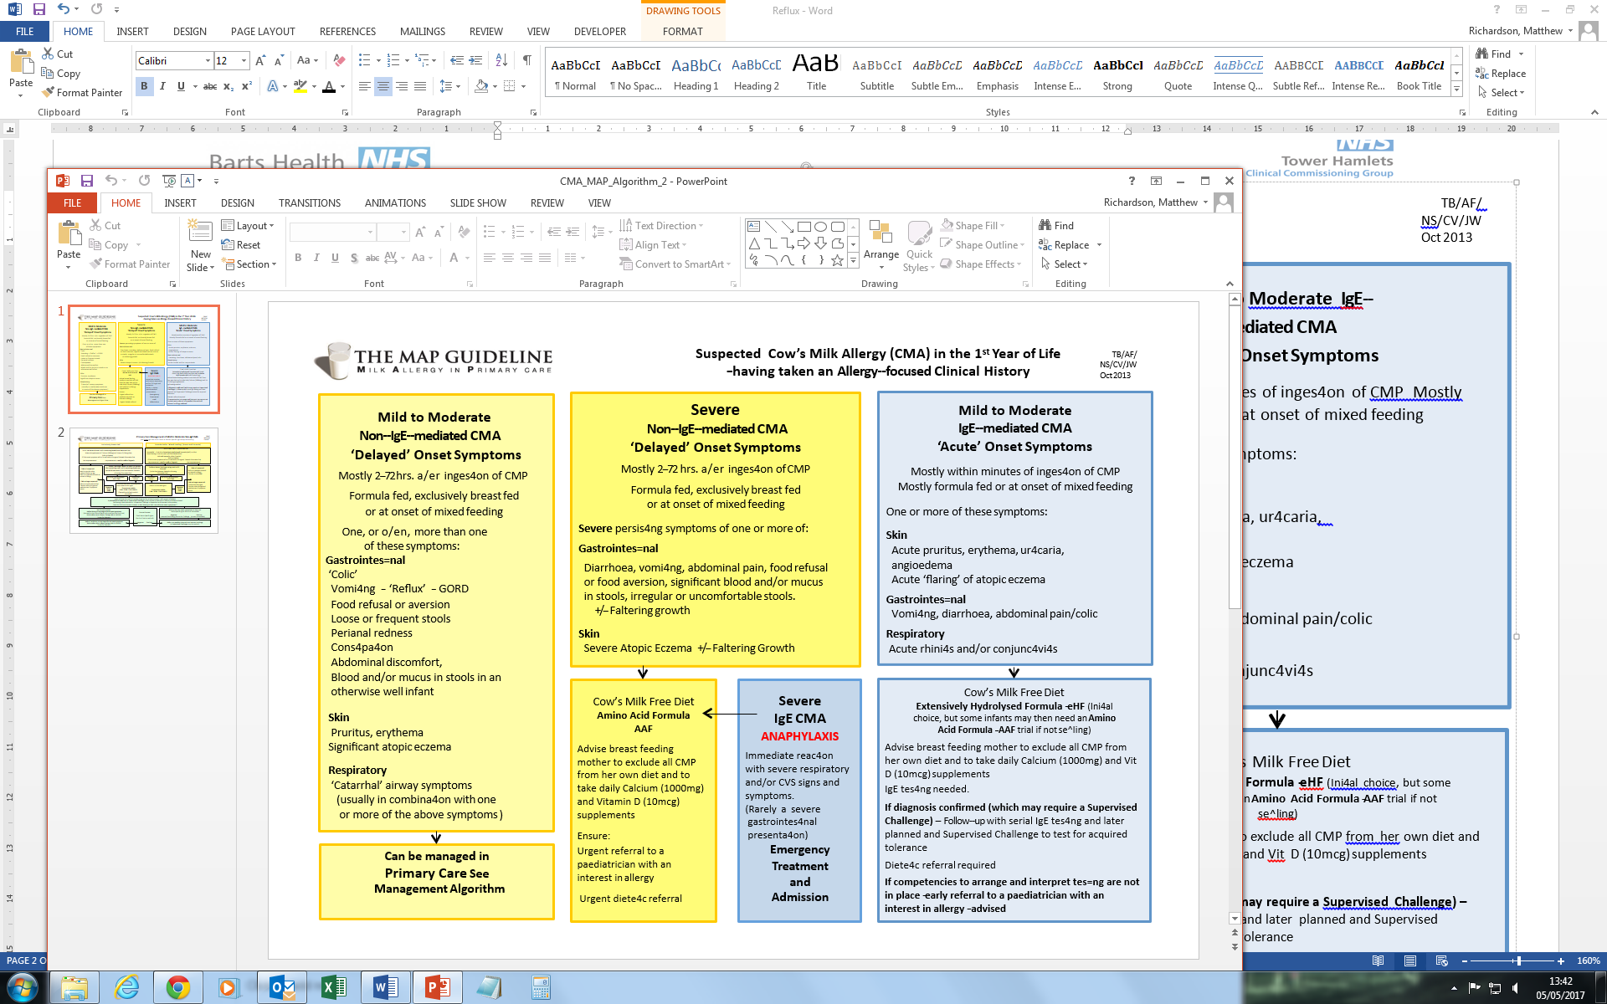

**Severe**

**IgE CMA**

**ANAPHYLAXIS**

Immediate reaction   
with severe respiratory and/or CVS signs and symptoms.

(Rarely a severe gastrointestinal presentation)

**Emergency  
Treatment   
and Admission**

**To**