Bright Start in Life campaign toolkit
Maternity and 0-5 immunisation campaign
July 2024
Background
This Bright Start in Life campaign launches on 8 July and will target prospective parents, pregnant women and parents/guardians of under-fives about maternity vaccines and all pre-school vaccinations (the vast majority of lifetime vaccinations are given by the age of five).
We want Bright Start in Life to inform, educate and empower the people in our communities whose children are not fully vaccinated, and those people who may soon become parents, to make positive decisions about vaccinations. Vaccination is an individual choice and success will be measured by the people we educate and inform around making informed decisions. The campaign is NOT about telling people to get vaccinated and driving vaccination uptake today directly.
Children in our communities become eligible for routine immunisations every day so we must educate and empower people all year round. It is not about engaging people whose children are either already vaccinated or people who are fundamentally against vaccination.
Contents
Useful links 2
Key text 3
Social media copy and asset grid 3
Translations grid 14
Asset list 17

Useful links
Campaign weblinks
- Campaign short link: https://northeastlondon.icb.nhs.uk/BrightStart
- Campaign website home page: https://northeastlondon.icb.nhs.uk/health-advice/vaccinations/childhoodvaccines/
- Interactive vaccine schedule and vaccine info: https://staging2.northeastlondon.icb.nhs.uk/health-advice/vaccinations/childhoodvaccines/about-vaccinations-and-when-to-have-them/
- Maternity: https://northeastlondon.icb.nhs.uk/health-advice/vaccinations/vaccinations-during-pregnancy/
Campaign materials G Drive
- Main G drive: https://drive.google.com/drive/folders/1PTAhfjqrYfQZBJ91TRn7WPKj2pGbJsxn?usp=drive_link
- Video files https://drive.google.com/drive/folders/1tOZGrcmdnCfhsLjU5OPsRgFFtfVRP3Mh?usp=drive_link
- Social media assets (including blanks to custom) https://drive.google.com/drive/folders/1ltSYbT3GOIs9PMP6PoeOkjxaysdKazTf?usp=drive_link
- Customised social media assets https://drive.google.com/drive/folders/1qp_QF1lnisPCQyEcH76cWeTwgL2Wkx_y?usp=drive_link
- Leaflets https://drive.google.com/drive/folders/1cR3L17jjPUh-ZATDkCYvo1q2WJEjIL35?usp=drive_link
- Translated leaflets https://drive.google.com/drive/folders/1vcslAye2-szdBKTE7PJoH4Nc7uyX68bV?usp=drive_link
- Maternity leaflets https://drive.google.com/drive/folders/1EUEpcMKIOjm09Nao_W7rzRzoNcmWodnI?usp=drive_link
- Posters https://drive.google.com/drive/folders/1UtIcDQgHZRs9UySvLxfh44H2u9Flr-QN?usp=drive_link
- Screens https://drive.google.com/drive/folders/1ArNKiRWxJp0MInmVzAmePIRhCsT1gX7U?usp=drive_link
- Schedule https://drive.google.com/drive/folders/19UNbR1pAkUGgLrHDTZzRRP-ZMYjCq02T?usp=drive_link
- Campaign guidelines https://drive.google.com/drive/folders/1Hx7ZzyJgfLPMI7c6kcG8e9_5S9Ghb2F8?usp=drive_link

Video Youtube links
Bright Start in Life playlist https://www.youtube.com/playlist?list=PLoTBiHRiMocnQ1ZdskoXoYK8gTCcDSfBV
- Let’s talk about childhood vaccinations – full length https://youtu.be/XDAc-3Oc3nw
- Let’s talk about childhood vaccinations – short version 1 https://youtu.be/sQ4dViFd8kk
- Let’s talk about childhood vaccinations – short version 2 https://youtu.be/OGMoVNhxw20
- Let’s talk about the MMR vaccine https://youtu.be/8xBdCK547dM
- Let’s talk about the MMR vaccine – short version 1 https://youtu.be/V6Ev4Dtd5Ac
- Let’s talk about the MMR vaccine – short version 2 https://youtu.be/FZJyEtNvlAc
- Let’s talk about vaccinations in pregnancy https://youtu.be/V6WM_pUTOtI
- Let’s talk about vaccinations in pregnancy – short version 1 https://youtu.be/EgbHjheb6jQ
- Let’s talk about vaccinations in pregnancy – short version 2 https://youtu.be/Uj7W1D7lbps

Key text
Key messages/web and newsletter text
Getting vaccinated is a normal part of growing up in the UK. It is one of many things people do to protect their children from serious diseases like meningitis, polio, measles, mumps and rubella.
The decision to vaccinate your children is yours and it’s natural to have questions about whether it is the right thing for you and your family. Visit the new NHS North East London Bright Start in Life website where you can find all the information you need about the vaccines your child can get at every stage of their life, why they are important, and the vaccines you can have while you are pregnant.
You can also find advice from local experts, download free resources, find information on where and how to book, and hear personal stories from local people like you.
www.northeastlondon.icb.nhs.uk/BrightStart

Social media copy and asset grid
Copy | Audience | Asset | Download link
Are your children up to date with their vaccines? 📆  Vaccines are a normal part of growing up in the UK and one of many things people do to protect their children.  Contact your GP to find out if your child is up to date with theirs. 👇  northeastlondon.icb.nhs.uk/BrightStart | Parents  (0-5) | Video  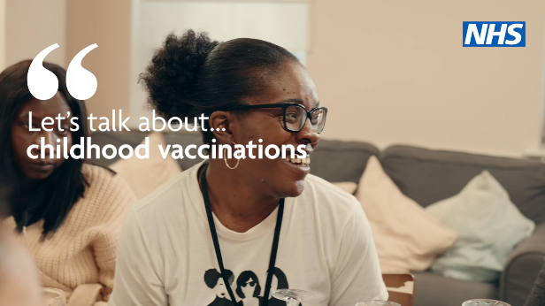 | - https://youtu.be/sQ4dViFd8kk  - https://youtu.be/OGMoVNhxw20
Is your child fully protected against measles, mumps and rubella/polio/meningitis?  Vaccines can help stop your children getting seriously ill from diseases like these.  Contact your GP to find out if your child is up to date.  👉northeastlondon.icb.nhs.uk/BrightStart | Parents  (0-5) | 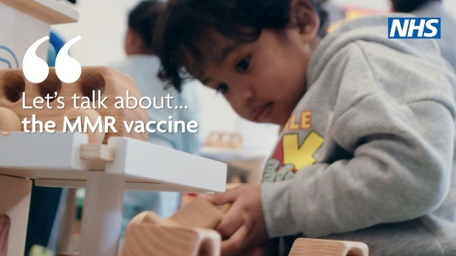 | - https://youtu.be/V6Ev4Dtd5Ac  - https://youtu.be/FZJyEtNvlAc
Unsure what vaccines you can have while pregnant?  It’s okay to have questions. We want to give you the information you need to make the right decision for you and your family.  northeastlondon.icb.nhs.uk/BrightStart for more information or speak to your GP or midwife for advice. | Maternity | 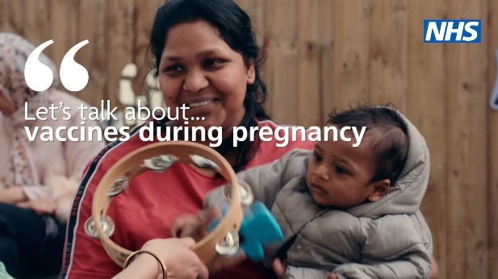 | - https://youtu.be/EgbHjheb6jQ  - https://youtu.be/Uj7W1D7lbps
Are your children up to date with their vaccines? 📆  Vaccines are a normal part of growing up in the UK and one of many things people do to protect their children.  Contact your GP to find out if your child is up to date with theirs. 👇  northeastlondon.icb.nhs.uk/BrightStart | Parents  (0-5) | 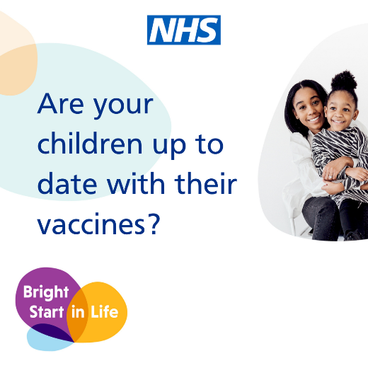 | https://drive.google.com/drive/folders/10PQMIJir2WUofmaKHRvb7hPCoK1ydQsy?usp=sharing
Is your child fully protected against measles, mumps and rubella/polio/meningitis?  Vaccines can help stop your children getting seriously ill from diseases like these.  Contact your GP to find out if your child is up to date.  👉northeastlondon.icb.nhs.uk/BrightStart | Parents  (0-5) | 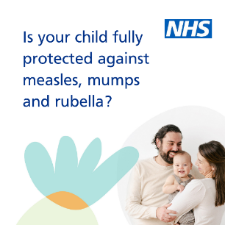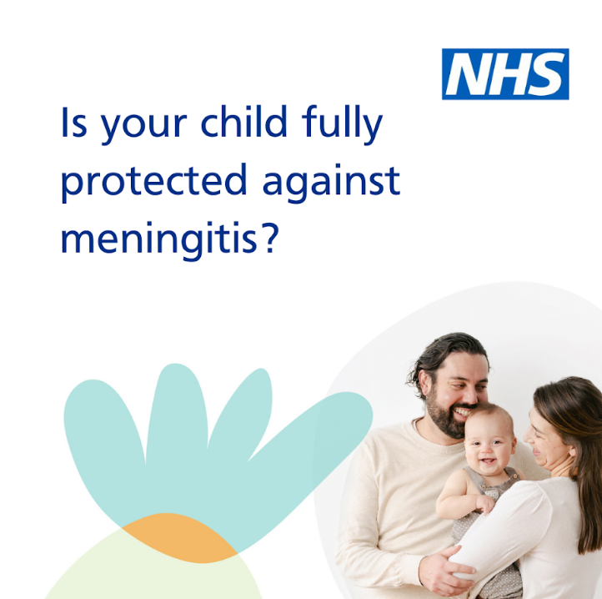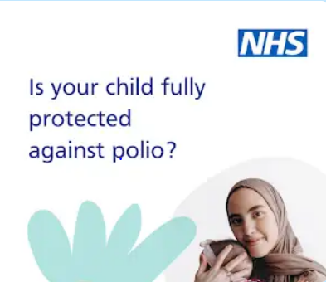 | https://drive.google.com/drive/folders/15-SAe8x6DJjs8yV1VQ2XIbJtYcX15i0j?usp=sharing
Thinking about getting your children vaccinated?  It’s okay to have questions. We want to give you the information you need to make the right decision for you and your family.  To find out more visit northeastlondon.icb.nhs.uk/BrightStart or speak to your GP or health visitor for advice. | Parents  (0-5) | 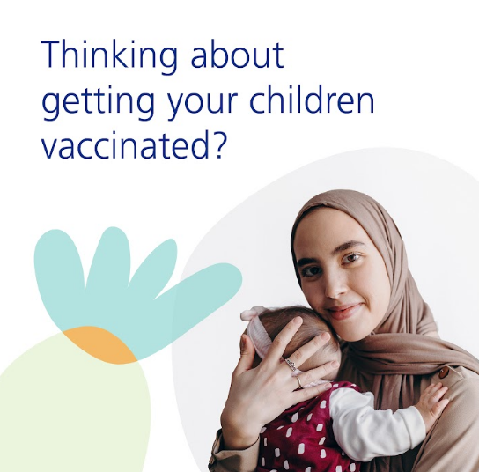 | Video  https://drive.google.com/file/d/1ZzqwZ501CRlnqgXXppn-x5c5Phd2JT_l/view?usp=drive_link  or  Carousel  https://drive.google.com/drive/folders/1NWNT8jzMNAyPoxZ927VWWZ4yXdZheOiV?usp=sharing  or  Static  https://drive.google.com/drive/folders/1a_mwMxUlV4Z4gI9bHj_iNMfcKP5CeRCH?usp=sharing
Are your children behind on their vaccines?  Vaccines are always free and are the best way to stop children from getting seriously ill.  Find your nearest vaccination clinic. 🔍📆  https://northeastlondon.icb.nhs.uk/health-advice/vaccinations/childhoodvaccines/how-to-get-a-vaccination/ | Parents (0-5) | 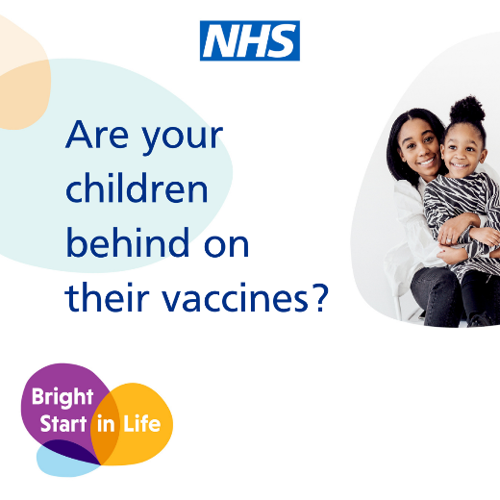 | https://drive.google.com/drive/folders/1CvTceaoYLyBgIZL9OUJ6CsUxzg3Epwe_?usp=sharing
There can be some confusing information that can spread about vaccinations.  We want to give you the information you need to make the right decision for you and your family. Read more⬇️ northeastlondon.icb.nhs.uk/BrightStart | Parents  (0-5) | 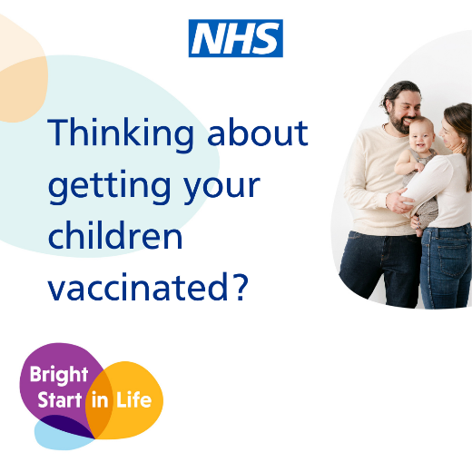 | Static  https://drive.google.com/drive/folders/1a_mwMxUlV4Z4gI9bHj_iNMfcKP5CeRCH?usp=sharing  or  Carousel  https://drive.google.com/drive/folders/1LgO6bKVyKnqhDoNLDDXn93u2wjau0_b1?usp=sharing
If you are worried that a vaccine contains pork gelatine, you can speak to your GP or midwife who can talk with you about possible alternatives.  Visit ⬇️ northeastlondon.icb.nhs.uk/BrightStart for more information | Parents  (0-5) | 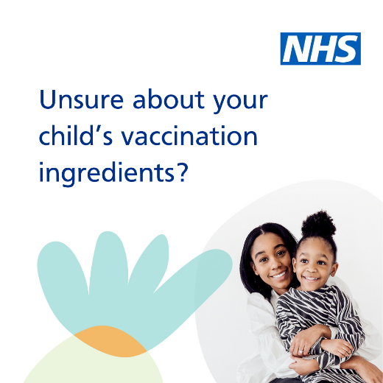 | https://drive.google.com/drive/folders/1o2Rxdmc8FX_9MblNcjSPirnhwey5ivNF?usp=sharing
Is your child up to date with their vaccinations?  Take a look at our helpful childhood vaccination schedule to make sure your child has had all of their vaccines, or if they need to catch up.📆  Visit northeastlondon.icb.nhs.uk/BrightStart | Parents  (0-5) | 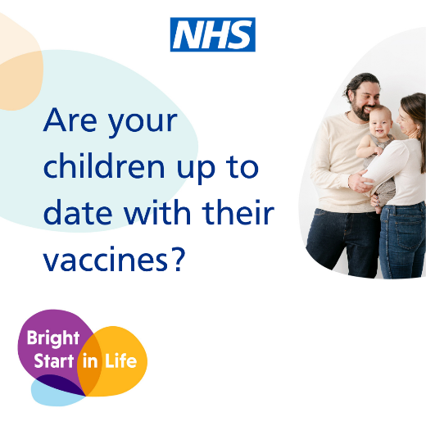 | Statics  https://drive.google.com/drive/folders/10PQMIJir2WUofmaKHRvb7hPCoK1ydQsy?usp=sharing  or  Carousel  https://drive.google.com/drive/folders/1LgO6bKVyKnqhDoNLDDXn93u2wjau0_b1?usp=sharing
Routine childhood vaccinations are free.  If you are not registered with a GP you can find a GP near you and register.  Find out more https://northeastlondon.icb.nhs.uk/health-services/general-practice-gp/register-with-a-local-gp/ | Parents  (0-5) | 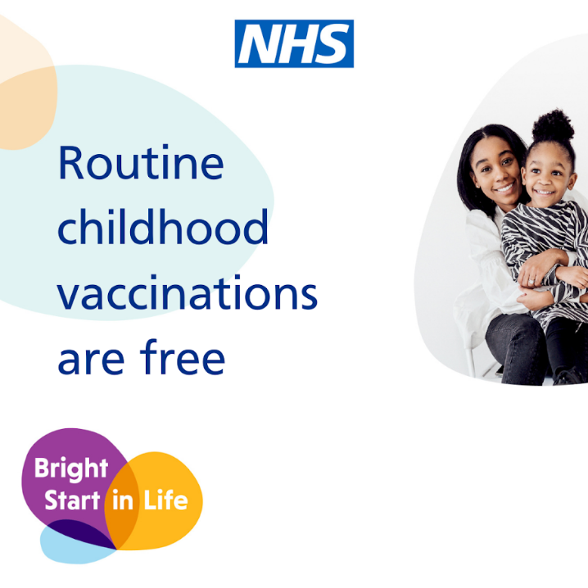 | https://drive.google.com/drive/folders/1DAsxyiqQJ5kZ4IZcW2nuSlzrta4zyQQ1?usp=sharing
CUSTOMISABLE  Are your children up to date with their vaccines?  XXX children in [area] are not fully vaccinated against [disease]  Contact your GP to find out if your child is up to date. | Parents  (0-5) | 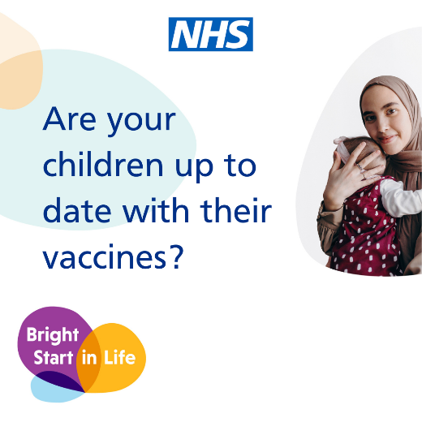 | Static  https://drive.google.com/drive/folders/10PQMIJir2WUofmaKHRvb7hPCoK1ydQsy?usp=sharing  or  Carousel  https://drive.google.com/drive/folders/1LgO6bKVyKnqhDoNLDDXn93u2wjau0_b1?usp=sharing
CUSTOMISABLE  Cases of [disease] are rising in your area/London.  Is your child fully protected?  Contact your GP to find out if your child is up to date with their vaccines. | Parents  (0-5) | Customisable assets available | https://drive.google.com/drive/folders/1ltSYbT3GOIs9PMP6PoeOkjxaysdKazTf?usp=sharing
CUSTOMISABLE  Cases of [disease] are rising in your area/London.  Is your child fully protected?  Find your nearest vaccination clinic. 👉northeastlondon.icb.nhs.uk/BrightStart | Parents  (0-5) | Customisable assets are available | https://drive.google.com/drive/folders/1ltSYbT3GOIs9PMP6PoeOkjxaysdKazTf?usp=sharing
Are you a new parent? 👶🏽  Your child’s red book records important details of your child’s health and can help you keep up to date with your child’s vaccines so that they stay protected from serious illness.  Visit northeastlondon.icb.nhs.uk/BrightStart for more information | New parents | 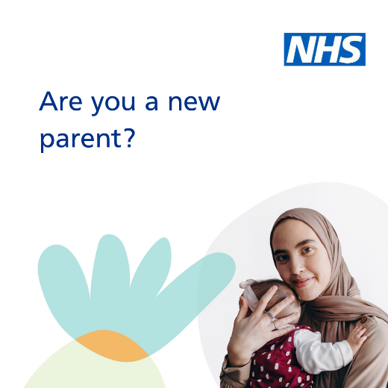 | https://drive.google.com/drive/folders/1tgsMKmHhmBSY_KOAez8I9Z-gtbhbrRP8?usp=sharing
Is your baby due to have their routine vaccinations?  Read our helpful hints that can make their vaccine appointment go a little smoother.  Read more https://northeastlondon.icb.nhs.uk/health-advice/vaccinations/vaccinations-during-pregnancy/ | New parents | 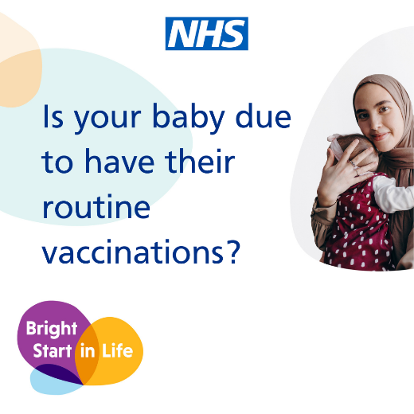 | https://drive.google.com/drive/folders/1zON9YBy0KxjztoX21g9SjvDcTBMW_gbQ?usp=drive_link
Unsure what vaccines you can have while pregnant?  It’s okay to have questions. We want to give you the information you need to make the right decision for you and your family.  Visit northeastlondon.icb.nhs.uk/BrightStart for more information or speak to your GP or midwife for advice. | Maternity | 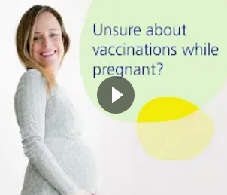 | Video  https://drive.google.com/file/d/1BUvspHYmY5xEUtBaqCS0e_XlYO61bkId/view?usp=sharing  or  Carousel  https://drive.google.com/drive/folders/1LgO6bKVyKnqhDoNLDDXn93u2wjau0_b1?usp=sharing  or  Static  https://drive.google.com/drive/folders/12pO8ZBB98colgYBUqlU794Lw7C1UYMtB?usp=sharing
Is your baby protected against whooping cough?  The best way you can protect your baby from birth is by having the whooping cough vaccine whilst pregnant.  Contact your midwife or GP for advice or to book an appointment. 📆 https://northeastlondon.icb.nhs.uk/health-advice/vaccinations/vaccinations-during-pregnancy/ | Maternity | 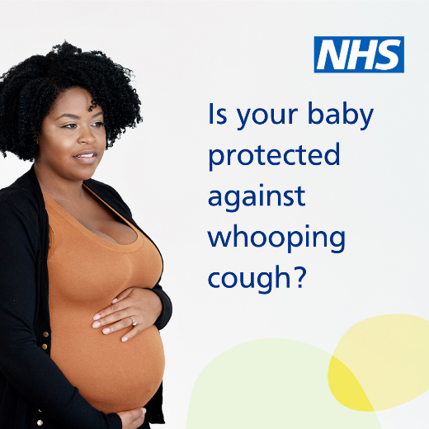 | https://drive.google.com/drive/folders/1ndihiN8nj8HX4Vl1pJ71Nshn49uMnIRm?usp=sharing
Are you and your baby protected against flu?  Getting the flu while pregnant can cause serious complications. The best way to protect you and your baby is having the flu vaccine whilst pregnant.  Contact your midwife or GP for advice or to book an appointment. https://northeastlondon.icb.nhs.uk/health-advice/vaccinations/vaccinations-during-pregnancy/ | Maternity | 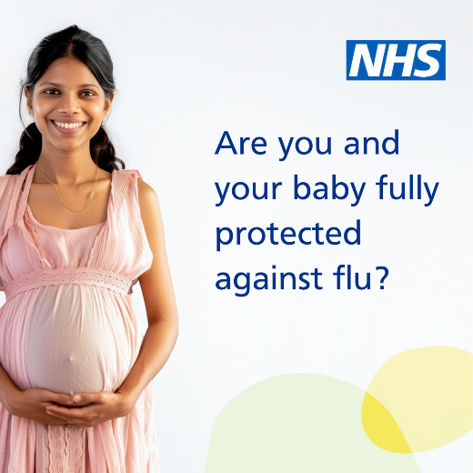 | https://drive.google.com/drive/folders/1Ck_ofTMhYHwaXzBVXjATx8qzJ_0zsuEe?usp=sharing
Are you and your baby protected against COVID-19?  Catching coronavirus while pregnant can cause serious complications. The best way to protect you and your baby is having the COVID-19 vaccine whilst pregnant.  Contact your midwife or GP for advice or to book an appointment. https://northeastlondon.icb.nhs.uk/health-advice/vaccinations/vaccinations-during-pregnancy/ | Maternity | 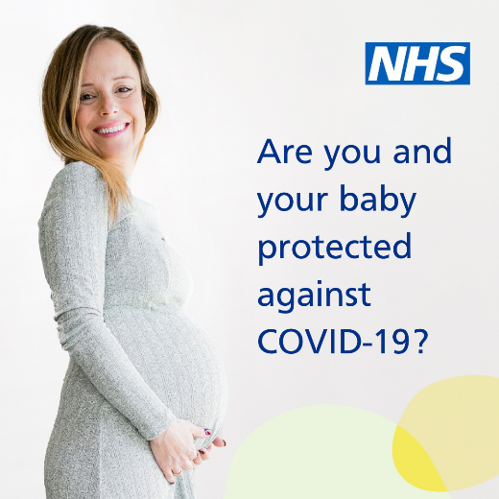 | https://drive.google.com/drive/folders/19tDKaM3prxaPDj0FfBSOwibM_atECQbN?usp=sharing

Child GP registration
Your child is not automatically registered with a GP when they are born.  They need to be to get vital medicines and vaccinations.  Find out how here https://northeastlondon.icb.nhs.uk/health-services/general-practice-gp/register-with-a-local-gp/ | 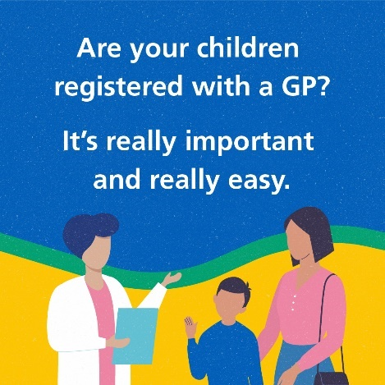  Animation | https://drive.google.com/drive/folders/1BpS3XiCGlocnzYbwfQBdsxHWFWBYzHGP?usp=sharing
Is your child registered with a GP?  It’s free and anyone can do it. You do not need any paperwork or ID.  Find out how here https://northeastlondon.icb.nhs.uk/health-services/general-practice-gp/register-with-a-local-gp/ |  | https://drive.google.com/drive/folders/1BpS3XiCGlocnzYbwfQBdsxHWFWBYzHGP?usp=sharing
Is your child registered with a GP?  Contact your GP to register. If you don’t have one you can register online or in person.  Find out how here https://northeastlondon.icb.nhs.uk/health-services/general-practice-gp/register-with-a-local-gp/ |  | https://drive.google.com/drive/folders/1BpS3XiCGlocnzYbwfQBdsxHWFWBYzHGP?usp=sharing

Translations grid
Language | Text
English | Vaccines are the best way of protecting your children from serious diseases.
Romanian | Vaccinurile sunt cel mai bun mod de a vă proteja copiii de boli grave.
Bengali | আপনার ছেলেমেয়েকে গুরুতর রোগ থেকে রক্ষা করার সবচেয়ে ভালো উপায় হলো টিকা নেওয়া।
Urdu | آپ کے بچوں کو سنگین بیماریوں سے بچانے کا بہترین طریقہ ویکسنز ہیں۔
Punjabi- Indian | ਵੈਕਸੀਨ, ਤੁਹਾਡੇ ਬੱਚਿਆਂ ਨੂੰ ਗੰਭੀਰ ਬੀਮਾਰੀਆਂ ਤੋਂ ਸੁਰੱਖਿਅਤ ਰੱਖਣ ਦਾ ਸਭ ਤੋਂ ਵਧੀਆ ਤਰੀਕਾ ਹਨ।
Punjabi - Pakistani | تہاڈے بالاں نوں خطرناک بیماریاں توں بچاؤن دا سب توں ودھیا طریقہ ویکسینز نیں۔
Polish | Szczepionki są najlepszym sposobem ochrony dzieci przed poważnymi chorobami.
English | Vaccines save millions of lives worldwide.
Romanian | Vaccinurile salvează milioane de vieți în întreaga lume.
Bengali | টিকা বিশ্বব্যাপী লক্ষ লক্ষ জীবন বাঁচায়।
Urdu | دنیا بھر میں ویکسینز لاکھوں جانوں کو بچاتی ہیں۔
Punjabi- Indian | ਵੈਕਸੀਨ, ਦੁਨੀਆਭਰ ਵਿੱਚ ਲੱਖਾਂ ਜ਼ਿੰਦਗੀਆਂ ਬਚਾਉਂਦੇ ਹਨ।
Punjabi - Pakistani | ویکسینز دنیا بھر اچ لکھاں جاناں نوں بچاؤندیاں نیں۔
Polish | Szczepionki ratują życie milionom ludzi na całym świecie.
English | Vaccines have been saving lives in the UK for decades.
Romanian | Vaccinurile salvează vieți în Regatul Unit de zeci de ani.
Bengali | টিকা কয়েক দশক ধরে যুক্তরাজ্যে জীবন বাঁচাচ্ছে।
Urdu | برطانیہ میں ویکسینز کئی دہائیوں سے جانیں بچا رہی ہیں۔
Punjabi- Indian | ਵੈਕਸੀਨ, ਦਹਾਕਿਆਂ ਤੋਂ ਯੂ.ਕੇ. (UK) ਵਿੱਚ ਜ਼ਿੰਦਗੀਆਂ ਬਚਾ ਰਹੇ ਹਨ।
Punjabi - Pakistani | برطانیہ اچ ویکسینز کئی دہائیاں توں جاناں بچا رہیاں نیں۔
Polish | Szczepionki ratują życie ludziom w Wielkiej Brytanii od dziesięcioleci.
English | Vaccination is your choice and its okay to have questions.
Romanian | Vaccinarea este alegerea dumneavoastră și este normal să aveți întrebări.
Bengali | টিকা নেওয়া আপনার পছন্দ এবং প্রশ্ন জিজ্ঞেস করতে কোনো সমস্যা নেই৷
Urdu | ویکسین لگوانے کا فیصلہ آپ کا ہے، اور اس کے بارے میں سوالات کرنا بالکل عام بات ہے۔
Punjabi- Indian | ਵੈਕਸੀਨ ਲਗਵਾਉਣਾ ਤੁਹਾਡੀ ਮਰਜ਼ੀ ਹੈ ਅਤੇ ਸਵਾਲ ਪੁੱਛਣ ਵਿੱਚ ਕੁਝ ਗਲਤ ਨਹੀਂ ਹੈ।
Punjabi - Pakistani | ویکسین لوان دا فیصلہ تہاڈا اے، تے ایہدے بارے وچ سوال کرنا بالکل عام گل اے۔
Polish | Szczepienie to Twój wybór i masz prawo do zadawania pytań.
English | Vaccines are a normal part of growing up in the UK and one of many things people do to protect their children.
Romanian | Vaccinurile sunt o parte normală a creșterii în Regatul Unit și unul dintre multiplele lucruri pe care le fac oamenii pentru a-și proteja copiii.
Bengali | যুক্তরাজ্যে বেড়ে ওঠার একটি স্বাভাবিক অংশ হলো টিকা নেওয়া এবং লোকজন তাদের ছেলেমেয়েকে সুরক্ষিত রাখার জন্য যেসব কাজ করে থাকে তার মধ্যে একটি৷
Urdu | برطانیہ میں پرورش پانے کے دوران ویکسین لگوانا پرورش پانے کا ایک عمومی حصہ ہے نیز یہ ان بہت سے اقدامات میں سے ایک ہے جو لوگ اپنے بچوں کو محفوظ رکھنے کیلئے انجام دیتے ہیں۔
Punjabi- Indian | ਵੈਕਸੀਨ, ਯੂ.ਕੇ. ਵਿੱਚ ਵੱਡੇ ਹੋਣ ਦੌਰਾਨ ਦਾ ਸਧਾਰਨ ਹਿੱਸਾ ਹਨ ਅਤੇ ਉਹਨਾਂ ਕਈ ਚੀਜ਼ਾਂ ਵਿੱਚੋਂ ਇੱਕ ਹਨ, ਜੋ ਲੋਕ ਆਪਣੇ ਬੱਚਿਆਂ ਨੂੰ ਸੁਰੱਖਿਅਤ ਰੱਖਣ ਲਈ ਕਰਦੇ ਹਨ।
Punjabi - Pakistani | برطانیہ اچ پرورش پان دے دوران ویکسین لواناں پرورش دا اک بنیادی حصہ اے، اتے ایہہ کم انہاں بہت سارے کماں اچوں اک اے جہڑے لوکی اپنے بالاں نوں محفوظ رکھن لئی کردے نیں۔
Polish | W Wielkiej Brytanii szczepionki są naturalnym elementem procesu dorastania, a także jedną z wielu metod, dzięki której rodzice chronią swoje dzieci.
English | We want to give you the information you need to make the right decision for you and your family.
Romanian | Dorim să vă oferim informațiile de care aveți nevoie pentru a lua decizia corectă pentru dumneavoastră și familia dumneavoastră.
Bengali | আপনার ও আপনার পরিবারের জন্য সঠিক সিদ্ধান্ত নিতে আপনার প্রয়োজনীয় তথ্য আমরা আপনাকে দিতে চাই।
Urdu | ہم آپ کو اپنے اور اپنے خاندان کے لئے بہترین فیصلہ کرنے کیلئے ضروری معلومات فراہم کرنا چاہتے ہیں۔
Punjabi- Indian | ਅਸੀਂ ਤੁਹਾਨੂੰ ਉਹ ਜਾਣਕਾਰੀ ਦੇਣਾ ਚਾਹੁੰਦੇ ਹਾਂ, ਜਿਸਦੀ ਲੋੜ ਤੁਹਾਨੂੰ ਖੁਦ ਲਈ ਅਤੇ ਆਪਣੇ ਪਰਿਵਾਰ ਲਈ ਸਹੀ ਫੈਸਲਾ ਲੈਣ ਲਈ ਹੈ।
Punjabi - Pakistani | اسی تہانوں اپنے اتے اپنی فیملی لئی بہترین فیصلہ کرن لئی ضروری معلومات دینا چاہندے آں۔
Polish | Dostarczymy Ci informacji potrzebnych do podjęcia właściwej decyzji dla Ciebie i Twojej rodziny.
English | Find out more on our website or speak to your GP or health visitor.
Romanian | Aflați mai multe pe site-ul nostru sau adresați-vă medicului de familie sau infirmierei pentru asistență la domiciliu.
Bengali | আমাদের ওয়েবসাইট থেকে আরো জানুন অথবা আপনার জিপি বা হেলথ ভিজিটরের সাথে কথা বলুন।
Urdu | ہماری ویب سائٹ پر مزید معلومات ملاحظہ فرمائیں یا اپنے GP یا ہیلتھ وزیٹر سے بات کریں۔
Punjabi- Indian | ਸਾਡੀ ਵੈਬਸਾਈਟ ਤੇ ਵਧੇਰੇ ਜਾਣਕਾਰੀ ਪ੍ਰਾਪਤ ਕਰੋ ਜਾਂ ਆਪਣੇ ਜੀ.ਪੀ. (GP) ਜਾਂ ਹੈਲਥ ਵਿਜੀਟਰ ਨਾਲ ਗੱਲ ਕਰੋ।
Punjabi - Pakistani | ساہڈی ویب سائٹ تے مزید معلومات ویکھو یاں اپنے GP یاں ہیلتھ وزیٹر نال گل کرو۔
Polish | Dowiedz się więcej na naszej stronie internetowej lub porozmawiaj ze swoim lekarzem rodzinnym lub pielęgniarką środowiskową.

Asset list
Asset name, format and image quantity | Audience and message | Link
Videos | Parents and pregnancy | https://drive.google.com/drive/folders/1tOZGrcmdnCfhsLjU5OPsRgFFtfVRP3Mh?usp=drive_link
Social media assets and ads  3 image square meta carousel (swipe) /portrait IG story / square gif/MP4 for X  Each of the three images has a parent from a diff ethnic group | Parents under 5s | https://drive.google.com/drive/folders/1NWNT8jzMNAyPoxZ927VWWZ4yXdZheOiV?usp=sharing
Customisable blanks of assets above.  3 image square meta carousel (swipe) /portrait IG story  Versions for each ethnic group | Parents of under 5s | https://drive.google.com/drive/folders/1suFLk6qzPypHQjVnrX4LGrJisjsg--kZ?usp=sharing
Social media assets and ads  3 image square meta carousel (swipe) /portrait IG story / square gif/MP4 for X  Each of the three images has a parent from a diff ethnic group | Pregnant women | https://drive.google.com/drive/folders/1oc2g6MN_2L42D6cO97F2rJadJyo4aPbF?usp=sharing
Customisable blanks of above  3 image square meta carousel (swipe) /portrait IG story  Versions for each ethnic group | Pregnant women | https://drive.google.com/drive/folders/183y9tKImlvL0AGACCAF3uqhZ7UxX4svX?usp=sharing
Customisable statics  Landscape, square and portrait IG  Versions for each ethnic group | Parents | https://drive.google.com/drive/folders/1VEYaZCY3jbGaPuLCvI9p7l3Ak0mrz_oa?usp=sharing
Customisable statics  Landscape, square and portrait IG  Versions for each ethnic | Maternity | https://drive.google.com/drive/folders/1PTARKSQK3ccNmqmsYFOuvuRfTPfx69a3?usp=sharing
Display adverts  3 sized, 3 page GIFS - 728×90, 300×100, 300×250 | Parents | https://drive.google.com/drive/folders/1fIDPhmI0c5OpB7sNImFIcfzUwdMI6N4z?usp=sharing
Display adverts  3 sized, 3 page GIFS - 728×90, 300×100, 300×250 | Maternity | https://drive.google.com/drive/folders/1hxnd5hwdA6LATL1AivtnVcCTwvPqL6R-?usp=sharing
Customisable Digital screen  Featuring people of all ethnicities  Landscape and portrait | Parents | https://drive.google.com/drive/folders/1ArNKiRWxJp0MInmVzAmePIRhCsT1gX7U?usp=sharing
Customised social media posts | Parents and pregnant women | https://drive.google.com/drive/folders/1qp_QF1lnisPCQyEcH76cWeTwgL2Wkx_y?usp=sharing
Customisable poster A4/A3  Web and print  Featuring people of all ethnicities | Parents and pregnant women | https://drive.google.com/drive/folders/1UtIcDQgHZRs9UySvLxfh44H2u9Flr-QN?usp=sharing
Campaign guide lines PDF | Professional comms | https://drive.google.com/drive/folders/1Hx7ZzyJgfLPMI7c6kcG8e9_5S9Ghb2F8?usp=sharing
Immunisation schedule web and print | Parents | https://drive.google.com/drive/folders/19UNbR1pAkUGgLrHDTZzRRP-ZMYjCq02T?usp=sharing
Leaflet print and web  Versions with different ethnicities represented | Parents | https://drive.google.com/drive/folders/1cR3L17jjPUh-ZATDkCYvo1q2WJEjIL35?usp=sharing
Leaflet translations  Bengali  Polish  Urdu  Punjabi  Romanian | Parents | https://drive.google.com/drive/folders/1vcslAye2-szdBKTE7PJoH4Nc7uyX68bV?usp=sharing
Leaflet print and web  Versions with different ethnicities represented | Maternity | https://drive.google.com/drive/folders/1EUEpcMKIOjm09Nao_W7rzRzoNcmWodnI?usp=sharing

