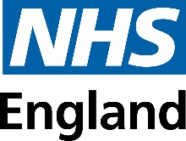
NHS Bowel Cancer Screening Programme
FIT aid FAQs
May 2024
What is a FIT aid?
The FIT aid is a tool that helps people complete their Faecal Immunochemical Test (FIT kit). The FIT aid has a stand and a channel to guide the sample stick into the FIT bottle. The FIT aid is currently being tested by people who are blind or partially sighted and/or have manual dexterity challenges. The design may change following the in-service evaluation,
FIT aid accessible feature– Channel developed to enable sample to be guided into the FIT bottle
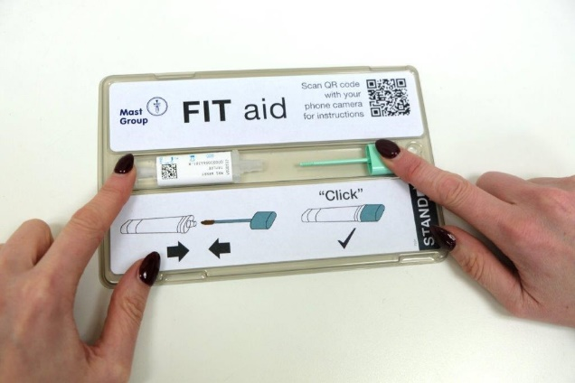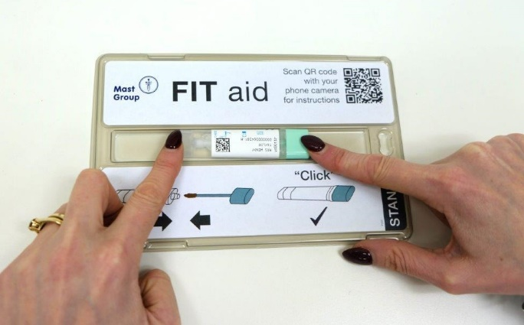
FIT aid accessible feature – Stand holds FIT tube steady to help those with manual dexterity challenges guide sample into FIT bottle
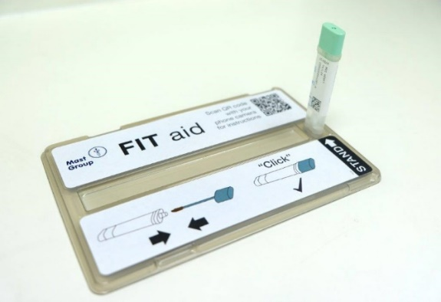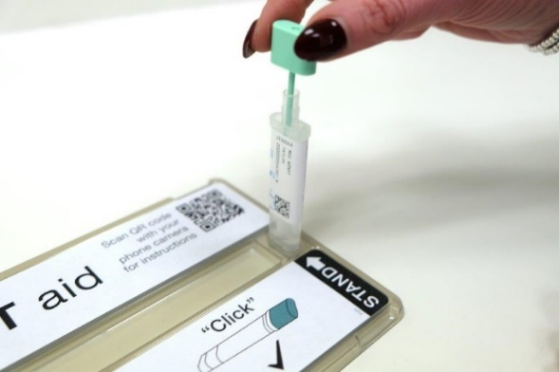

Why has the FIT aid been developed?
The FIT aid has been developed to help people who find it difficult to complete their bowel cancer screening test independently. The FIT aid has a stand and a channel making it easier for people to guide the sample stick into the FIT bottle.
Who is eligible for a FIT aid?
People eligible for a FIT aid are those who are due to be invited to complete their bowel cancer screening from May 2024 for 6 months. These people have registered that they need reasonable adjustments to complete their bowel cancer screening test because they are blind or partially sighted and/or have manual dexterity challenges.
How will this be communicated to those people who will receive a FIT aid?
The screening hubs will identify people who have registered that they require reasonable adjustments and they will receive an additional letter with their pre invitation letter informing them that they will receive a FIT aid in the post either before or after they receive their FIT kit. People will also be given information about how to request the instructions in a different format or opt out of receiving a FIT aid.
Did you consult with the blind and partially sighted community on this to ensure the community’s view were considered?
Throughout the design and development of the FIT aid and instruction we have worked in partnership with the Royal National Institute for the Blind (RNIB), Thomas Pocklington Trust who helped us test the design and instructions with a cohort of 30 people who were sent a FIT aid when completing their bowel cancer screening in September 2023. Feedback from the small cohort has been incorporated into the current evaluation.
What formats are the FIT aid instructions available in?
The FIT aid instructions are available in large print, audio CD, braille and email or text link to use with screen readers.
How many people will be sent a FIT aid during the trial period and how many people across England could benefit if it is rolled out?
There are currently approximately 900 people who are registered on the bowel cancer screening IT system as requiring reasonable adjustments because they have a sight impairment and approximately 40 who have manual dexterity challenges. These people notified the bowel cancer screening programme that they require an adjustment to be made. It is difficult to know when the people registered are due their screening kit, as people receive their kits every 2 years from when they last completed their last invitation. The programme can identify people who require an adjustment, when they are due a screening kit within the next 90 days if they have informed us of their reasonable adjustment required previously.
There are estimated to be more than two million people living with sight loss in the UK and it is estimated that by 2050 this will double to over four million. [1] [2] The FIT aid if rolled out may also be beneficial to other people, such as those with learning disabilities.
How is the FIT aid being evaluated?
The evaluation of the FIT aid is taking place over 6 months from May to October 2024 which will include feedback from people who are using the FIT aid.
The evaluation team will identify if participants who received the FIT aid completed and returned their bowel cancer screening test and if they have previously not done so. It will also identify people who were sent a FIT aid but did not return their FIT kit.
This analysis will help us understand if providing the FIT aid to those who are blind or partially sighted and/or have manual dexterity challenges makes them more likely to complete their Bowel Cancer Screening Test independently.

Will the current leaflets and videos be changed to include the FIT aid?
As this is an evaluation of the FIT aid it will be issued with accompanying instructions, but we will not be updating the current leaflets and videos at this time. They will be updated in the future if the FIT aid is to be rolled out nationally.
Will any guidance be published for NHS Bowel Cancer Screening Programme providers?
The screening hubs in England have been working closely with the NHS Bowel Cancer Screening Programme to develop a standard operating procedure (SOP) for the screening hubs. We will also share these FAQs with key stakeholders including the screening centres.
Is this available in Northern Ireland, Scotland and Wales?
England is the first country to design a tool to support people to complete their bowel cancer screening test. The FIT aid has been designed and developed based on the FIT test that is used in England. However, we will be sharing our evaluation with the other UK nations.
Are FIT aids available through symptomatic services?
No. The FIT aid is only available for people being sent FIT kits during the evaluation period through the NHS Bowel Cancer Screening Programme. FIT aid is not available for symptomatic services, although will be considered as part of any potential roll out.

What should GPs advise if patients ask for a FIT aid?
They should advise that they are only currently available if a FIT kit has been sent by the NHS Bowel Cancer Screening Programme. However, if FIT aid is rolled out more widely it will be available for anyone completing a FIT kit.

