Did you know, 8 MILLION disposable nappies are thrown away EVERY DAY in the UK?

As a health worker that comes into contact with people planning and starting families you can promote these incentives to make the switch to reusable nappies.
Reusable Nappies are made from natural or synthetic materials, making them kinder to your baby’s skin. What’s more is, Reusable Nappies are a great way to save money, with some families saving up to £1000 over 2.5 yrs.

Choosing Reusable Nappies can lower carbon emissions by at least 25%, making them kinder to the planet too.

Try them out yourself, ELWA support the London Boroughs of Barking & Dagenham, Havering, Newham and Redbridge offer a Reusable Nappy trial pack.

Each pack contains 2 Reusable Nappies for families to keep and try on their little ones. You can find more details, including how to apply for a pack worth over £35 by visiting www.eastlondonwaste.gov.uk/reusablenappies

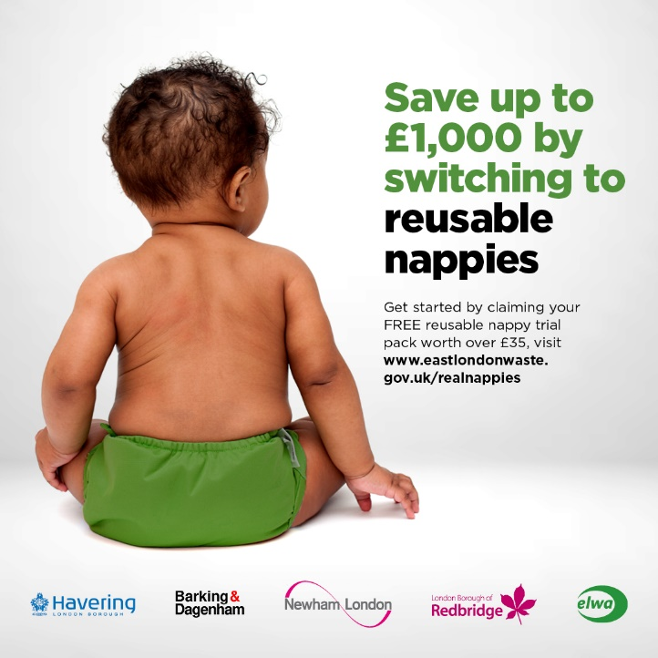

In addition to the impact at home, in North London recycling contamination caused by disposable nappies can cost taxpayers £1.5 million
For residents in Hackney and Waltham Forest you can apply for a £70 voucher towards the costs here: Apply Online - Real Nappies for London.

For more information can visit Real Nappies London or the Women’s Enviromental Network websites for tips and events.

