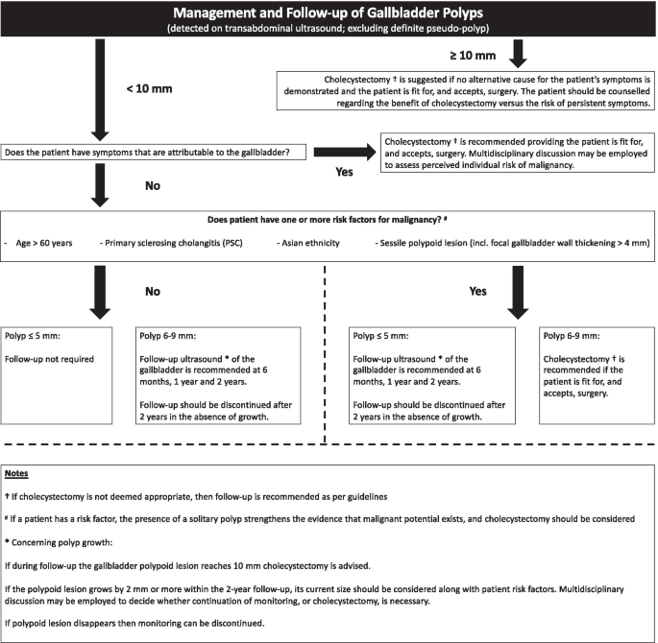

Reference
Foley, K.G., Lahaye, M.J., Thoeni, R.F. et al. Management and follow-up of gallbladder polyps: updated joint guidelines between the ESGAR, EAES, EFISDS and ESGE. Eur Radiol 32, 3358–3368 (2022). https://doi.org/10.1007/s00330-021-08384-w

