Customer User Guide
Apps for Enterprise 0365
[End User Guide]– Office 365
Version v0.1
Raphael Perez
Vivian Durueke
Neil Goodman

Date: 25th September 2023

Contents
1. Welcome to Office 365 Apps For Enterprise 4
2. Statement 4
3. Purpose 5
4. Scope 5
5. N365 Platform Guidelines 5
6. Difference Between Office 2016 and O365 5
7. Customer Step by Step Guide 6
7.1. Start Menu Icons 6
7.2. Task Bar Icons 7
7.3. Desktop Icons 7
7.4. Sign In 8
7.5. Multiple Computers Usage 12
7.6. Outlook 13
7.6.1. Outlook Ribbon Bar 13
7.6.2. Outlook Sidebar Icons 14
7.7. Further Guidance 14
8. Frequently Asked Questions 15
9. Further Training and Information 15

- Welcome to Office 365 Apps for Enterprise
NEL ICB Primary care practices and health centres are in the process of transitioning from MS Office 2016 to Office 365. This strategic shift is poised to bring about significant advantages for our organisation, primarily in terms of enhancing messaging, calendaring, and collaboration capabilities. With this upgraded service, you'll gain seamless access to email and files from virtually any location and device, promoting flexibility and productivity.
The primary objective of this document is to assist you in the setup process, establish clear expectations, and help you become acquainted with the Office 365 environment. Within this guide, you will find step-by-step instructions on how to sign into your Office applications, configure your Outlook for optimal performance, fine-tune your Windows Start Menu and Task Bar settings, and receive answers to common queries.
We hope you find Office 365 a valuable addition to your workflow, and we're excited to guide you through this transition.
Let's embark on this journey of enhanced productivity and collaboration with Office 365—let's get started!
- Statement
NEL ICB, acting on behalf of Primary Care Practices, has procured and are offering access to the Microsoft 365 platform through the national discount agreement known as N365. While we recognise the immense benefits of this platform in supporting our organisation's activities, we also acknowledge the potential risks to security and personal data that come with its use.
The N365 platform is a comprehensive suite of interconnected solutions encompassing various tools and systems designed to enhance productivity and collaboration. These include, but are not limited to:
- Microsoft Office: This includes familiar applications such as Outlook, Word, Excel, PowerPoint, OneNote, and Access. These tools are available both as web-based cloud versions and locally installed applications, now referred to as Apps for Enterprise.
- NHSmail (Exchange Mail): Our secure email service, approved by the Department of Health and Social Care, facilitates the secure electronic exchange of formal messages, including patient-identifiable and sensitive information.
- Microsoft Teams: This collaboration hub combines voice and video conferencing with chat features, instant messaging, and document storage. It also integrates with other applications, enhancing teamwork and communication.

We are committed to maximising the benefits of the N365 platform while prioritising the security and responsible use of these powerful tools and resources.
- Purpose
The objective of this procedure is to furnish staff members with comprehensive details and guidance pertaining to the utilisation of tools and solutions within N365. This procedural framework is designed to mitigate the risks associated with the corporate use of the platform.
- Scope
This procedure is applicable to all personnel within the organisation, encompassing permanent, fixed-term, temporary staff, third-party representatives, sub-contractors, agency workers, volunteers, interns, locums, agents, and individuals engaged with the organisation, both in the UK and overseas. It also extends to staff on secondment, students on placement, external/3rd party support services personnel, and those working in voluntary capacities. The procedure holds relevance within the organisation's premises and beyond, covering situations where employees are utilising or accessing corporate systems while working from home or during travel. Additionally, this procedure pertains to all devices used for accessing N365 data, including smartphones, tablets, other mobile devices, laptops, and desktop computers.
- N365 Platform Guidelines
The N365 platform offers versatile and robust systems and tools that can greatly benefit the organization when employed in a suitable manner.
To ensure proper usage, the organization has established the following guidelines for employees regarding the optimal use of all solutions within the N365 platform, acceptable practices, and actions that are considered unacceptable when accessing or utilising organisational data on this platform.
It's important to note that the N365 solution adopted by the organisation adheres to a set of information security controls that provide an adequate level of safeguarding against data loss or unauthorised access. Furthermore, the operation and utilisation of Microsoft Office 365 align with a suite of national policies and procedures.
- Microsoft Teams Apps Security and Compliance - NHSmail Support
- Policies - NHSmail Support

- Difference Between Office 2016 and O365
Microsoft Office 2016 and Microsoft Office 365 are two distinct productivity suites offered by Microsoft, each with its own set of features and deployment models.
1. Licensing and Deployment:
Office 2016: This is a traditional, perpetual-license version of Microsoft Office. It requires a one-time purchase, typically for a single device or computer. Users get access to applications like Word, Excel, PowerPoint, and Outlook with a one-time payment. However, upgrades to newer versions are not included, and users need to purchase new licenses for newer releases.
Office 365: Office 365, on the other hand, operates on a subscription-based model that is being paid by NEL ICB. NEL ICB pay a monthly or annual fee to access Office applications. This subscription model often includes cloud-based services like OneDrive for Business and Teams. Office 365 users receive continuous updates, including feature enhancements, security patches, and new applications, ensuring they are always using the latest version of Office.
2. Features and Updates:
Office 2016: This suite provides a fixed set of features and functionalities that do not change until the next major version is released. Users can access and use the features available in the version they purchased.
Office 365: Office 365 is a dynamic platform. Subscribers receive regular feature updates, security patches, and improvements, so they always have access to the latest tools and capabilities. This flexibility and continuous improvement are especially valuable for businesses that want to stay up-to-date and leverage the newest features without additional costs.
3. Cloud Integration:
Office 2016: This suite primarily relies on local installations with limited cloud integration. While users can save files locally, they have fewer cloud-based collaboration options.
Office 365: Office 365 is deeply integrated with the cloud. It allows users to store files in the cloud using OneDrive or SharePoint, facilitating real-time collaboration and access to documents from anywhere with an internet connection. This cloud integration enhances productivity and collaboration among users, especially for remote or distributed teams.
4. Collaboration and Communication:
Office 2016: While it provides core office applications, Office 2016 offers fewer tools for real-time collaboration and communication compared to Office 365.
Office 365: Office 365 includes additional tools like Teams and Stream, enabling seamless communication, video conferencing, and collaboration. These tools promote teamwork and productivity, making it an excellent choice for modern workplaces.
In summary, the main differences between Office 2016 and Office 365 revolve around licensing, features, updates, cloud integration, and collaboration tools. Office 2016 is a one-time purchase with a fixed set of features, while Office 365 operates on a subscription model with continuous updates, cloud-based services, and advanced collaboration capabilities. The choice between the two depends on an organization's specific needs and preferences.
- Customer Step by Step Guide
  - Start Menu Icons
Throughout the migration process, the Start Menu icons associated with Office 2016 will be removed. To include the Office 365 icons within the Start Menu, follow these steps:
- Initiate by clicking on "Start" located on the taskbar. You can then locate the desired application either by scrolling through the list or by using the search feature, which can be accessed by typing the name of the application in the search box.
- Upon finding the application, execute a right-click on it. This will open a context menu. From this menu, opt for "Pin to Start."
- If you ever wish to remove an application from the Start Menu, simply choose the "Unpin from Start" option.
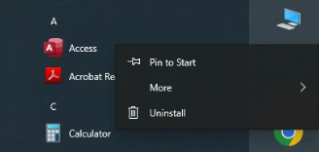
  - Task Bar Icons
Throughout the migration process, the Task Bar icons associated with Office 2016 will be removed. To include the Office 365 icons within the Task Bar, follow these steps:
- Start by clicking on the "Start" button and then scrolling to locate the application you wish to pin. Once found, execute a right-click on the application.
- From the context menu that appears, select "More," and then choose "Pin to taskbar."
- Alternatively, if the application is already open on the desktop, you can right-click the app's icon on the Task Bar, and then select "Pin to taskbar."
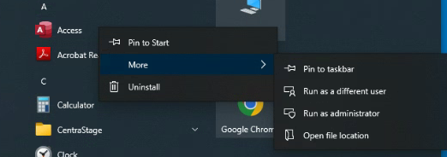
  - Desktop Icons
Throughout the migration process, centrally managed desktop icons for Office 2016 will be replaced with desktop icons for Office 365. Nevertheless, if you have manually added an Office 2016 desktop icon, you will need to manually remove it and copy the new Office 365 icon from the Start Menu.
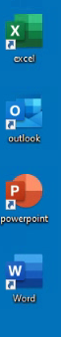
  - Sign In
Word, Excel, PowerPoint, Outlook, or Access, you will be prompted to sign in if you haven't already done so on the computer you're using. Here are the steps to sign into the Office application:
- Select Start, scroll to any Office 365 application (e.g., Word), and click to open it.
- Open Word.
- On the "Sign in to set up Office" screen, click "Sign in."
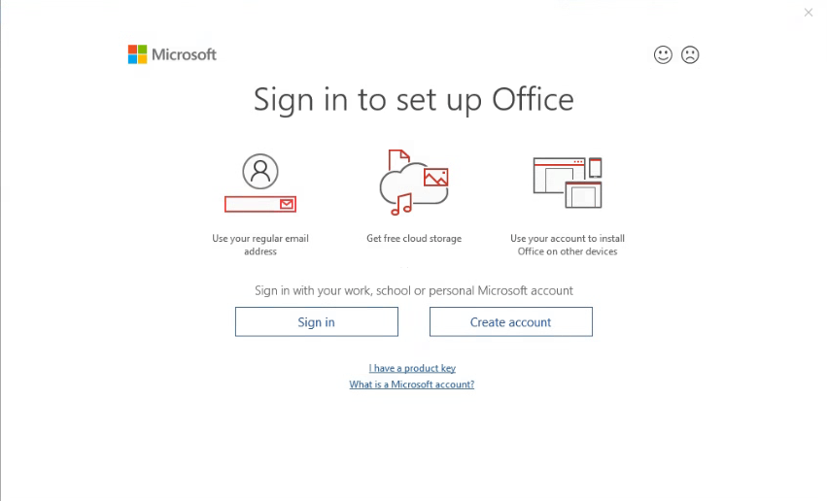
- On the "Activate Office" screen, enter your @NHS.NET email address and click "Next."
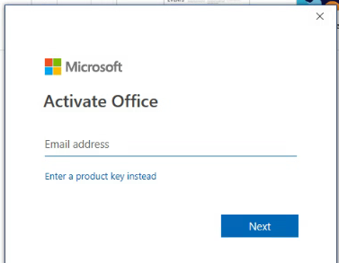
- On the NHS login screen, enter your password and click "Sign in."
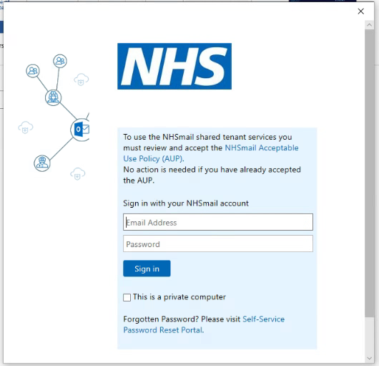
- If prompted, follow the Multi-Factor Authentication (MFA) security check.
- On the "Stay signed in to all your apps" screen, click "Ok."
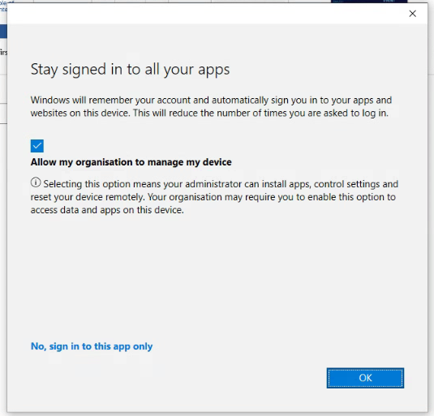
- On the "You're all set!" screen, click "Done."
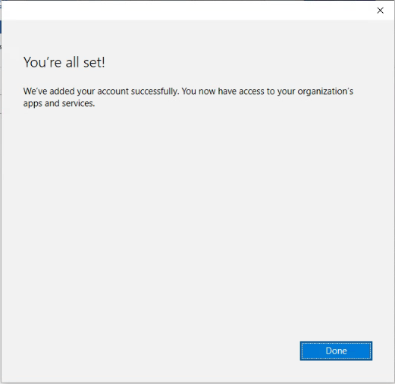
- You will see your user details at the top of the screen.
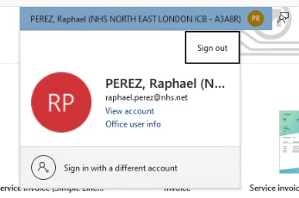
- Close Word.

This process ensures that you are signed into your Office 365 account for a seamless experience when using Office applications.

  - Multiple Computers Usage
Each user account grants access on a maximum of 5 devices. To view the list of devices currently associated with your account, please follow these steps:
- Visit https://portal.office.com/account and log in using your @nhs.net email address.
- Click on "View apps & devices."
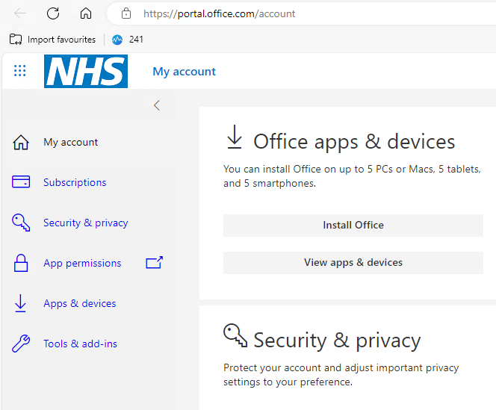
- Under the "Office" section, expand the "Devices" tab.
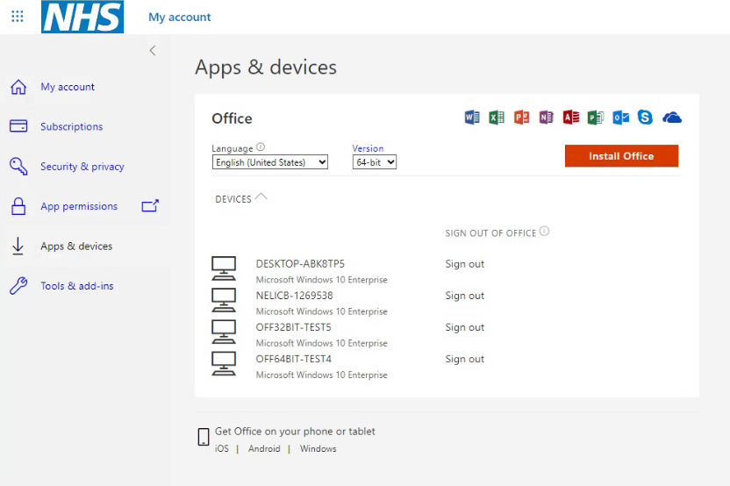
- To sign out from a device, simply click "Sign out." Confirm your action on the subsequent screen by clicking "Sign out."
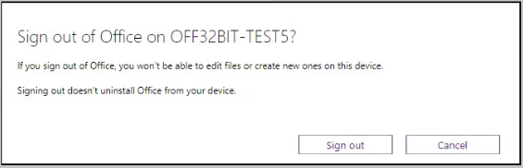
  - Outlook
Following a successful migration and sign into of Office, essential elements such as emails, signatures, and other end-user customizations will remain unchanged, preserving your previous settings.
However, there may be certain modifications that some users may find less favourable. These adjustments are elaborated upon in the subsequent sections, along with detailed step-by-step instructions on how to make these changes as needed.
    - Outlook Ribbon Bar
When you launch the Outlook 365 application, you might notice that the Ribbon Bar is initially in Simplified mode. To switch from Simplified mode to the full mode, please follow these steps:
- Locate the "Switch Ribbon" button positioned at the bottom right corner of the ribbon.
- Click on this button to toggle to the full mode.
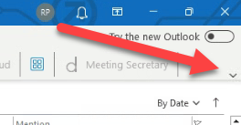
    - Outlook Sidebar Icons
To return the icons (Mail, Calendar, Tasks, etc.) in your Outlook 365 application to their original position at the bottom of the screen, please follow these steps:
- Click on "File" -> "Options."
- In the "Outlook Options" window, click on "Advanced."
- Uncheck the "Show apps in Outlook" box.
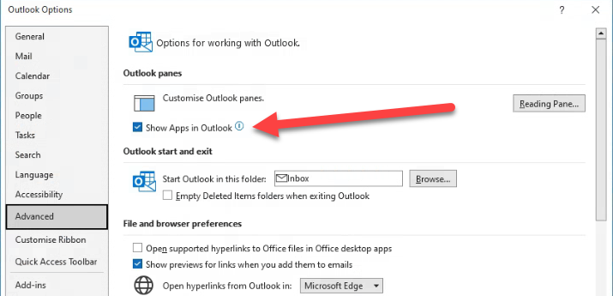
- Click "OK."
- When prompted to restart, click "OK."
- Close and then reopen Outlook to see the icons now located at the bottom of the screen.
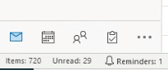
  - Further Guidance
For additional Office 365 guidance and resources, the NHS offers training and knowledge materials. To access these valuable resources, please visit the following link: Office 365 – NHSmail Support

- Frequently Asked Questions
Q. What is Microsoft Office 365?
A. Microsoft Office 365 is a subscription-based suite of office software and services hosted in the cloud. It provides access to a range of services and software built around the Microsoft Office platform.

Q. What are the primary benefits of Office 365?
A. Office 365, being a cloud-based service, relieves primary care practices from the burdens of maintaining servers, performing updates, and associated operational costs. Moreover, Office 365 enables end users to access their contacts, emails, calendars, and documents from virtually anywhere and on various devices. Migrating to this cloud-based system expands the functionality available to GP practice staff (e.g., larger mailbox and online file storage) while significantly reducing operational expenses.

Q. Is there a maximum number of computers my account can be used on/activated?
A. Yes, you can activate your account on a maximum of five computers.

Q. How can temporary staff like Locums, Pharmacists, and Students access Microsoft Office?
A. The program has set up generic email accounts with the assigned licenses. Practice Managers have been trained to use these accounts to activate Office and access Office applications for temporary staff.

Q. Is there an alternative method for other temporary staff who only need basic computer access?
A. Practice Managers can log in with standard accounts, and staff members can use Office online, like Outlook Web App (OWA) for email if needed.

Q. How do I use Office 365 for email and calendars?
A. You can access your email account in several ways:
  - Web browser: Outlook Web App (OWA) allows you to access your mailbox through a web browser from any computer with an internet connection. It supports reading and sending emails, organizing contacts, creating tasks, and managing your calendar. OWA is compatible with most web browsers, including Microsoft Edge, Chrome, and others on Windows and Apple operating systems.
  - Desktop: You can also access Office 365 using the desktop version of Microsoft Outlook, in addition to Outlook Web App.
  - Mobile phones and tablets: Office 365 is compatible with various mobile phones and tablets. You can configure your mobile device to access email, calendar, contacts, and tasks. It supports Apple iOS, Google Android, and Windows Phone operating systems.

Note: Users who move between locations that do not fall under the NELICB umbrella may not be eligible for licensing, in this scenario, you may not be able to access Office 365 resources. If they are required, speak to the Practice Manager to sign into Office 365 with one of the available Generic Accounts.
- Further Training and Information
To facilitate continuous learning and support for Office 365 users, the following links are available that offer a comprehensive range of resources and training materials. Whether you want to master advanced features, enhance collaboration techniques, or strengthen your security awareness, our resources provide valuable insights.
We encourage you to explore these materials at your convenience. We aim to empower you with the knowledge and skills needed to maximise your productivity within the Office 365 environment.
Guidance – NHSmail Support
Microsoft Office Training Center
NHS Roadmap
Secure file sharing using office 365
Data Retention and Information Management Policy – Office 365
Change your password – NHSmail Support
Forwarding emails – NHSmail Support
Sending and receiving emails – NHSmail Support
Creating an email signature – NHSmail Support
Microsoft 365 basics video training - Microsoft Support
Microsoft 365 Training

