 | Tower Hamlets Community Learning Disability Service | City and Hackney Integrated Learning Disability Service | Newham Health Team for Adults with Learning Disabilities | Learning Disabilities Specialist Community Healthcare (Bedfordshire)
Images | 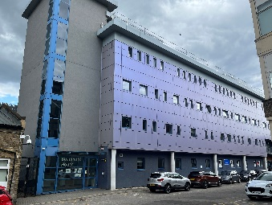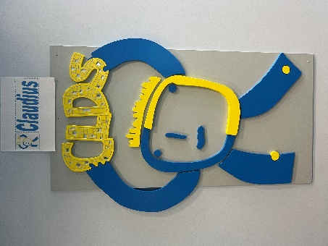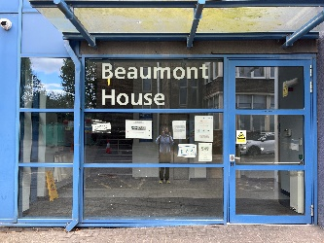
About our service | The service is a team of health staff and social workers who assess and support adults who live in Tower Hamlets with learning disabilities, their families and carers.  We can meet at your home, college, or day service.  We help people to be as independent as possible by offering advice, therapy, and practical support. We can direct you to other services that can also help you.  Our team is made up of health professionals, social workers, managers, and administrators.  You will meet with two members of the team to help us do a single assessment, to decide if you have a learning disability and what help you need. The meeting can be at our offices or at home, at your day service, college or school, and will take place within 28 days of your referral. | We are an integrated multi-agency, multi-disciplinary team, providing specialist health and social care support to adults with Learning Disabilities, who are residents of the London Borough of Hackney and the City of London and have a GP in the area.  The service is jointly commissioned by Hackney Council and the City and Hackney CCG.  The service is made up of specialist social workers, psychiatrists, psychologists, physiotherapists, occupational therapist, speech and language therapists, and specialist community nurses. | Newham Health Team for Adults with Learning Disabilities offers a single access point to a specialist multi-disciplinary service comprising a core staff establishment of psychiatrists, clinical psychologists, occupational therapists, speech and language therapists, physiotherapists, art therapists, community nursing (RNLD), supported by an operational manager, Continuing Care Coordinators, and admin staff.  We work with people who have significant or severe levels of learning disabilities with additional communication, sensory, and mobility problems that require support and intervention from specialist health professionals with specific expertise and experience of this client group. The work is always at the client’s pace and so sessions may take longer than in mainstream services. We work with a variety of providers both specialists and mainstream including GPs, social services, mental health services, employment, education, and the voluntary sector. | Learning disabilities services in Bedfordshire and Luton are provided by services for People with a Learning Disability (SPLD).  SPLD has a Specialist Community Healthcare Team, Intensive Support Team (IST) and the Coppice Inpatient Service.  Community multi-disciplinary healthcare team for people with a learning disability.
How to contact us and make a referral? | You can contact us yourself or ask your GP, social worker, health or education worker, relative, carer or support worker to refer you to the Community Learning Disabilities Service.  Professionals can download a referral form from the forms and leaflets section and email to CLDS.  We will see you within 28 days of referral.  If you need help more quickly or are being hurt, neglected, or abused we can see you within 48 hours. | Making Contact  If you or someone you know has a learning disability and would like to refer to the team please make contact with us using our contact details on this webpage. | We accept referrals by social workers/ occupational therapists/district nurses/GP’s/carers/self-referrals/schools and colleges  - Referral form  - NHLD Referral Guidance  - Team Leaflet October 2018  - Referral form for GP’s
Who do we support? | We help adults (persons aged 18 or over) with learning disabilities who live in Tower Hamlets. | What is a learning disability?  A learning disability is a significant, lifelong condition that starts before adulthood and affects development. People with a learning disability will need help to understand information, learn skills, and manage their life independently.  Following an assessment, the service will support an individual and their family where there is evidence that the individual has a significant intellectual impairment (IQ less than 70) and impaired adaptive functioning, and difficulty with practical activities and social skills.  Learning difficulty  A learning difficulty is not the same thing as a learning disability. For example, a learning difficulty is any learning or emotional problem that affects a person’s ability to learn and get along with others. Specific learning difficulties are dyscalculia, dysgraphia, dyslexia, and dyspraxia. | We accept referrals for adults:  - With severe to profound learning disabilities who have an unmet health need.  - Who are aged 18 or over  - Who have a GP in Newham  We sometimes work with people with mild to moderate learning disabilities with an unmet health need but only if they are unable to access mainstream services even with reasonable adjustments.  We do not accept referrals for:  - - Learning Disability diagnosis without a related unmet health need  - - Adults with specific learning difficulties only e.g., dyslexia  - - Diagnosis of High Functioning Autism / Asperger’s Syndrome  - - People with mild/moderate learning disabilities who are able to access mainstream service with reasonable adjustments  - - Adults with an acquired brain damage/ injury in adulthood (i.e., an injury NOT acquired before the age of 18) | The team provide specialist healthcare services for people with a learning disability
What can we help with and how do we help? | We can help you:  - Live a health independent and safe life  - Have a place to live  - Understand money  - Have a job or support with training or employment  - Make decisions and choices  - Have positive relationships with friends and family  - Go out have fun and meet new people  - Get around and be respected in the community  - Prepare for a hospital stay or visit to your GP  - If you are sad, angry, or having a difficult time  We also support parents or carers of someone with a learning disability in their caring role and to have a better life. | The purpose of our service is to:  Assess and meet the needs of people with an eligible learning disability, including young people transitioning into adulthood.  Support positive access to and responses from mainstream services.  Enable all services to provide effective person-centred support to people with learning disabilities.  Provide direct specialist clinical, therapeutic and social care support for people with a complex learning disability and/or mental health needs | Newham Health Team for Adults with Learning Disabilities (NHLD) offers a single access point to a specialist multi-disciplinary service comprising a core staff establishment of Psychiatrists, Clinical Psychologists, Occupational Therapists, Speech and Language Therapists, Physiotherapists, Art Therapist, Community Nursing (RNLD), supported by an operational manager, Continuing Care Coordinators and admin staff. In addition to the core team, two Primary Care Nursing posts have been commissioned to work with GPs to improve annual health check compliance and health facilitation for LD clients.  We work with people who have significant or severe levels of learning disabilities with additional communication, sensory and mobility problems that require support and intervention from specialist health professionals with specific expertise and experience of this client group. The work is always at the client's pace and so sessions may take longer than in mainstream services. We work with a variety of providers both specialist and mainstream including GPs, social services, mental health services, employment, education and the voluntary sector.  NHLD is a specialist multi-disciplinary team comprising of:  - Art Therapy  - Clinical Psychology  - Learning Disability Community Nursing, including an Access to Acute Liaison Nurse  - Occupational Therapy  - Physiotherapy  - Psychiatry  - Speech and Language Therapy  NHLD use person-centred approaches that may involve:  - Working with people individually or in groups  - Adapting/developing clinical interventions to make them accessible to people with learning disabilities  - Working with families and carers  - Adapting clients’ environments  - Working in a person’s home or at our base or local community centres / facilities.  The service is based at 29 Romford Road, London E15 4LY but can be delivered wherever service is needed in the community. This includes at the person’s home, school, GP surgery, leisure centres etc. | When it is not possible for people to access mainstream health services, our specialist healthcare team will intervene and either facilitate access with some extra support or if required, we will provide some clinical interventions which are more tailored to meet the needs of someone who has a learning disability and additional complex issues.  Our clinical interventions include:  Psychology – adapted therapies and Positive Behaviour Support planning  Art Therapies – Music, Art, Dance and Movement, Drama therapies.  Occupational Therapy- Sensory Processing /Integration assessments, Skills for daily living, specialist equipment.  Speech and Language Therapy – support with communication methods and dysphagia assessments  Sensory Impairment – Nursing support to access sight and hearing assessments  Health Facilitation – Nursing support to access primary care and general acute care settings  Physiotherapy – support with changes in mobility and postural care  Psychiatry – medical input and support with mental health conditions, complex behavioural issues, dementia within the LD population and monitoring of any medications prescribed.
Forms and leaflets | Referral form  How to find us |  | Referral form  NHLD Referral Guidance  Team Leaflet October 2018  Referral form for GP’s | Referral form
Contact information | Address  Beaumont House Mile End Hospital,  Bancroft Road,  London  E1 4DG  United Kingdom  Email address  elft.thclds@nhs.net  Opening hours  9am-5pm, Monday to Friday  Please note we do not offer a rapid/crisis response service within this team  Telephone number  020 7771 5500 | Address  Hackney Service Centre  1 Hillman Street  London  E8 1DY  United Kingdom  Email address  learningdisabilitiesduty@hackney.gov.uk  Opening hours  09:00 - 17:00  Monday to Friday  For out of hours / emergency (after 17:00 Monday to Friday, Weekends, and Bank Holidays) please call 0208 356 2300  Telephone number  020 8356 7444 | Address  29 Romford Road, Stratford  London  E15 4LY  United Kingdom  Email address  elt-tr.newhamLD@nhs.net  Opening hours  9am and 5pm, Monday to Friday.  Please note we do not offer a rapid/crisis response service within this team.  Telephone number  0207 059 6600 | Address  Clinical Resource Centre  Milton Road  Clapham, Bedfordshire  MK41 6AT  United Kingdom  Email address  Elt-tr.spldreferrals@nhs.net  Telephone number  01234 310589

