Sacubitril valsartan (Entresto®) for patients with symptomatic chronic heart failure
North East and North Central London Position statement
Version 2 revised January 2019 (Version 1 June 2016)

Summary
Sacubitril Valsartan (Entresto®) is licensed for the treatment of symptomatic chronic heart failure in adults with reduced ejection fraction and it can be used in North East and North Central London in line with NICE Technology Appraisal (TA) 388 (NICE TA 388).

- Initiation: Initiation of sacubitril valsartan (Entresto®) is to be undertaken under the direction of a consultant with an established expertise in managing patients with heart failure and access to a multidisciplinary team.
- Initiation: Individual secondary care units may wish to delegate the initiation of sacubitril valsartan to community heart failure teams provided the team has a clinical lead consultant cardiologist and specialist in heart failure who has directly reviewed or had an MDT discussion regarding the patient for treatment options in line with NICE guidance. Community teams should prospectively declare their competence in writing to be able to prescribe sacubitril valsartan or else refer the patient to the consultant to initiate sacubitril valsartan
(Sacubitril valsartan (Entresto ®) should not be initiated by a primary care clinician who is not a part of the heart failure multidisciplinary team.)
- Continuation: Following titration to optimum tolerated dose, sacubitril valsartan (Entresto®) can be continued in primary care in line with the Factsheet: Sacubitril valsartan (Entresto®) for chronic heart failure with reduced ejection fraction.
Useful Information

- Key interactions: ACE-inhibitor (ACEi) and/or angiotensin-II receptor blocker (ARBs) should not be used concurrently with sacubitril valsartan (Entresto®). Patients require a minimum of 36 hour wash out from concomitant ACEi and sacubitril valsartan. Review patients medication history and discontinue ACEi/ ARBs.
- Patient information leaflet (Appendix 4) can be provided by the initiating clinician.
Aim
To support health service in North East and North central London to use sacubitril valsartan (Entresto ®) in line with NICE Technology Appraisal NICE TA 388 by:
- Managing patients with chronic heart failure with reduced ejection fraction (HFrEF) in line with NICE guidelines (NG 106) (new 2019) Chronic heart failure in adults: diagnosis and management (September 2018)
- Initiating sacubitril valsartan, in a safe and controlled manner where indicated for treatment of chronic heart failure with reduced ejection fraction HFrEF.
- Transferring patients who are established on therapy with sacubitril valsartan into primary care with appropriate guidance and support in terms of management and monitoring of the drug and disease.
- Establishing and implementing treatment pathways for initiation, maintenance and monitoring of sacubitril valsartan for chronic HFrEF.

Current pharmacological therapy in treatment of symptomatic chronic heart failure
Pharmacological treatment in patients with HFrEF include as a first line:
- Selective beta-adrenergic receptor antagonists (BB) and an angiotensin converting enzyme inhibitors (ACEi) or angiotensin II receptor blocker (ARB) where ACEi are not tolerated. These are titrated to maximum tolerated evidence based doses (see Appendix 1).
- If patients remain symptomatic and left ventricular ejection fraction (LVEF) <35%, a mineralocorticoid receptor antagonist (MRA) should be added and titrated up to maximum tolerated licensed dose (see Appendix 1).
- Additional agents in those remaining symptomatic are limited. Options include addition of hydralazine and nitrates, digoxin, ivabradine depending on specific patient characteristics.

Other interventions in the treatment of chronic symptomatic heart failure:
- Use of implantable cardioverter defibrillators (ICD) and cardiac resynchronisation therapy (CRT) should be guided as per NICE technology appraisal TA 314 in those with heart failure with a LVEF <35% and additional criteria as summarised in Appendix 2.
- Valve disease, revascularisation and correction of atrial fibrillation or other tachyarrhythmias or withdrawal of cardiotoxic drugs are decisions to be undertaken by the supervising heart failure team prior to being considered for sacubitril valsartan.

Sacubitril valsartan (Entresto®) is an option for patients who:
- Meet criteria as defined in NICE TA 388 and NG106 where sacubitril valsartan (Entresto®) is an option in those with symptomatic chronic HFrEF who remain symptomatic (NYHA II or above) taking a stable dose of ACEi or ARB and LVEF is <35% .
- Receive the current optimum therapy (as listed above: BB, ACEi or ARB and a MRA titrated to maximum tolerated evidence based doses) a stable period of three months is required without any other pharmacotherapy drug or dose amendment (or withdrawal in the case of cardiotoxic drugs) or other non-pharmacological interventions prior to checking response and changes in ejection fraction. Thereafter, LVEF is to be <35% on echocardiogram or equivalent function on alternative imaging.
- For patients on longstanding therapy, a recent (within 6 months) LVEF is required to be <35%.
- Natriuretic peptides can be used (new 2019) to select patients (as was undertaken in the PARADIGM study) to identify patients who will benefit from treatment with sacubitril valsartan (BNP > 150pg/ml (NT-proBNP>600pg/ml) or if hospitalisation for HF within the last 12 months BNP>100pg/ml (NT-proBNP>400pg/ml). To date there is no large outcome data to support its use in those with natriuretic peptide below those stated.
- A summary of the use of sacubitril valsartan in clinical practice (NG 106) is provided in Appendix 3.

Initiation of sacubitril valsartan
- Initiation of sacubitril valsartan is to be undertaken under the direction of a consultant with an established expertise in managing patients with heart failure and access to a multidisciplinary team. Individual secondary care units may wish to delegate the initiation of sacubitril valsartan to community heart failure teams provided the team has a clinical lead consultant cardiologist and specialist in heart failure who has directly reviewed or had an MDT discussion regarding the patient for treatment options in line with NICE guidance. Community teams should prospectively declare their competence in writing to be able to prescribe sacubitril valsartan or else refer the patient to the consultant to initiate sacubitril valsartan (New Jan 2019).
- At initiation, patients must be non-pregnant, have systolic BP > 100 mmHg, serum potassium <5.4 mmol/l, eGFR>15 ml/min/1.73 m2 (see below for further details regarding dosing in renal impairment) without severe hepatic impairment, biliary cirrhosis and cholestasis. Other exclusion criteria are on the summary of product characteristics.
- For those taking an ACEi, a wash out period of 36 to 48 hours is required, the exact duration determined by patient’s current therapy and clinical characteristics. This is to reduce increased risk of severe angioedema with concomitant ACEi and sacubitril use.
- For those taking an ARB, start sacubitril valsartan at next scheduled dose of ARB.
- Initiation and titration to stable maintenance dose should be undertaken by the initiating team, it is estimated this may take up to 3 months in selected patients as although tolerability was similar to ACEi in the PARADIGM trial, this was undertaken in highly selected patients that the group felt were relatively more stable than those generally seen in clinic.
- Starting dose and titration in those on established ACEi or ARB (after ceasing ACEi or ARB):
  - Initiate 49mg/51mg sacubitril valsartan twice daily for 2-4 weeks then
  - Increase to 97mg/103mg sacubitril valsartan twice daily thereafter
- Starting dose in those patients not taking an ACEi or ARB, or taking low doses:
  - Initiate 24mg/26mg sacubitril valsartan twice daily for 3-4 weeks then
  - Increase to 49mg/51mg sacubitril valsartan twice daily for 3-4 weeks then
  - Increase to 97mg/103mg sacubitril valsartan twice daily thereafter
- If patients experience tolerability issues (systolic blood pressure ≤95 mmHg, symptomatic hypotension, hyperkalaemia, renal dysfunction), adjustment of concomitant medicinal products, temporary down–titration or discontinuation is recommended). NOTE: Full details of side effects and monitoring parameters can be found in the summary of product characteristics available at www.medicines.org.uk
- It is encouraged to follow up outcomes in patients newly started on sacubitril valsartan. Depending on resources available this could be undertaken locally or collectively using a registry data base ideally supported by academic health science network.

Dosing in renal impairment (new Jan 2019)
- No dose adjustment is required in patients with mild eGFR (60-90ml/min/1.73m2). A starting dose of 24mg/26mg twice daily should be considered in patients with moderate renal impairment (eGFR 30-60 ml/min/1.73m2). There is limited clinical experience in patients with severe renal impairment (eGFR 15-30 ml/min/1.73m2) and as such should be used with caution and a starting dose of 24mg/26mg twice daily is recommended. There is no experience in patients with end-stage renal disease and use of sacubitril valsartan is not recommended.

Maintenance and transfer to primary care
- Following titration to optimum tolerated dose, maintenance will be continued in primary care.
- Ongoing monitoring of urea and electrolytes (as in NICE NG 106) every 6 months should be sufficient to monitor renal effects of sacubitril valsartan.
- A factsheet have been prepared to support primary care practitioners in prescribing sacubitril valsartan and will facilitate a seamless transition to primary care.
- CCG commissioned community heart failure services would be expected to play a key role in facilitating an integrated care approach, in accordance with local guidelines.

Patient support and information
- A patient information leaflet (Appendix 4) can be offered to patients to support treatment initiation of sacubitril valsartan therapy. Additionally, it will detail instructions to avoid concomitant ACEi and confirm advice for patients during sick days.
- There should be an amnesty to encourage patients to bring all ACEi and ARB to clinic/pharmacy for destruction to prevent inadvertent consumption while taking sacubitril valsartan
- Novartis has developed a wallet sized cards for patients to carry that can be shown to health care professionals to alert them to the interactions of sacubitril valsartan and ACEi.

References
- Chronic heart failure in adults: Diagnosis and management. NICE guideline 106 (September 2018).
- Ivabradine for treating chronic heart failure. NICE technology appraisal guidance no. 267 (2012).
- Implantable cardioverter defibrillators and cardiac resynchronisation therapy for arrhythmias and heart failure. NICE technology appraisal guidance no. 314 (2014).
- Insertion and use of implantable pulmonary artery pressure monitors in chronic heart failure. NICE interventional procedure guidance 463 (2013).
- Sacubitril valsartan for treating symptomatic chronic heart failure with reduced ejection fraction. NICE technology appraisal guidance no. 388 (2016).
- Ponikowski P, Voors AA, Anker SD et al. 2016 ESC Guidelines for the diagnosis and treatment of acute and chronic heart failure, available at doi:10.1093/eurheartj/ehw128.
- McMurray JJV, Packer M, Desai AS et al. Angiotensin-neprilysin inhibition versus enalapril in heart failure. N Eng J Med 2014; 371:993-1005.

[(Contributors to Version 1 of the Position Paper (June 2016) B Amadasun, Dr H Amer, S Antoniou, A Barron, Dr A Bakhai*,R Carter, Dr C Davis, R Enti, F Fahad, P Gouldstone, Dr S Hardman, Y Korimbux, Dr M Thomas, Dr C Whelan, Dr S Woldman, P Wright*, Dr S Velmurugan (*Initiating authors)]

Appendix 1: Optimum doses of selected pharmacotherapy used in heart failure
(Adapted from ESC guidance 2016 and UK license)

 | Starting dose | Target dose |  |  | Starting dose | Target dose
ACEi |  |  |  | ARB
Captopril | 6.25mg bd - tds | 50mg tds |  | Candesartan | 4mg od | 32mg od
Enalapril | 2.5mg bd | 20mg bd |  | Losartan | 25mg od | 150mg od
Lisinopril | 2.5-5mg od | 35mg od |  | Valsartan | 40mg bd | 160mg bd
Ramipril | 2.5mg od | 10mg od (preferably in divided doses)
 | Starting dose | Target dose |  |  | Starting dose | Target dose
MRA |  |  |  | BB
Eplerenone | 25mg od | 50mg od |  | Bisoprolol | 1.25mg od | 10mg od
Spironolactone | 25mg od | 50mg od |  | Carvidolol | 3.125mg bd | 25mg bd
 |  |  |  | Nebivolol | 1.25mg od | 10mg od

Appendix 2: Current device recommendations (summary table)

Taken from NICE TA 314

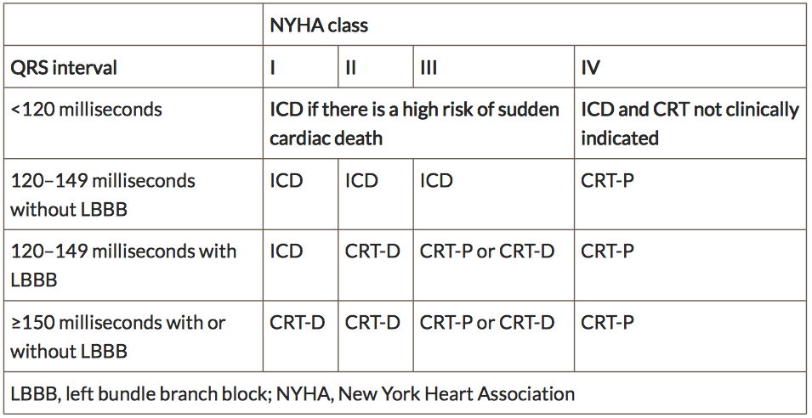

Appendix 3: Treatment algorithm for Heart failure – NICE NG 106

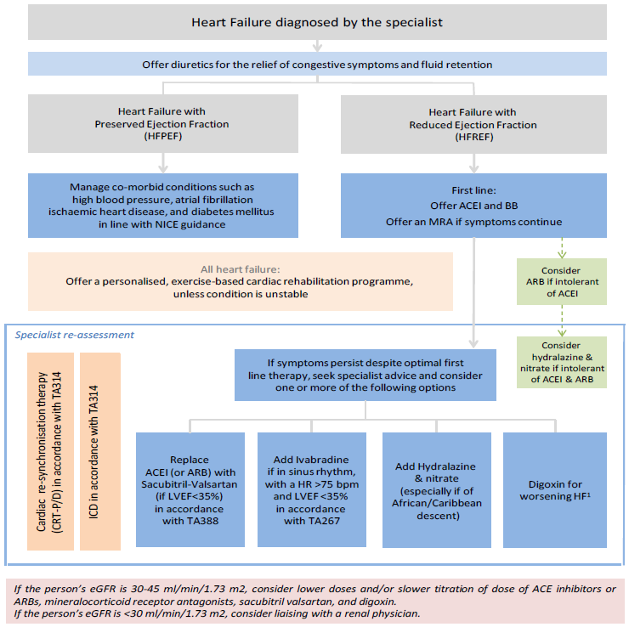

Appendix 4

Patient information for those starting on sacubitril valsartan (Entresto®)

What is sacubitril valsartan (Entresto®)?
Your clinician has recommended a new treatment for you to reduce the risk of death and hospitalisation in people with certain types of long-lasting (chronic) heart failure. This treatment is used with other heart failure therapies and will replace an ACE inhibitor (such as ramipril or lisinopril) or an ARB therapy (such as candesartan or losartan). The generic name for the drug is sacubitril valsartan while the branded name is Entresto®, for the purpose of this leaflet the brand name will be used throughout.

Are there side effects of treatment?
Like all medicines, Entresto® can cause side effects although not everybody gets them. In a large clinical trial comparing Entresto® to an ACE inhibitor, patients in both groups suffered in equal numbers to common side effects as listed below (this is not a complete list but highlights the main side effects):

Very common (may affect more than 1 in 10 people):
- low blood pressure (dizziness, light-headedness)
- high level of potassium in the blood (shown in a blood test)
- decreased kidney function (kidney impairment)

Common (may affect up to 1 in 10 people):
- cough - feeling sick (nausea) - headache
- dizziness, fainting - spinning sensation - tiredness, weakness
- diarrhoea - inflammation of the lining of the stomach (stomach pain, nausea)
- (acute) kidney failure (severe kidney disorder)

Uncommon (may affect up to 1 in 100 people):
- allergic reaction with rash and itching
- dizziness when switching from sitting to standing position

May be serious.
- Stop taking Entresto® and seek immediate medical attention if you notice swelling of the face, lips, tongue and/or throat, which may cause difficulties in breathing or swallowing. These may be signs of angioedema (an uncommon side effect which may affect up to 1 in 100 people).
- British-Caribbean, British-African or African, Caribbean and take Entresto® may have a higher risk of having angioedema than people who are not Black and take Entresto®, although the risk still remains relatively small affecting up to 1 in 100 people.

There may be a theoretical increased risk of Alzheimer’s disease. There is on‐going research into this area. In the most recent trail this was not seen but please be aware it was a short trail and further research needs to take place to confirm whether or not there is a risk.

How do I take Entresto®?
The starting dose will be determined by a number of factors but you will usually start on a lower dose which will be adjusted depending on how you respond to treatment until the best dose is found for you. The tablet is taken twice a day (once in the morning and again in the evening). It should be taken with a small glass of water and can be taken with or without food. It is advisable to take your medicine at the same time each day. Should you forget to take a dose, you should simply take the next one at the scheduled time. Do not take a double dose to make up for a forgotten tablet.

What if I am pregnant or planning to have a family?
You must inform your doctor if you think that you are (or might become) pregnant. Your doctor will normally advise you to stop taking this medicine before you become pregnant or as soon as you know you are pregnant, and will advise you to take another medicine instead of Entresto®. This medicine is not recommended in during pregnancy as it may cause serious harm to your baby. Additionally Entresto® is not recommended for mothers who are breastfeeding. Tell your doctor if you are breastfeeding or about to start breastfeeding.

Can I drive and/or use machinery while taking Entresto®
Before you drive a vehicle, use tools or operate machines, or carry out other activities that require concentration, make sure you know how Entresto® affects you. If you feel dizzy or very tired while taking this medicine, do not drive a vehicle, cycle or use any tools or machines.

Other important information
It is important that you DO NOT take an ACE inhibitor or an ARB at the same time as Entresto®. Your doctor will advise you to start Entresto® at least 36 hours before or after you take an ACE inhibitor medicine. Talk with your doctor or pharmacist before taking Entresto® if you are not sure if you take an ACE inhibitor medicine. It is advisable that you take any remaining ACE inhibitors or ARBs to your chemist for destruction if you are starting Entresto®, if you are unsure then ask your doctor or pharmacist and they can point out which ones these are.

Should I stop my tablets if I’m suffering from diarrhoea and/or sickness during treatment?
Should you suffer from a brief bout of diarrhoea or sickness (less than 2 days), it is recommended from your heart failure team to keep taking your medication. Should you become dehydrated or the illness lasts longer than 2 days without improving, you should seek advice from your heart failure team or GP on whether to continue taking this and other heart failure medication. Depending on your symptoms a blood test to check your kidney function may be requested prior to making a decision.

Patient alert card
The company have developed a “patient alert card” that will be given to you with your first prescription and should be kept with you at all times. The card alerts other health care professionals about the serious interaction between Entresto® and ACE inhibitors and a reminder that it should not be prescribed with either ACEi or ARBs.

If you have any other questions about starting Entresto®, please be sure to ask your doctor prior to starting treatment.

