**Patient Safety Issue**

**Re: Home Enteral tube feeds for Adults & Infants Fresenius Kabi**

Fresenius Kabi (FK) is a nutritional homecare health company that has been contracted to supply home Enteral tube feeds for all adults and children including infants in Newham, Tower Hamlets.

They have a process in place to ensure they request a prescription in sufficient time for patients on their list, who require feeds and will contact your surgery directly for a prescription.

We have now had several concerns raised by FK Homecare, hospital and community health dietitians who manage and support the most vulnerable patients; who are partially or fully dependent on their tube feeds to meet their nutrition and hydration needs.

It has been highlighted that practices often prioritise requests from healthcare professionals such as the dietitians over the pharmacy / service team at FK. When FK are unable to source the prescription, this leads to FK contacting the dieticians to escalate and contact the respective practices, in between clinics on an already overstretched service.

We are working closely with the FK Service Team to ensure that the surgery they call are aware of who they are and understand the importance of the patient receiving their feed on time.

Prescription requests are made two weeks before patient delivery is due and FK contact the patient prior to check the feed is still required. For the timeous delivery of feeds to patients, a prescription needs to be issued and sent on time to FK. This ensures that the delivery is made to the patient and they are not left without feeds.

Where this does not happen, a prescription, as a last resort is sent to the patient’s local pharmacy. However, this is not ideal and often there are concerns around stock availability, delivery and patient access as many are unable to physically go to their local pharmacy. This does not always resolve the issue and the patient can still be left without feeds.

Current Issues and Risks:

* Surgeries not actioning FK Homecare Pharmacy/ Service Team requests
* Having to rely on Healthcare professionals (HCP)/dieticians making requests on behalf of patient and FK
* Affects dieticians and Community Health Teams clinics
* Delays in tube feeds being delivered
* Distress to patients/carers/parents of late / absent feeds
* Possible patient hospitalisation/increased risk of re-admission, presenting at A&E
* Risk of dehydration
* Worsening of malnutrition
* Increased costs in emergency supplies made and duplication of prescriptions

**Actions to be taken immediately:**

* Inform and train reception/admin team/prescription clerk/pharmacists in practices and raise awareness amongst all staff of incoming phone calls and emails from FK requesting patient’s prescription for their enteral tube feed.
* Be familiar with the email FK Homecare use to send prescription request: [fkl.portalreports@nhs.net](mailto:fkl.portalreports@nhs.net) (see template email below for reference)
* These requests should be referred to the pharmacist / prescriber to action immediately and not left in inbox.
* Add on EMIS system an alert/ pop-up message for patients identified who require enteral tube feeds and state “Use company FK/Calea” or other examples of alerts that could be used include: “ONS/enteral nutrition” prescription to go to … post code of supplier”, Nominated pharmacy of other feed is ….” See examples of details below.
* If prescriber is not familiar searching for or switching EPS nomination please refer to following help guide for EMIS: <http://www.digitalhealthforum.co.uk/nominations-in-eps/> this provides a step- by -step guide.
* Refer to the attached information document in this email directly from FK (**Important information regarding Electronic Prescription Service (EPS) Implementation at Fresenius-Kabi)**
* Action requests from FK in time
* Include the stepwise guide below in new staff induction to reduce the risk of delays during absence and staff turnover.
* Discuss in your weekly practice meeting and ensure ALL staff are aware of FK Homecare and importance of prescription being sent correctly.

|  |
| --- |
| **Step- by- step process of how to send electronic prescriptions via EPS to FK Homecare:** |
| 1. Select feed from Medication list 2. Click on 'Issue' 3. Click on 'EPS nomination' 4. Under “Would you like to choose One-Off Pharmacy nomination? Click 'Find' and type in **ZE1 0AA**   Please note that the NHS has given a “dummy” Post Code to Distance Selling Pharmacies.  Then Select the Pharmacy with the details below:  **Organisation Name**: **Calea**  **Organisation Code:** FVG64  **Organisation Address:** Cestrian Court, Runcorn, Cheshire, WA7 1NT   1. Complete prescription as normal 2. **Ensure you revert back to the nominated local pharmacy for all other medication patient has on their list and send to usual nominated local community pharmacy when needed. Patient can only have one nominated pharmacy at a time.** 3. Process needs to be repeated when ONS/enteral feed due (e.g. monthly or as previously as agreed). Having a record of these patients (e.g. patient list) will help identify patients easily to plan the activity on a regular basis. |
| **Top Tip:**   * Add to EMIS screen message for identified patients using the nutrition company e.g. Calea * “ONS/enteral nutrition” prescription to go to ..… post code of supplier”   “Nominated pharmacy of other medication is ….” |

Please see below the template for the prescription request, the email that is used to send these email request out is: [fkl.portalreports@nhs.net](mailto:fkl.portalreports@nhs.net)

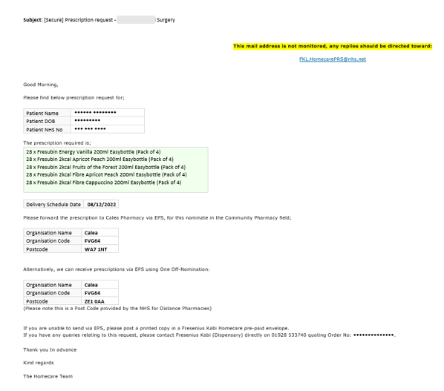

* **WHAT NOT TO DO:**
* Refuse to issue tube feed prescription to FK homecare, if you have a query discuss this with them
* Refuse to alter nomination from patient’s usual local community pharmacy for enteral tube feeds
* Changing feed type or quantity before consulting specialist dietician

The above will severely compromise patient safety, leading to potential harm and be a cause of significant distress to parents of infants & children, patients and carers who solely rely on their tube feeds.

Contact Details:

|  |  |  |
| --- | --- | --- |
| Tower Hamlets | 07927 683112 | [bhnt.nutritionprescribing@nhs.net](mailto:bhnt.nutritionprescribing@nhs.net) |
| Newham | 020 7363 9249 | [BHNT.THdietitians@nhs.net](mailto:BHNT.THdietitians@nhs.net) |