**Course facilitators:**

* **Pip Pinhorn**
* **Julie Morgan**

**Children’s Group worker:**

* **Shahena Khatun**

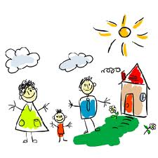

Both **Pip & Julie** are parents and have many years experience of supportive work with families and young children, both individually and in groups.

**Shahena** is a parent and a qualified Early Years Practitioner.

***“Thank you - it’s helped me and I hope in the future it helps other mums” Parent***

***“It felt really good as everybody understands you” Parent***

If you would like to join this course please contact:

**Pip or Julie**

**020 7987 7399**

**Email:**

[**info@toyhouse.org.uk**](mailto:info@toyhouse.org.uk)

This course will be for Mums & their pre school children & held at

**The Toyhouse Centre**

92 St. Paul’s Way, E3 4AL

**On Wednesdays**

Running every Wednesday from Autumn through to the spring

(during term time)

**For 14 sessions**

**Between 9.30am – 2.30pm**

|  |  |
| --- | --- |
|  |  |

INFO 4 PARENTS11092015/MP.DOCx

**Information for parents**



**Mellow Parenting**

**Course**

MCj04361630000[1]

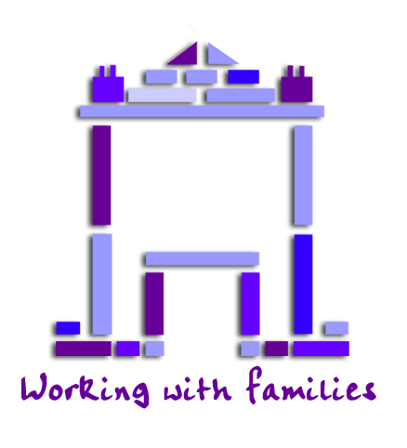

**Toyhouse**

**The Toyhouse Centre**

**92 St. Paul’s Way**

**London E3 4AL**

[**www.toyhouse.org.uk**](http://www.toyhouse.org.uk)

**info@toyhouse.org.uk**

*Toyhouse is a local charity independent from, but working in partnership with, The London Borough of Tower Hamlets*

**What is Mellow Parenting**

**Mellow Parenting helps parents** who for one reason or another struggle with the challenges of parenting

* For parents and their Children under five years
* We will meet one day a week for 14 weeks.
* There will be a maxium of 8 parents in the group.
* The course is free of charge & includes a light lunch
* Each day will be divided into 3 parts.

1. **Personal Group**

You will join a group of parents with whom you can discuss the links between your own experiences in childhood and your experience of being a parent.

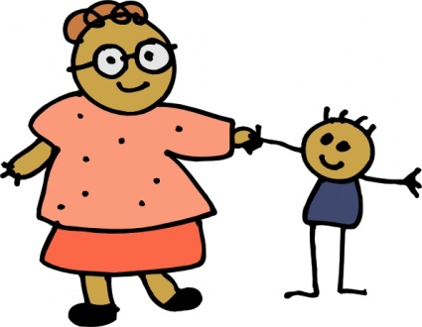

1. **Activity and lunch with your child**

All parents& facilitators involved in the group will prepare and eat a healthy light lunch together with their children. After lunch, we will all take part in group activities, during which you will be encouraged to play together with your child.

1. **Parents’ workshop**

In this session, you will get the chance to watch films of interactions between parents and their children and learn about positive parenting. Usually you will be given tasks to “Have a Go” at home, to practise new activities or skills that you have learned about on the course. During this final group session you will have the opportunity to discuss your ‘Have a Go’, successes from what you’ve learned. You will also be encouraged to try new solutions to your parenting challenges.

**Other information**

Use of video……



We will take a camcorder film of you and your children in your home, before the course starts. Most people do not like to be filmed but we have found it is a great way to look back on you and your children.

The film will belong to **YOU** and you will be able to watch it through with staff before choosing a clip to share in the group.

Most people are usually surprised at how much is going on between parents and children when they get the chance to see it on film!