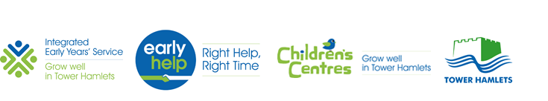

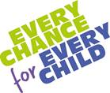
GP One Minute Guide to Early Help Support

 | EARLY HELP HUB (EHH)
Description | The Early Help Hub (EHH) is a key front door for the Early Help system. It is an access point between Early Help and the public including all professionals working with children, young people and their families within the local community and across the authority. The aim of the EHH is to improve communications and information sharing between internal and external partners and to support more effective delivery of Early Help services where there is a need for a multi-agency response. The EHH has five main functions:  - Provides a telephone access point offering information, advice and guidance on Early Help to the public and professionals who have queries about children who may need a coordinated response.  - Supporting Practitioners to complete assessments and convene Team Around the Family (TAF) meetings by offering advice and guidance.  - Screening Early Help enquiries to ensure that there is an appropriate level of response for children, young people and their families which also includes cases referred across from MASH (where the threshold for statutory intervention is not met).  - Short term direct work with families to assess need and to identify the most appropriate Lead Professional who can complete the Early Help Assessment (EHA) (if level 2 needs are identified) and co-ordinate the family action plan.  - Front Door for Early Help Birth to 19 Family Support Service  - Step-down/Step-up: An Early Help Social Worker co-located in the EHH ensures cases are safely de-escalated from Children’s Social Care at the end of statutory interventions where on-going support is required; or are escalated into Children’s Social Care when the child or family’s needs increase.  - The EHH only undertakes triage or discusses cases with consent; however GP’s and other health professionals can make a general enquiry and ask for advice without consent, as long no names are given.  The EHH does not replace the existing ‘Safeguarding Arrangements’ for Children’s Social Care in Tower Hamlets. If at any stage you have any concerns that a child is at risk of harm you must follow your agency’s safeguarding procedure and make a referral to the Multi Agency Safe- Guarding Hub (MASH) 020 7364 5006 (Option 3).
EHH Telephone no. | 020 7364 5006 (Option 2)
Website | www.towerhamlets.gov.uk/earlyhelp
Email | earlyhelp@towerhamlets.gov.uk (secure to nhs.net users)
EMIS EH ENQUIRY FORM  Child’s record  'Early Help notification TH CEG (RP)' | Please provide details of at least one parent and the details of all children where possible or one child as a minimum unless pre-birth and there are no other children. Give child/childrens school details where known as this helps with case screening. The families address is a must as well as a contact number. Please give as much information as you can about the reason for enquiry.

