Requesting a New VPN (MobilePass) Token

From the 1st April 2023, there will be a change of VPN provider and new process for requesting a software-based VPN token.
NEL ICB IT have sought to ensure that the service currently provided to our GP clients is one of high quality and value for money. To this end NEL ICB IT commissioned EMIS to provide this service.
The process for requesting a VPN (MobilePASS) token requires the below table to be fully completed before a token can be issued.

NEL ICB area (i.e. Newham)
Practice/PCN
First Name
Last Name
NHS email Address
CDB Number (do not change) | 140164
Quote Number (do not change) | 84122/85325

Once you have completed the above table you will need to copy and paste the table in to an email and send through to: deliveryoperations@emishealth.com.
Please allow up to 72 hours for the provision of a new token from first request, however and only by exception if this is an urgent request EMIS maybe able to bring this time forward depending on their resource availability.

Once EMIS have enrolled you on their system, you will receive an email from noreply@safenetid.com with the subject line: Egton N3 Connect Account Self-enrolment, which will contain a link you need to follow to activate your MobilePass VPN token.

- The activation link will be sent to your designated NHS email address from - noreply@safenetid.com.
- Your token username will be in the following format, e.g.: 140164MMouse@egton (140164 being the EMIS CDB number and MMouse your name).
- Only use CDB 140164 when setting up and activating your MobilePass token, not your practice CDB.
- Full instructions and a step-by-step video guide explaining the steps that need to be followed to download the software and connect, are available on EMIS Now and can be accessed via the following URL: https://www.emisnow.com/csm?id=kb_article_view&sysparm_article=KB0064401&sys_kb_id=016351841b80dc107937a8a4bd4bcb4b –
  - you will need an EMIS Now user account to access the EMIS Now portal.
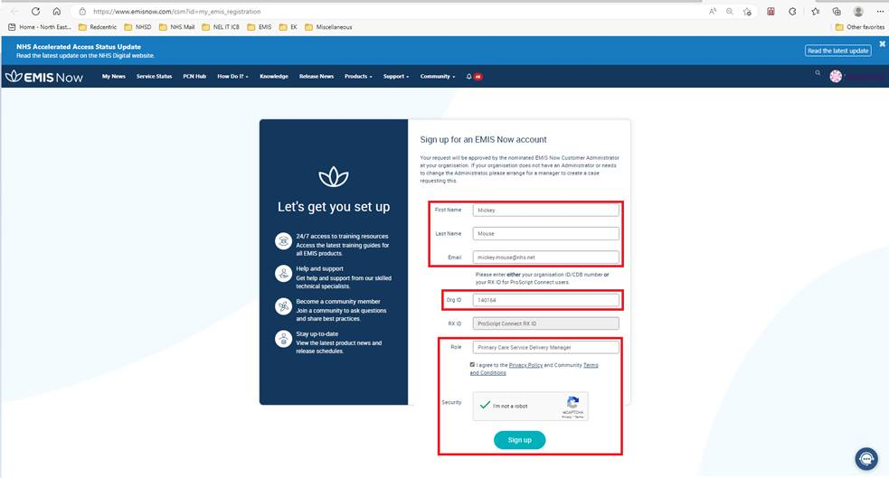
- If you do not have an EMIS Now account you can create one by following this link EMIS Now Registration - Customer Support and populating the fields shown in the screenshot below.

If you have any questions or issues in relation to the new VPN service please direct them to EMIS – using the following contact details:

- EMIS Portal: https://www.emisnow.com/csm
- Email: mysupport@emishealth.com
- Telephone: 08451255530

Please be aware that if you token remains unused for a period of 90 days or more it will be revoked and you will need to request a new token.

